Institutions and Prosperity
Public Institutions for Enabling the Private Sector
with a focus on public procurement and regulatory institutions

Contents
Executive Summary i
Organizational dimensions iii
Governance Dimensions vi
Chapter 1. A Framework for Understanding Public Institutions 1
Defining public institutions, institutional capacity, and policy mandates 2
Conceptual framework: The role of public institutions 3
Cross-cutting dimensions 12
Applying the framework 13
Chapter 2. Public Institutions that Procure from the Private Sector 17
Conceptual framework for public procurement institutions 17
Applying the framework: Corruption and “passive waste” in public procurement 31
Chapter 3. Public Institutions that Regulate the Private Sector 34
Conceptual framework for regulatory institutions 34
Applying the framework: Case study on telecoms regulatory institutions in Peru 47
Annex 1. Methodology for Assessing Procurement Systems (MAPS) indicators 52
References 55

Executive Summary
The private sector is the main driver of economic growth and development, but it needs a functioning public sector to thrive. Governments around the world invest heavily in public goods, such as roads, bridges, ports, and regulatory frameworks, that are essential for private sector growth. Yet waste, corruption, insufficient expertise, and uneven enforcement mean that spending does not always translate into results. Consequently, policies and projects may not actually be as effective as citizens, firms, and policymakers themselves had originally hoped. These implementation failures are a central challenge and are one of the primary reasons why governments fail to enable economic development (World Bank 1997 and 2017; Andrews, Pritchett and Woolcock 2017).
Institutions and Prosperity: Public Institutions for Enabling the Private Sector is the first report in a series that focuses on why policy implementation fails and how it can be improved. This edition focuses on two areas that sit at the heart of market competition: public procurement and regulation. Public procurement represents a large share of government expenditures globally and that spending is primarily concentrated in the construction of critical infrastructure. Likewise, regulations are policy instruments used by governments to ensure that the private sector develops in a manner compatible with the public interest, particularly in instances where markets fail to do this on their own. When either type of institution functions poorly, the costs fall on firms, consumers, and taxpayers.
The report advances the current knowledge on governance and institutions by focusing on specific public institutions rather than entire countries or governments. Since governments may demonstrate robust policy implementation in some areas while falling short in others, this report concentrates on individual ministries, departments, and agencies responsible for carrying out policies rather than evaluating governments as a whole. These bodies, which this report calls public institutions, are defined as "public sector organizations mandated with policy implementation, along with the rules and processes that guide these organizations." The World Bank Business Ready Dataset illustrates how the performance of different public institutions serving the private sector varies substantially within the same country, providing evidence of the importance of focusing on specific public institutions (figure E.1).
The report further develops a conceptual framework for identifying constraints to implementing effective policies that foster private sector development. The conceptual framework unpacks institutional capacity along four organizational dimensions and three cross-cutting governance dimensions. The organizational dimensions, namely personnel, financial resources, information systems, and management practices, capture the internal structures that determine whether an institution can deliver on its mandate. The governance dimensions, or independence from undue influence, accountability to citizens and their representatives, and transparency in decision-making, determine whether that delivery serves the public interest rather than narrow private or political ones (figure E.2, Kim and others 2025).

Figure E.1 Wide variation in institutional capacity within countries across ten policy areas
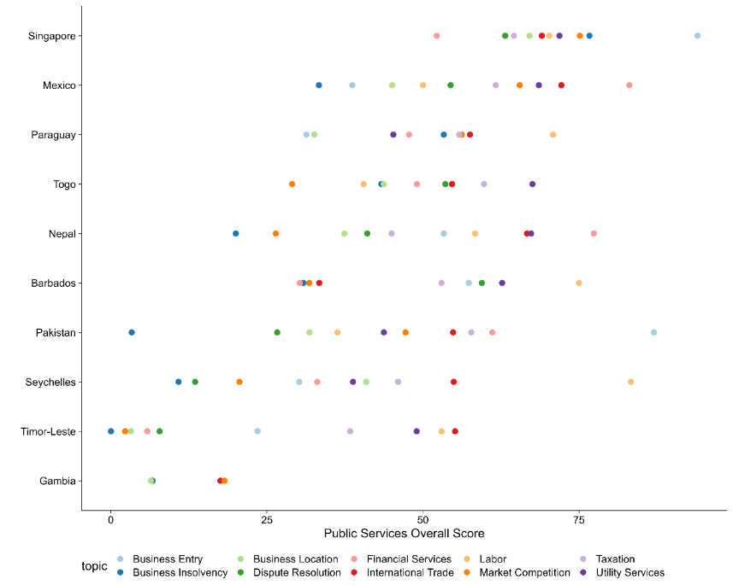
Source: World Bank Business Ready Database. Note: Ten countries out of the 50 covered were randomly selected for illustrative purposes. According to the World Bank Business Ready Database, “Public Services spans the facilities that governments provide to support compliance with regulations and the institutions and infrastructure that enable business activities. Indicators under this pillar are limited to the scope of the business environment in areas related to the life cycle of the firm. They emphasize such aspects as digitalization, interoperability of government services, and transparency.”
Figure E.2 From policies to outcomes - public institutions assessment framework
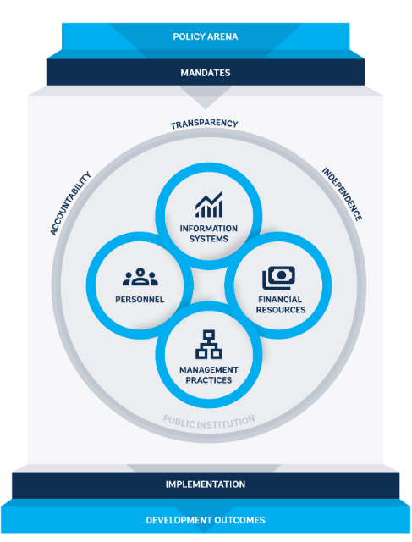

A key feature of this framework is its emphasis on how institutions actually function, rather than their formal attributes. Many governance assessments emphasize the de jure form of institutions rather than their de facto capacity to function and implement their mandates. The framework takes many of these forms and policy mandates as a starting point and focuses its attention on how they are executed in practice.
This emphasis on implementation rather than form highlights the importance of a holistic and multi-dimensional approach to strengthening institutional capacity. Typically, development projects that strive to increase institutional capacity tend to focus on one formal aspect at a time. Government technology reform projects, for instance, often emphasize information systems, while public administration reform projects often focus on personnel aspects. In contrast, the focus on common problems in policy implementation illustrates that such problems are often due to interconnected weaknesses across multiple dimensions. Coordination failures across departments, for example, may be tied to ineffective sharing of information systems as well as management practices that keep departments siloed. Similarly, low budget execution can stem from weak public financial management, staff who cannot spend their available budget due to insufficient training on budget processes, or high transaction costs due to information systems that are not well-connected – highlighting the importance of simultaneously understanding the financial resources, personnel, and information system dimensions. Additionally, governance dimensions of the framework can be applied to each organizational component to understand whether a given component is contributing to policy implementation in ways that align with the public interest. For example, an institution’s personnel may be highly motivated and face strong career incentives to implement its mandate, but mechanisms for their independence from the private sector are important for ensuring that they do not exercise undue favoritism.
Taken together, these contributions allow the framework to diagnose the specific and interconnected constraints that prevent procurement and regulatory institutions from fulfilling their mandates. The report demonstrates how the conceptual framework developed for the Institutions and Prosperity series can help diagnose the challenges and tradeoffs that emerge for institutions mandated to enable the private sector effectively, while minimizing favoritism and corruption.

Organizational dimensions
The organizational dimensions related to personnel, financial resources, information systems, and management practices are factors that help an institution translate policy into implementation. These dimensions are interconnected: an institution’s management practices, for example, are likely to shape the career, skills, and compensation of its personnel. Similarly, strong information systems may enable effective management of financial resources. Moreover, the organizational dimensions are also intertwined with the governance dimensions.
Personnel are a key factor when assessing the capacity of both regulatory and procurement institutions. The framework’s personnel component includes aspects like recruitment, promotions, skills, and compensation. Skills include the staff’s competencies and work experience, which are critical for effective regulation and procurement (figure E.3). In telecoms regulation, for instance, regulators need to be experts in highly technical fields, including broadband technology and spectrum allocation (Stern 2000). Likewise, procurement agencies that lack personnel or expertise can pay higher prices, face cost overruns, and experience contract delays, incurring costs for taxpayers and the private sector at large. In the Russia Federation, for example, roughly 20 percent of the variation in quality-adjusted prices paid for goods and services is attributable to the skills of individual officers who manage the procurement process (Best, Hjort, and Szakonyi 2023).
Figure E.3 Quality of procurement personnel is positively correlated with procurement outcomes
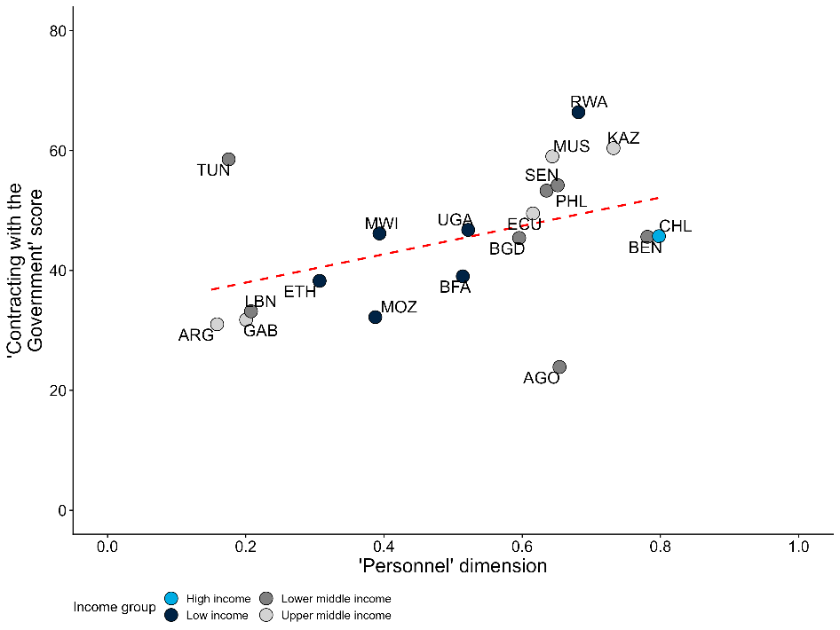
Source: MAPS and Nogues Comas and Mendes dos Santos (2021).
Note: The x-axis is a country-level measure of the quality of procurement personnel derived from the MAPS assessments. Please see annex 1 for more details and a list of the MAPS indicators used to calculate the measure. The y-axis is a country-level measure of the ease of contract with the government from Nogues Comas and Mendes dos Santos (2021). The indicator combines three dimensions: the steps required to complete the procurement process, the time associated with each step, and the sophistication of e-procurement platforms. The correlation remains significant at the 90% confidence level after controlling for GDP per capita.
While public agencies often struggle with insufficient budget, inadequate management of that budget is also common. Poor financial management in procurement institutions often results from cost overruns, contract renegotiations, payment delays, and capacity bottlenecks due to fiscal cycles. Payment delays can be particularly harmful for the private sector – though they are not always the fault of procurement institutions and may result from problems in the broader public financial management chain (e.g., lack of budget space and liquidity), requiring a more holistic approach to address them. In southern European countries, for instance, public entities took an average of five to six months to pay for goods and services purchased between 2000 to 2010 (Conti and others 2021). Delays are usually more common in construction projects than smaller contracts for off-the-shelf goods, but where these delays occur, they can decrease firm cash reserves and corporate investment (Abad and others 2023). Payment delays may also lead firms to exit the market, especially smaller and less experienced firms (Conti and others 2021). As a result, issues like payment delays can often conflict with procurement institutions’ common policy goal of increasing SME participation in public contracts.
Information systems help public institutions reduce transaction costs and make better-informed decisions, which are critical for both regulation and procurement. Given that regulatory institutions supervise dynamic and often rapidly evolving markets, they need data on market trends, technological developments, and compliance with existing regulations. For instance, automated data gathering on air pollution can enhance the quality and accuracy of information for environmental regulators (Greenstone and others 2022). For procurement institutions, information systems like e-procurement (which enable tender documents to be published online) can help reduce transaction costs at each step of the procurement process. The implementation of e-procurement platforms in Indonesia and India, for example, enabled firms beyond the public buyers’ home regions to win contracts (Lewis-Faupel and others 2016). While about 160 countries in the world had some type of system by 2024, only about 40 of those systems were directly connected to other information management systems outside procurement (figure E.4). Moreover, information systems will not fulfill their promise if bureaucrats have neither the ability nor the incentive to fully use them.
Figure E.4 Many countries have e-government procurement (GP) systems, but those systems have varying capabilities
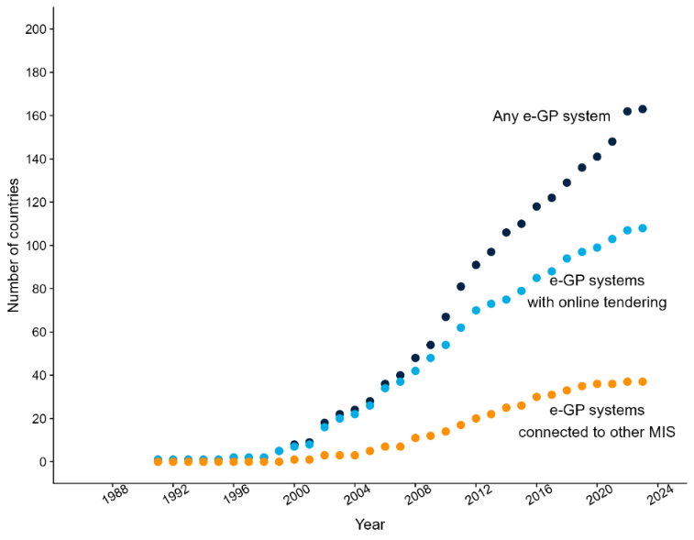
Source: GovTech Maturity Index.
Note: “Any e-GP” system refers to the countries that have any type e-government procurement system. The countries with “e-GP systems with online tendering” are a subset of the first group where tendering can be done online. The countries with “e-GP systems connected to other MIS” are a subset of the first group where the procurement system is connected to other management information systems (MIS) with the government.
Strong management practices can help regulatory and procurement institutions function more effectively, particularly in terms of strategy setting and coordination. Management practices that contribute to excessive workloads in procurement institutions, for example, have been found to harm procurement outcomes, particularly with respect to innovation in procurement. Evidence from the United States, for example, indicates that when the workload of government procurement officers declines, the probability that a procurement contract generates a patent increases (Giuffrida and Raiteri 2023). Similarly, procurement outcomes are strongly correlated with the degree of employee cooperation (Best, Hjort, and Szakonyi 2023) – potentially due to the complexity that public procurement entails, with its many different steps across multiple individuals with different skills. Setting a strategy and committing to it in the medium-long term is an important backbone of a regulatory institution. This forward-looking vision is crucial for reducing regulatory uncertainty for firms and consumer.

Governance Dimensions
The framework’s governance dimensions – independence, accountability, and transparency – focus on whether the implementation of the mandate of a public institution is aligned with the public interest. They reflect the importance of considering the broader political economy within which public institutions function. As with the framework’s organizational dimensions, the governance dimensions are interconnected and are intertwined with the organizational dimensions.
Accountability – or the influence of external stakeholders (including the private sector) on public institutions – has an impact on regulatory and procurement institutions. It is important to establish structured and diverse accountability mechanisms for the many different stakeholders that procurement and regulatory institutions face. Accountability relationships for regulatory institutions can be divided into “horizontal relationships” (i.e., with political institutions and other regulatory institutions) and “vertical relationships” (i.e., with regulated entities). Establishing annual reviews and oversight committees can be useful to ensure horizontal accountability (OECD 2014), while dispute resolution and grievance mechanisms can ensure vertical accountability by enabling firms to voice their concerns. Evidence suggests that these accountability mechanisms increase foreign direct investment and regulatory compliance by firms (Hebous, Kher, and Tran 2020; Malesky and Taussig 2019). Accountability relationships that connect procurement institutions to oversight actors can broadly be divided into oversight relationships that are ex ante (i.e., overseeing the procurement process before contracts are awarded) and those that are ex post (i.e., investigating the process following the award phase). Most procurement systems have complaints processes – an example of ex post accountability – whereby firms can submit complaints that challenge the validity or legality of a procurement process. Generally speaking, ex post accountability through the publication of audits can provide incentives that decrease corruption risk (Avis, Ferraz, and Finan 2018).
Independence protects procurement and regulatory institutions from undue influences that are not aligned with the wider public interest. In regulatory agencies, independence refers to the rules and processes to prevent regulatory capture – ensuring that regulators are free from undue influence from the private sector, politicians, and other interest groups (Carpenter and Moss 2013). For example, protecting regulatory institutions from revolving door appointments (where regulatory agency employees move to industry they were originally regulating and reverse) can reduce their likelihood of being captured (Dal Bó 2006). In regulatory institutions, frequent changes in management can lead to vacuums in leadership and changes in priorities that can prevent important decisions from being taken and disrupt implementation. For instance, in the report’s case study on Peru’s regulatory institutions ecosystem for telecom, frequent changes of the relevant minister delayed decisions of key regulatory milestones (figure E.5). These delays can have significant consequences for the quality, accessibility, and price of telecom services, given the high speed of technological changes in this sector. Similarly, procurement institutions require sufficient independence from the private sector firms that hope to win public contracts, as well as from politicians who seek to deploy procurement contracts as a form of patronage. Given the significant financial stakes involved, suppliers have a strong incentive to offer bribes to officials in exchange for favoritism in the procurement process (Campos and others 2021). Without sufficient independence, bribes and kickbacks may incentivize officials to award contracts based on factors other than quality, price, or policy objectives.
Figure E.5 Frequent leadership changes delay key regulatory milestones (Peru)
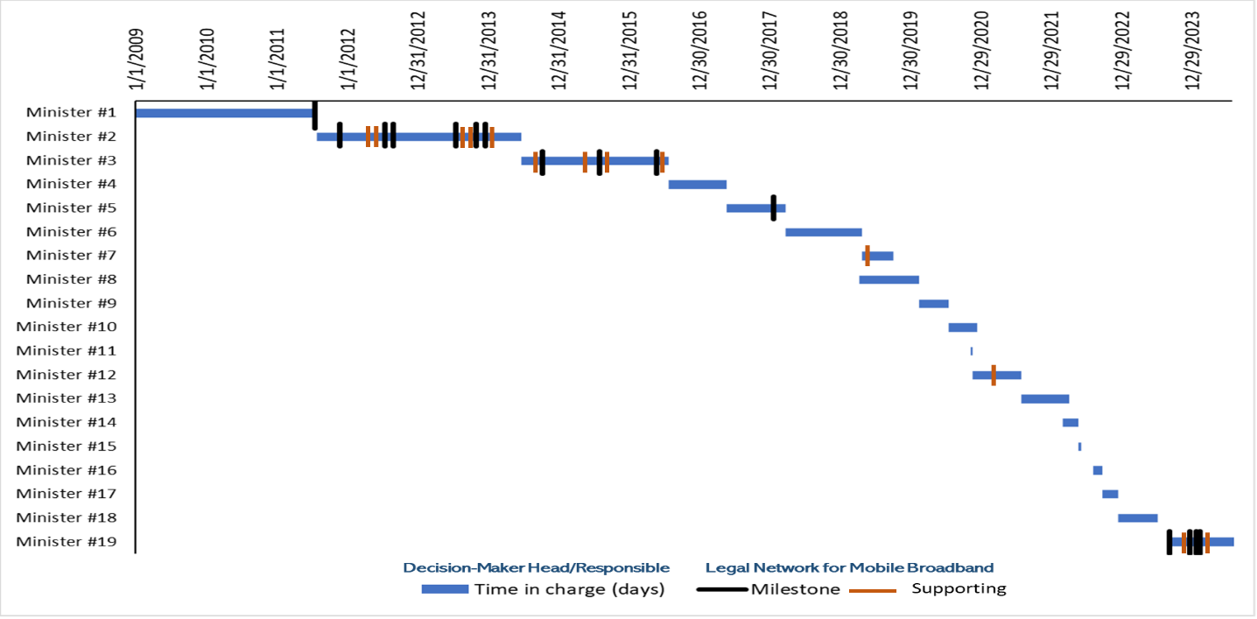
Source: Author’s elaboration.
Note: Each black line represents key legislative or regulatory acts (Milestones) that have significantly impacted the mobile internet service sector in Peru. Each orange line represents other legislative or regulatory acts (Supporting) that complemented Milestones. For instance, key regulatory milestones, like the 4G spectrum auction and Mobile Virtual Network Operator (MVNO) regulations, were also delayed across multiple leadership changes. Each transition in leadership often shifts priorities, resulting in inconsistent implementation and lack of follow-through on existing plans.
Transparency helps enable the accountability and independence of regulatory and procurement institutions. External stakeholders can more effectively hold public institutions in check when they have detailed information about their behavior. Transparency reduces the risk of regulatory capture by enabling the public to see and understand how regulatory decisions are made. When interactions between the public and private sectors are more visible, there are more opportunities for public scrutiny. For example, as a case study documents, the telecoms regulator in Peru could reduce firms’ regulatory uncertainty by adopting a more transparent and accountable approach to market indicators and what the regulations are. For procurement institutions, different actors will benefit from the publication of different types of data. Ex ante transparency in tender criteria is most effective, since it allows for horizontal monitoring by bidders (Bauhr and others 2019). In contrast, ex post transparency about contract awards may be most helpful to citizens, civil society (e.g., non-profit organizations, journalists), and non-selected bidders who want to lodge disputes with national procurement regulators (Duguay, Rauter, and Samuels 2023).
This report series is designed to help policymakers and practitioners understand, analyze, and develop solutions for the public institutions they engage with. Through examples and case studies, it demonstrates how the framework can be applied to diagnose and address capacity issues that hinder effective implementation in procurement and regulatory institutions worldwide. Figures E.6.a and E.6.b provide an overview of core challenges in the organizational and governance dimensions of procurement and regulation, as well as the outcomes that can result from successfully addressing these challenges.
Figure E.6.a How addressing issues in organizational and governance dimensions can affect outcomes in procurement
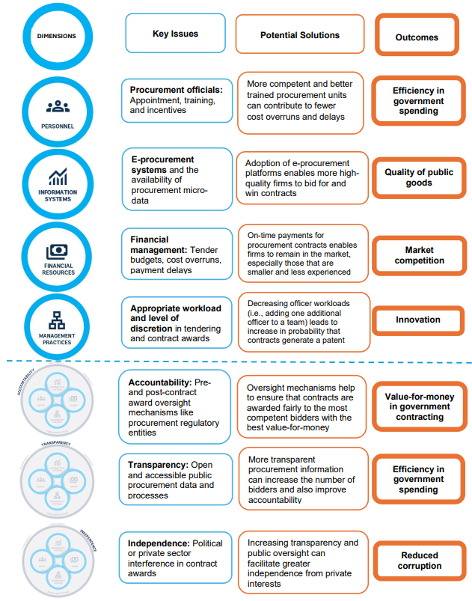

Figure E.6.b How addressing issues in organizational and governance dimensions can affect outcomes in regulation
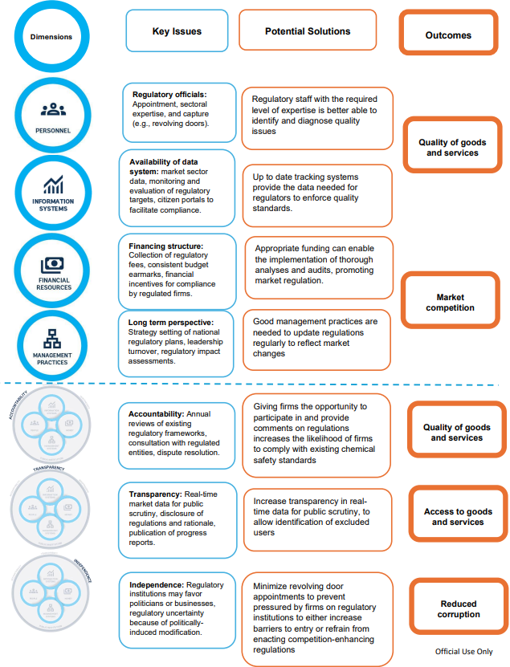

Chapter 1. A Framework for Understanding Public Institutions
While governments may formulate effective policies on paper, their efforts often falter in the process of implementation. Implementation failures are a central challenge in development and are often cited as one of the primary reasons why governments fail to enable economic development (World Bank 1997 and 2017, Andrews, Pritchett and Woolcock 2017).
Existing work on policy effectiveness frequently focuses on policy design rather than policy implementation. For example, governance assessments that focus on best practices in public financial management, public procurement, or tax administration frequently focus on de jure aspects such as laws, policies, and structures. However, policies can be ineffective not because their de jure form is suboptimal but rather because they are poorly executed in practice.
This report goes beyond policy design to focus on failures that occur during the implementation process, which can take on several forms. Implementation failure by public institutions can occur for a variety of reasons, including coordination failures across departments, lack of sufficiently specialized employees to take on tasks, or insufficient information for the highly technical or context-specific aspects of policy implementation. Even when employees have sufficient skills, resources, and coordination, they may also shirk their duties or misuse resources, performing their duties in a manner that privileges their own private benefits over the public interest. These implementation problems can lead to poor development outcomes: teachers who evade their duties and fail to come in for work can lead to poor educational outcomes; ineffective regulation of the private sector can lead to environmental externalities or poor service provision; rent-seeking and corruption can misdirect public funds from public service delivery to private interests.
To better understand the implementation challenges in public procurement and in regulatory agencies, the report presents a novel conceptual framework that maps the institutional-level roots of implementation failure in any type of public agency. Many prior assessments use imprecise language around “weak capacity” or “insufficient political will.” Even if accurate, these concepts do not pinpoint specific weakness or actors that can be targeted for interventions or reforms. This report proposes a framework to help policymakers and practitioners describe, with greater precision, the weaknesses that too often lead to failures in policy implementation.
While most governance assessments are government-wide, this framework adopts a different unit of analysis: individual public institutions. To date, many policy-oriented analyses of government performance and institutional capacity are at the level of countries or governments. Such country-level analyses are imprecise because they hide the significant variation in policy implementation that exists within any single government. To be actionable, assessments should focus only on the specific entities within a government that are relevant for implementing a given mandate, policy, or project.
The conceptual framework unpacks institutional capacity along four organizational and three cross-cutting governance dimensions. While the organizational dimensions capture the internal structures and processes that shape a public institution’s ability to deliver on its mandate, the governance dimensions focus on whether this implementation will be aligned with the public interest, especially when considering the broader political economy within which institutions function.
Thi report draws on insights from several World Development Reports to provide a more granular and specific analytical framework for assessing the capacity of public institutions. The 1997 World Development Report, which highlights the importance of effective states and institutions for development, emphasizing that the capacity of public institutions limits the set of policies that states can implement effectively. Likewise, the 2004 World Development Report emphasizes the principal-agent problem of service delivery and how accountability and transparency can ensure that public services work for the poor. Finally, as noted, the 2017 World Development Report established a high-level framework for understanding how power asymmetries within the policy arena shape how public institutions function. The series builds on the accumulated knowledge of these and other reports to provide a more granular and specific analytical framework to assess the capacity of public institutions. This issue’s focus on enabling private sector development likewise builds on previous work developed in the 2002 World Development Report, which highlighted how institutions can be designed for market-led economic growth.
To demonstrate how the framework can be used to measure and diagnose problems with policy implementation the report takes advantage of the growing availability of micro-data on the public sector. These data shed light on how specific dimensions of specific public institutions function, including personnel (via payroll and micro-level employment data) and financial resources (via procurement bids and tax records) (Rogger and Schuster 2023). In addition to administrative data, the report also leverages surveys of public officials and the development of web-scraping or machine learning technologies. For instance, the World Bank’s Bureaucracy Lab has pioneered surveys of public officials in multiple countries via the Global Survey of Public Servants. The report leverages these data initiatives to move beyond aggregate, country-level measures and thus better understand the diversity present in public institutions within and across governments.

Defining public institutions, institutional capacity, and policy mandates
Building on existing literature, this report defines public institutions as the public sector organizations mandated with policy implementation, as well as the rules and processes that govern these organizations. Douglass North’s canonical definition describes institutions as the “rules of the game in a society, or more formally, the humanly devised constraints that shape human interaction” (North 1990). This report’s definition of public institutions, while narrower than the canonical definition, builds on existing literature at the World Bank. For example, the 2017 World Development Report defines institutions as “a set of formal state institutions (a term used in the literature to denote organizations and rules) that enforce and implement policies.”
The report defines institutional capacity as the ability of public institutions to successfully complete projects and/or implement the policies defined in their mandate. More colloquially, it is the ability to “get things done.” Increasing institutional capacity can thus be understood as decreasing the gap between the de jure policy mandates and the de facto reality of policy implementation. Many previous definitions of capacity have focused on the state level (i.e., state capacity). However, focusing on capacity at the government-level hides variation in capacity across institutions with similar mandates within the same government.
Mandates help identify which public institutions to analyze. The policymaker or practitioner first defines the aspect of policy implementation to be improved, and then identifies the institution tasked with that area of policy. For example, a practitioner may be interested in reducing cost overruns in budget execution. The public institutions responsible for implementing this policy mandate would include the Ministry of Finance and, more specifically, a particular Department of Budgeting. In addition, some mandates require public institutions to coordinate together. For example, addressing climate change requires multiple policies to be implemented in tandem involving an ecosystem of public institutions. Public institutions responsible for green public procurement, water management and other sectoral policies should be analyzed in tandem to enhance their capacity to implement their higher-level mandate (La Cascia and others 2023). The framework, described below, starts with the policy mandate but then inquires whether the institution has sufficient organizational and governance factors to implement that mandate.

Conceptual framework: The role of public institutions
Effective public policy requires both good policies and successful policy implementation. One of the main messages of the 2017 World Development Report is that the process through which policies are made – referred to as the “policy arena” – fundamentally shapes policy effectiveness. This is true, but the process through which policies are implemented fundamentally shapes which policies can be deemed to be “effective.” While acknowledging the importance of the policy arena and policy design, this report focuses on whether the policy mandates developed in the policy arena can and will be implemented in a manner that serves the public interest.
Figure 1.1 presents a conceptual framework that highlights the organizational and governance dimensions necessary for implementation. The framework starts with a public institution’s policy mandate. Then, the framework identifies four organizational dimensions relevant for all public institutions: personnel, financial resources, information systems, and management practices. These are the core factors internal to public sector organizations. Second, it identifies three governance dimensions: transparency, accountability, and independence. These factors are externally facing in that they capture how public institutions relate to other institutions, politicians, firms, or civil society more broadly. The governance dimensions are cross-cutting in that they manifest in the four organizational dimensions. In other words, one should consider not just independence in the abstract but the independence of personnel or the independence of financial resources. Taken together, a public institution’s organizational and governance dimensions shape its ability to function effectively in the public interest and contribute to development outcomes.
The purpose of the framework is not to advocate for a set of “best practices.” This is particularly true given the pitfalls of isomorphic mimicry, the tendency of states to superficially mimic the processes, rules, and systems of governments they see as successful with insufficient attention to whether they are suitable or effective in the relevant context. Instead, the framework seeks to provide a common language for policymakers and practitioners to make vague diagnoses of “weak capacity” and “insufficient political will” more precise and granular. For any given public institution, the combination of organizational and governance dimensions that shape implementation capacity depends on the specific political economy and historical context in question. Management practices may be particularly important in some environments, while the financial resources may be the largest issue in others. Furthermore, the reform that improves the financial resources in one context may differ from the reform that improves it in another.
In many cases, the framework can help diagnose the aspects of political economy that contribute to weak institutional capacity or poor policy implementation. The 2017 World Development Report emphasized how political economy and power dynamics within the policy arena affect what policies are created (World Bank 2017). Yet political bargaining in the policy arena often influences policy implementation, as well. The framework’s organizational and governance dimensions are the outcome of historical processes, political bargaining, and an iterative process of institution building (Vogler 2020; Iyer and Mani 2012). For example, a lack of independence in personnel practices (i.e., lack of meritocratic hiring) might suggest that politicians seek to influence staffing decisions through bribes, patronage, and personal connections (Dahlstrom and Lapuente 2022), leading to suboptimal outcomes. Likewise, since improvements to an institution’s organizational and governance dimensions will be constrained by the broader political economy of the context being analyzed, the multidimensional and interrelated nature of the framework can highlight opportunities for reform. In the previous example, while it may not be feasible to strengthen independence by directly mitigating political influence over staffing, it may be possible to strengthen accountability by establishing new management practices, such as institutional target-setting (see figure 1.5 below) and evaluations of whether targets have been met.
Figure 1.1 From policies to outcomes - public institutions framework


Organizational dimensions
The organizational dimensions are internal to the public institution and represent the core “nuts and bolts” that public sector organizations need to function. This aspect of the framework is based on evidence that the organizational structure of a public institution affects its capacity to implement policies. (Pepinsky, Pierskalla and Sacks 2017; Bertelli and others 2020). Though they are discussed one-by-one below, these dimensions are connected. For example, management practices are likely to shape the career, skills, and compensation of an institution’s personnel. Similarly, strong information systems may enable effective management of financial resources.
The framework therefore emphasizes the importance of considering multiple organizational dimensions in a holistic manner rather than a more piecemeal approach. Public financial management reforms, for example, should consider not only aspects related to financial resources, but also the personnel who construct the budget and the practices through which they are managed. In most cases, implementation failures occur because of problems related to multiple dimensions rather than a problem with one single factor. Practically speaking, this means interventions and reforms aimed at increasing institutional capacity should simultaneously target several of these dimensions instead of seeking to change one dimension at a time.

Personnel
Personnel are crucial for public institutions to deliver on their mandates and ensure effective implementation. Effective personnel are those civil servants who can work together and respond to challenges that arise, rather than simply complying with a set of bureaucratic rules. As such, three connected elements are particularly important for incentivizing personnel: career, skills, and compensation.
Career concerns are those related to issues like recruitment, promotion, dismissal, and the balance between specialists and generalists. For instance, the method through which civil servants are recruited is widely considered to select bureaucrats of different abilities (Finan, Olken and Pande 2017; Pepinsky, Pierskalla and Sacks 2017; Hasnain and others 2019). In particular, meritocratic exams are associated with better development outcomes than other recruitment methods (Evans and Rauch 1999, 2000), although it is important to ensure the content is aligned with the knowledge and skills required for the job (Muralidharan 2024). Once recruited, opportunities for career advancement and promotion can present staff with strong incentives to improve performance (Bertrand and others 2020; Deserranno, Kastrau, and León-Ciliotta 2022).
Skills aspects like the educational and professional background of an institution’s staff as well as training and other professional development activities are also important. Education attainment and prior relevant work experience at the time of recruitment is important (Decarolis and others 2020; Best, Hjort and Szakonyi 2023). Azulai and others (2020) also suggest that capacity training programs can help improve performance once officials are on the job.
Compensation (both monetary and in-kind benefits also shape incentives. In addition to career advancement, promotion is also usually associated with a corresponding salary increase. These raises represent further incentives to improve performance (Bertrand and others 2020; Coviello and others 2024).
Figure 1.2 uses data from the Global Survey of Public Servants to demonstrate variation in recruitment patterns across countries and institutions. Public institutions in countries such as Kosovo and Croatia predominantly hire public servants through an interview process, while institutions in Brazil tend to rely on written exams. Institutions in Ethiopia vary widely in their recruitment practices.
Figure 1.2 Percentage of public servants interviewed in their recruitment process varies within and across countries
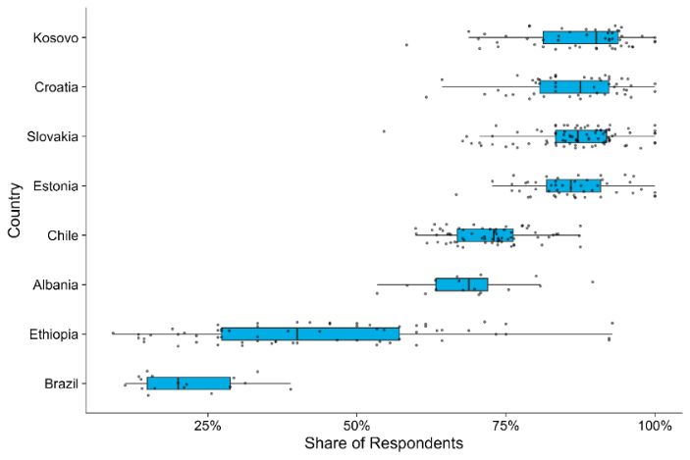
Source: Global Survey of Public Servants. Each black dot represents an institution-level share. The survey question is, with minor variation across countries: For your first job in the civil service, do you remember whether you had to pass an interview as an assessment. Note that later cohorts’ recruitment process may be distinct from newer cohorts.

Financial resources
The framework’s financial resources dimension refers to both a public institution’s overall level of funding as well as the public financial management (PFM) processes through which those funds are spent. While many international PFM assessments exist – such as the Public Expenditure and Financial Accountability Framework (PEFA) or the Open Budget Index (OBI) – they often emphasize whether the “form” of PFM processes reflect international best practices (Andrews and others 2014). However, many governments do not execute their budgets as originally planned (Addison 2013). While corruption and rent extraction are obvious challenges in this regard, budget execution is also often hampered by “passive waste” due to excessive procedures, ineffective training, a lack of incentives for officials to minimize costs, or coordination problems (Bandiera, Prat and Valletti 2009;Rasul and Rogger 2018; Williams 2017). The framework primarily covers the de facto function of a given public institution’s PFM practices, such as the extent to which public institutions draft credible budgets, make prudent fiscal decisions, and access reliable resource flows.
Figure 1.3 Levels of budget execution vary across and within governments, which can be an impediment for public institutions to deliver
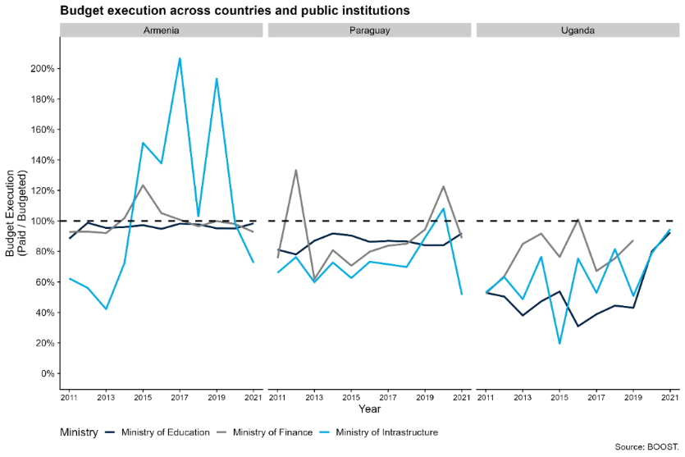
Source: BOOST data on budget execution across key public institutions in Armenia, Paraguay, and Uganda. These three countries were chosen based on data availability as well as preference for countries from different income levels and regions.
Budget execution varies considerably across public institutions within a single country. Figure 1.3 uses the World Bank’s BOOST public expenditure database to illustrate institutional-level variation on budget execution for three key public institutions in Armenia, Paraguay, and Uganda: the finance ministry, the education ministry, and the infrastructure ministry. While budget execution in general is consistently lower in Uganda than Armenia and Paraguay, there are considerable differences in execution across institutions within a single country. While the budget execution of the infrastructure ministry in Armenia is highly variable, Armenia’s finance and education ministries expenditures are much more closely aligned with their budget. These large differences are not visible in Paraguay and Uganda. Interestingly, in both Armenia and Paraguay, the education ministry’s budget execution is remarkably consistent over time. Within-country variation in budget execution may reflect differences in institutional capacity of the line ministry and the mix of recurrent versus capital expenditures that they are responsible for executing, or may rather reflect cross-country differences in institutional capacity of the Ministry of Finance, which is responsible for allocating funding to the line ministries.

Information systems
The framework’s information systems dimension assesses how public institutions use government technologies in their core processes and routine operations, such as budgeting, human resource management, and procurement. These systems are increasingly digital as digitalizing core government functions reduces costs, minimizes delays, prevents corruption, and facilitates access to information.
Because the mere presence of an information system is insufficient, the framework refers to whether information systems are actively used by public officials. Public officials may not use information systems for a variety of reasons, but two primary factors stand out. First, officials may prefer to stick with analog processes rather than digital systems if they do not have the knowledge, skills, or resources to fully use the technology. For instance, officials may not have a reliable internet connection or sufficient understanding of the software in question to easily use the system. Second, officials may prefer to use analog processes if they are hesitant to render their actions more traceable and transparent. Digitized processes and systems are more easily captured and analyzed, while paper-based processes are more obscure and harder to trace. Officials’ failure to use information systems or provide correct information can highlight important political drivers of weak institutional capacity, such as officials’ personal or political interests or their ability to coordinate with other institutions (Eutsler and others 2023; Liu 2023; Sandefur and Glassman 2015; Trinh 2019). As noted below, these incentives are closely related to the transparency of information systems.
Figure 1.4 analyzes the uptake and interoperability of information systems using the World Bank’s GovTech Maturity Index (GTMI), a survey of governments’ use of digital technology and various management information systems (MIS). The left panel shows the availability of different systems within governments. While many countries have financial management information systems (FMIS) or customs systems, relatively few have public investment management systems (PIMS). This is true even for upper- or middle-income countries. The right panel underscores that system interoperability in existing systems varies: only about half of low- and lower-middle-income countries with e-procurement systems, for example, can easily exchange information with other government technologies. Similarly, while almost all countries have a human resource management information system (HRMIS) , the absence of HRMIS bars in the right panel indicates that these systems cannot exchange information with other government systems. This lack of information exchange may originate in rules about the confidentiality of personnel data, yet it also represents a tradeoff: not being able to connect data across different parts of the government, prevents information flow, creates silos, undermines coordination and effectiveness of the government.
Figure 1.4 While many countries have information systems, information exchange is limited – undermining these systems’ potential to help public institutions deliver
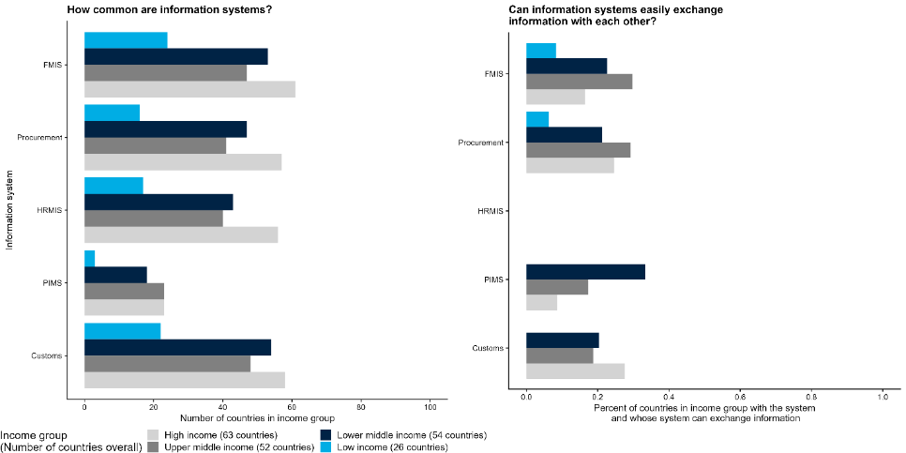
Source: GovTech Maturity Index (2022).

Management practices
To function effectively, public institutions need strong management practices to coordinate and steer their operations and strategic direction. Three connected elements are particularly important: (a) strategy and decision-making or how an institution sets its strategies and distributes decision-making authority to implement those strategies; (b) monitoring and evaluation or how an institution oversees, evaluates, and incentivizes staff; (c) organizational culture or mutually agreed-upon behaviors and beliefs that are not codified or written down. While the first two parts of management practices refers to practices often formalized through written rules and processes, the third part – organizational culture – captures more informal aspects such as esprit de corps, norms, and trust between public officials. These management practices are distinct from the personnel dimension because they are not about individuals, but rather about how groups or teams of individuals interact within an institution.
The formal aspects of management practices have been shown to affect institutional capacity in the public and private sectors. Both cross-country and single country studies emphasize how effective management can enhance productivity in Scur and others 2021; Bloom and others 2015; Rasul and Rogger 2018). Effective management practices balance giving public officials sufficient autonomy to perform and innovate, while also providing enough monitoring to ensure the institution’s objectives are met. Public sector management practices are often overly focused on the second dimension – monitoring – and provide limited autonomy or discretion (Rasul, Rogger, and Williams 2021) or overburden officials with compliance tasks (Dasgupta and Kapur 2020). Honig (2024) argues that motivating officials to fulfill the overall mission of the organization can be more effective than simple monitoring of compliance The Global Survey of Public Servants (GSPS) data provide evidence of the high degree of variation within the governments of Guatemala and Ghana with respect to whether they set mission-driven targets at the institutional level (figure 1.5).
The informal aspects of management practices – in other words, organizational culture – are also crucial for implementation. While the framework takes “culture” at the societal level as given, organizational culture may differ across institutions in the same country and evolve over time. For instance, public sector managers can inspire greater motivation in their personnel through non-financial appeals like calls to appeals to the public interest (Honig 2021). This type of prosocial motivation has been shown to improve job performance in a wide range of settings (Callen and others 2015).
Figure 1.5 Institutions within Guatemala and Ghana vary in the extent to which they set targets
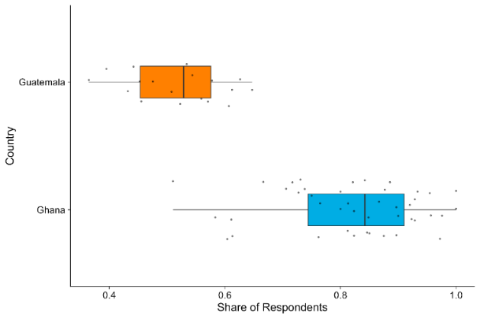

Sources: Global Survey of Public Servants. Each black dot represents an institutional-level share. The survey question is: Does your organization have a clear set of targets derived from the organization’s goals and objectives?

Governance dimensions
Alongside strong organizational dimensions, effective public institutions also need strong governance. Even with large staff, generous budgets, sophisticated information systems, and sound management practices, public institutions can still fail to fulfill their mandates in a way that aligns with the public interest by working inefficiently or drifting from its policy mandate. Through the misallocation of public resources, it may also be implementing policy in the private interest of some set of internal or external stakeholders. To address these possibilities, the framework emphasizes the importance of three cross-cutting governance dimensions: accountability, independence, and transparency. While the organizational dimensions are internal to a public institution, these governance dimensions are concerned with the institution’s relationship with external actors like politicians, the private sector, and civil society. These dimensions are motivated by an understanding of policy implementation as a principal-agent problem in which public institutions implement policy on behalf of external stakeholders, such as citizens and political representatives (World Bank 2004). Governance dimensions help ensure alignment of the public institutions’ incentives with the interests of their stakeholders.

Accountability
Accountability is the appropriate influence of external stakeholders over a public institution’s decision-making. Often, the stakeholder is another public institution within the same government, for example, public sector auditors who investigate allegations of abuse of public spending. In other cases, the stakeholders can be private firms or civil society organizations. For example, can firms meaningfully challenge regulatory decisions that they believe to be biased or unfair? In either case, the stakeholder’s influence can take multiple forms, including the ability to review an organization’s decisions, enact consequences (negative or positive) for policy outcomes, and provide feedback on the organization’s performance. When the stakeholder is the public, accountability can include oversight by citizens and bottom-up mobilization in what is often called the “short route of accountability” (World Bank 2004; Kosack and Fung 2014).
The accountability dimension is meant to align an institution’s interests with those of the external stakeholder and prevent the organization from acting in its own interests or drifting from its mandate (Schillemans and Busuioc 2015). Several examples from the literature illustrate the effect of mechanisms for accountability on developmental outcomes. In China, for example, citizen monitoring in the form of public appeals to regulators when firms violated pollution standards decreased pollution emissions (Buntaine, Zhang, and Hunnicutt 2021). In Brazil, bureaucrats’ personal connections to politicians increases public accountability and performance (Toral 2023).

Independence
Independence consists of the rules and processes that protect a public institution from undue influence and ensure that private interests do not capture it. While accountability ensures that external stakeholders have influence over policy implementation, independence ensures that an institution acts without bias and evades institutional capture. The framework specifically considers the independence of public institutions from two sets of actors: politicians and the private sector. Independence from politicians can be enhanced through a civil service system that protects some public servants from dismissal or appointment by the executive leadership (Grindle 2012). The appointment process of some central bank officials – which requires legislative approval or term appointments that span consecutive administrations – is another example of independence. Independence from the private sector can be ensured through rules that prevent the “revolving door” in which public officials alternate between careers in public institutions and private firms. Similarly, policies prohibiting the exchange of gifts and bribery are also examples of rules to reduce the likelihood of private capture and increase independence (Bajpai and Myers 2020).
The independence dimension is particularly important when political institutions are not fully democratic or private interests have captured the policy arena. When the political process is captured, politicians in the policy arena and other stakeholders external to the public institution in question may not act in the public interest (Rijkers, Freund and Nucifora 2017; Canen and others 2023). Moreover, independence measures prevent elected officials from using institutions for their own political gain. For instance, competitive elections may incentivize politicians to extract resources from public institutions to finance political campaigns (Brierley 2020).
Figure 1.6 uses GSPS data to highlight indicators that measure the independence of personnel and management practices at the institutional level. It shows the extent to which personnel recruitment is not perceived to be influenced by political connection, showing the wide variation across institutions within the same country.
Figure 1.6 Large institutional-level variation in perceptions of the influence of political connections on recruitment
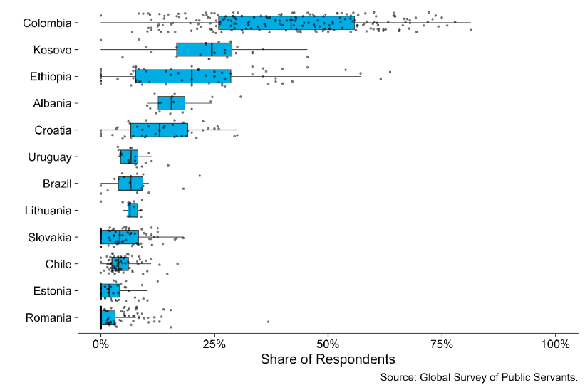
Source: Global Survey of Public Servants. Only countries covered in the GSPS are analyzed. Share of respondents who agree that knowing a politician or having political connections is important to get a public sector job. The survey question, with minor variations, is: How important have the following criteria been for you to get your first job in the civil service? Knowing a politician or someone with political links.

Transparency
Transparency is the visibility of a public institution’s decisions and actions to external stakeholders. Transparency is essential for enabling accountability: enforcement mechanisms are only effective if the relevant stakeholders have enough visibility into a public institution’s operations to become aware of infractions or deviations from the policy mandate (Khemani et al. 2016). Cross-country analysis finds that during economic emergencies, countries with more transparent central banks face lower costs of disinflation (Stasavage 2003). Increased media freedom – a proxy for transparency – is also associated with decreased corruption (Camaj 2013). As noted above, transparency is particularly effective at improving outcomes when paired with accountability mechanisms. In a famous example, a Ugandan newspaper campaign monitoring local officials’ handling of a large education grant reduced the local capture of funds and improved school enrollment and learning outcomes (Reinikka and Svensson 2011).
At the most basic level, the transparency dimension emphasizes that government information and data should be public, easily accessible, and presented in formats that are reasonably easy for citizens to understand. Figure 1.7 demonstrates that information systems vary in their degree of transparency, even within individual countries. Across multiple types of information systems, the plot shows whether countries do not have a particular system, have the system but do not publish governance information, or have the system and do publish the information. For instance, about 30 percent of low-income countries with customs information systems publish key governance information like audits. In contrast, fewer than 10 percent of low-income countries with HRMIS systems make the same kind of information accessible to the public. The same country is often in each of these three categories across different systems. Malawi, for instance, has a financial management information system (FMIS) that publishes system governance information, but they have no e-procurement system. Such variation in transparency across information systems suggests that – even within a single country – different kinds of government information will be more accessible to the public than others.
Figure 1.7 Governments frequently have systems for collecting information but may not publish it, undermining transparency
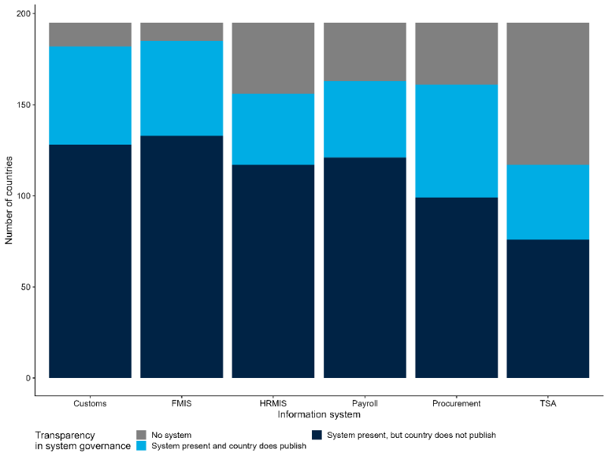
Source: 2022 GovTech Maturity Index (GTMI).
Note: Financial Management Information System (FMIS), Human Resource Management Information System (HRMIS), Treasury Single Account (TSA).

Cross-cutting dimensions
The framework’s governance dimensions are cross-cutting, in that they apply to each of the framework’s organizational dimensions. For example, reforms designed to strengthen independence cannot target independence in and of itself; instead, the concept of independence must be applied to one or multiple of the organizational dimensions. Independence reforms with respect to personnel, for instance, may increase the number of public officials that are recruited through meritocratic processes rather than political appointments. Similarly, independence reforms with respect to information systems may seek to render the information collected by digital technologies more neutral, more comprehensive, and less biased (table 1.1).

Table 1.1 Examples of measures for governance dimensions, applied to organizational dimensions
 |  | Organizational dimensions
 |  | Personnel | Financial resources | Information systems | Management systems
Governance dimensions | Accountability | Rewards/sanctions based on performance evaluations or other observable measures of behavior | Release of funds conditional on periodic budget review/audit | Repercussions for data manipulation | Pay-for-performance schemes
 | Independence | Percentage of civil service recruited through meritocratic processes | Whether cash flows are forecasted, monitored, and predictable | Whether those collecting, processing, and securing data are different from those enacting policy | Autonomy in determining staffing and use of budget
 | Transparency | Publicly available organizational structure | Publicly available budget and expenditures | Public documentation on how data is collected and secured | Existence of reporting on monitoring and evaluations

Applying the framework
The framework can help policymakers and practitioners diagnose the causes of failure in policy implementation. Table 1.2 presents examples of common problems in policy implementation and illustrates how a public institution’s organizational and governance dimensions might contribute to those problems. While several problems may also originate in the policymaking or institutional design phase, the focus of the report and framework is on identifying potential institution-level problems at the time of policy implementation. The exact ways in which organizational and governance dimensions contribute to problems will be context dependent; table 1.2 simply presents examples to illustrate different possibilities.
As table 1.2 illustrates, any given implementation problem can have its roots in multiple organizational or governance dimensions, highlighting the interconnected nature of the framework’s components. For example, recruitment practices (an aspect of the personnel dimension) may prevent the hiring of public officials who are sufficiently skilled for the job. At the same time, these recruitment practices might be inhibited by a lack of sufficiently specialized departments to hire technical staff, an aspect of the overall management strategy. As such, weakness in one dimension may result in weakness in another. Following table 1.1, weakness in a given organizational dimension may also be related to ineffective governance. Poor hiring practices may originate in the capture or insufficient independence of personnel practices.
Once the most relevant dimensions for a problem have been identified, practitioners can identify the policy solutions appropriate for a given context. The last column of table 1.2 presents selected examples from the literature.

Applying the framework to procurement and regulatory institutions
To demonstrate the framework’s diagnostic potential, the next chapters will apply it to analyze how procurement and regulatory institutions’ capacity may affect outcomes in the private sector. Rather than focusing on the “right” regulatory or procurement policies for a particular sector, this report focuses on whether institutions are capable of delivering on their given policy mandates and the organizational and governance dimensions which may prevent them from doing so. Box 1.1, for example, examines the Country Growth and Jobs Reports (CGJR) as well as the Country Private Sector Diagnostics (CPSD) to understand common challenges that firms face in these two areas. They highlight clear scope for improving institutional capacity to conduct basic functions like procuring infrastructure and maintaining strong regulatory environments to address domestic constraints to private sector growth.
Box 1.1 Public Institutions for Procurement and Regulation – Insights from World Bank Group Diagnostics
Procuring infrastructure contracts
The effective management of financial resources fundamentally shapes the ability of public institutions to procure the construction of physical infrastructure like electricity, roads, and infrastructural nodes in supply chains. For instance, the CGJR for Moldova emphasizes the need to improve the low quality of infrastructure. The country CPSD finds that roads in particular have received insufficient investment. Not only is the State Road fund insufficiently capitalized, but it also fails to provide a predictable source of funding for road maintenance. One of the recommendations is to establish multiyear payment mechanisms to enable output- and performance-based contracts to improve road maintenance and operation. As one of Europe’s poorest countries, it may be difficult for Moldova to allocate more funding to road maintenance; even so, changing how existing funds are managed can improve contracting outcomes.
Regulatory environments
A lack of transparency, accountability, and independence among regulatory institutions can create constraints for firms. In Pakistan, for instance, domestic and foreign investors cite corruption in the country’s fragmented regulatory environment as one of the major impediments to doing business, and the CGJR suggests that this is a key barrier to FDI. There are at least 12 different categories of regulations in the country, and enforcement is irregular, opening the system to rent seeking and corruption. The CPSD for Pakistan advocates the establishment of accountability mechanisms, particularly redress and dispute mechanisms for investors.

Public Procurement
Public procurement represents a large share of government expenditure globally and that spending is primarily concentrated in the construction of important public goods like roads, bridges, and ports. Procuring a quality road network, for example, helps decrease transport costs, make supply chains more resilient, and integrate labor markets, (Banerjee and others 2020; Shamdasani 2021; Chaurey and Trung Le 2022). The performance of government is in turn directly linked to the growth and quality of these public goods. The adoption of electronic procurement systems in India, for example, led to a change in the composition of winning roads contractors and – as a result – an increase in the quality of the road network (Lewis-Faupel and others 2016).
Strong institutional capacity is essential to ensure that procurement institutions deliver these benefits. Inefficiencies including passive waste, administrative delays, and “home bias” can severely increase timelines and costs while simultaneously disincentivizing firms from bidding in the first place Bandiera, Prat, and Valletti 2009; Garcia-Santana and Santamaria 2024; Conti and others 2021). Additionally, because, procurement contracts directly benefit firms who win them, it is important that institutions rely on efficient allocation practices that are free from corruption, collusion, or undue favoritism. (Mironov and Zhuravskaya 2016; Avis, Ferraz, and Finan 2018; Chassang and Ortner 2019).

Regulation
Regulations are the laws and formal rules that determine requirements and standards for firms, citizens, and the public sector. They aim to ensure that the private sector develops in a manner compatible with the public interest, when markets fail to do so. Developing and developed countries alike are exposed to market failures in the form of weak competition and information asymmetries (Jacobs and Ladegaard 2010). Among other responsibilities, regulations set business registration requirements and fees as well as credit market and labor regulations (World Bank 2016a). Existing evidence suggests that weaknesses in institutional capacity lead to regulatory failures, increasing costs and risks to firms (Estache and Wren-Lewis 2010; Jacobs and Ladegaard 2010).
Regulatory institutions are responsible for several processes that complement and enhance the design of regulations and their implementation (OECD 2014). For example, financial market regulatory institutions gather market data on innovative products, such as cryptocurrencies or blockchains, to design regulations that address underlying market risks (Government Accountability Office 2023). Regulatory institutions may also engage with manufacturing firms to gather comments on regulations, strengthening accountability mechanisms and improving compliance (Malesky and Taussig 2019).
However, the design and enforcement of regulations in developing countries is often inhibited by the weak capacity of regulatory institutions (Laffont 2005). A lack of independence, in the form of political interference, can lead to prioritization of electoral rather than welfare goals (Müller 2023). Low institutional capacity can also exacerbate regulatory risk and uncertainty, negatively affecting firms’ investment and business decisions (World Bank 2016a). Improving regulatory institutional capacity can therefore enable private sector development in developing countries (Brown and others 2006).

Table 1.2 Using the framework to diagnose potential sources of common policy implementation problems
Implementation problem | Potential Sources of Problems |  |  |  | Possible solutions
 | Personnel | Financial Resources | Information Systems | Management Practices
Public officials lack the skills for the job  (i.e., regulators do not have the skills to understand a specific market, leading to failures in consumer protection) | Recruitment does not identify the most relevant skills  Independence: Recruitment favors private interests  Accountability: Few repercussions for poor hiring | Institutions lack financial resources to recruit, employ, and retain skilled officials |  | The institution lacks sufficiently specialized departments to tackle technical issues | Limited term-lengths along with public election or joint administrative and legislative appointment of administrative officials (independence of personnel practices) reduces the likelihood of their capture by private interests (Besley and Coate 2003; Martimort 1999; Smart 1994)
The institution lacks information about the nature of the problem it is addressing (i.e., procurement agencies do not track schools’ needs, leading to lack of supplies) |  |  | Information about the problem is not stored in a systematic and interoperable way  Independence: Private actors prevent the collection of data that might expose malfeasance | The institution lacks departments specialized in the nature of the problem it is addressing  Accountability: There are no repercussions for technical failures in program implementation | Focus on officials’ personal or political interests or their ability to coordinate with other institutions that are inhibiting their use of information systems (Eutsler and others 2023; Liu 2023; Sandefur and Glassman 2015; Trinh 2019)  Technology for monitoring expenditures (transparency of financial resources) can reduce corruption and graft (Khemani and others 2016); audits decrease unaccounted-for expenditures (Olken 2007)
Public officials shirk duties (i.e., teachers’ absenteeism leads to poor learning outcomes) | Career advancement and salary are not appropriately tied to individual performance; multiple individuals responsible for an outcome, leading to free-riding  Independence: personnel are motivated by private interests  Accountability: There are few mechanisms to sanction absenteeism | Passive waste limits resources available to tie salary to individual performance; or salaries not paid in a timely manner | Systems to monitor progress on a project do not exist or are not used  Transparency: The public and higher-level officials do not have access to the data measuring officials’ effort |  | The potential to reach the top of a public organization is a powerful determinant of bureaucrat performance (Bertrand and others 2020); meritocratic promotions lead to higher worker productivity (Deserranno, Kastrau, and León-Ciliotta 2022); capacity training programs can help improve performance even further (Azulai and others 2020)Target-setting can increase productivity and motivation (Locke and Latham 2002); yet target-setting can crowd out other objectives, inhibit learning, and reduce intrinsic motivation (Ordonez and others 2009); increased autonomy is associated with higher rates of task completion (Rasul, Rogger, and Williams 2021)

Chapter 2. Public Institutions that Procure from the Private Sector
Public procurement enables the private sector by creating important public goods like roads, bridges, and ports that benefit firms across the economy. Quality public goods are in turn important for improving supply chains, connecting workers to jobs, reducing transaction costs, and beyond. These public goods – facilitated by public procurement – are the engines that fuel economic growth. Weak procurement institutions can therefore harm private sector development through poor provision of public goods, inefficient use of public resources, and undue favoritism in awarding contracts.
This chapter applies the conceptual framework to diagnose weak institutional capacity among procurement institutions. This complements the Independent Evaluation Group’s (IEG) recent report on the World Bank’s 2016 procurement reform which focused on the procurement rules and processes used in World Bank financed projects. The second policy recommendation in that report’s conclusion specifically recommends the Bank “strategically strengthen country-level procurement capacity” (World Bank 2024b). Expanding upon that recommendation, this chapter first identifies the policy mandates of procurement institutions. It then clarifies how the organizational and governance dimensions can be applied and measured using concrete examples. It concludes with a case study illustrating how the framework can be used to diagnose the causes of corruption and waste in public procurement.

Conceptual framework for public procurement institutions
To diagnose these issues, figure 2.1 applies the conceptual framework to the case of public procurement institutions. As noted in chapter 1, the report defines institutional capacity here as the ability of procurement institutions to “get things done” or to successfully complete the projects and/or implement the policies described in their mandates. The remainder of this section unpacks the framework in figure 2.1, highlighting the relevant literature and presenting novel analysis of the available data on procurement institutions. Measuring the organizational and governance dimensions of procurement systems is difficult, but as discussed below, the available data can be used to explore and diagnose weaknesses in these concepts across countries and across institutions within the same government. Many of these data are indicators constructed from the Methodology for Assessing Procurement Systems (MAPS) assessments, which are detailed evaluations of country procurement systems.
Figure 2.1 Framework applied to procurement institutions
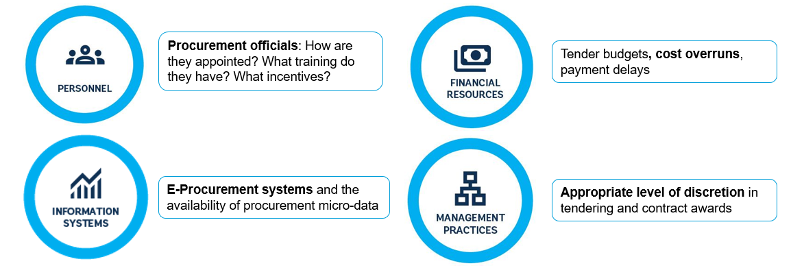
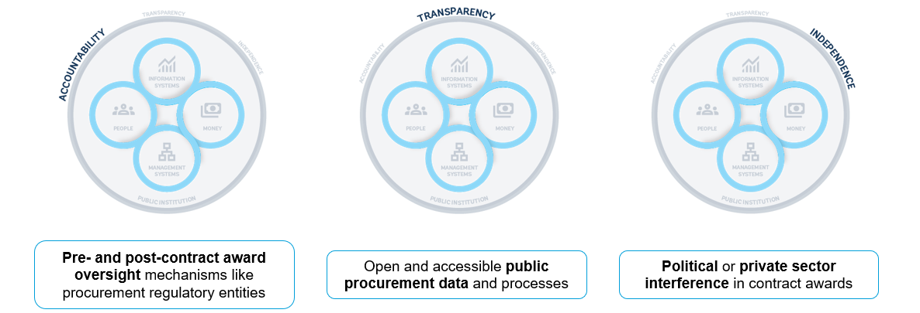
Source: Adapted from Kim, Kumar, Ramalho, and Russell (forthcoming).

Policy mandates
Procurement institutions are spread across different levels and layers of government. Some countries have a central government procurement agency that procures standardized items like medicine or office materials for use across the administration. The procurement of non-standardized goods and services, however, is usually handled by individual units lodged within ministries, agencies, state-owned enterprises, and other institutions. These units – which may comprise only two or three individuals – are responsible for coordinating with the staff of their ministry or agency about their procurement needs and conducting the necessary purchases. The report takes a broad definition of “procurement institutions” as both the centralized buyers and the more disaggregated units lodged within other ministries and agencies. These two types of procurement institutions – the centralized buyers and the disaggregated units – are conceptually distinct and have different personnel and responsibilities. That said, the framework outlined in figure 2.1 can be applied to either type and their respective policy mandate.
Most procurement institutions have two key policy mandates, the first of which is to maximize efficiency and economy. Procurement institutions are responsible for purchasing goods and services in a manner that maximizes both quantity and quality while simultaneously minimizing costs. In other words, public buyers make purchases that try to maximize efficiency and economy. “Efficiency” is usually related to transactional efficiency or the timeliness of the process, while “economy” is generally concerned with avoiding unnecessary or unproductive costs (World Bank 2022b).
Procurement institutions’ second key policy mandate is to advance the governments’ broader policy objectives. Increasingly, procurement institutions are also asked to focus on strategic objectives like “value for money,” a concept encompassing both fiscal savings and broader socio-economic concerns (World Bank 2022b). The purpose of value for money is typically to pursue ancillary policy goals, such as minimizing greenhouse gas emissions, promoting the growth of small and medium enterprises (SMEs), supporting firms owned by women or disadvantaged groups, and favoring the development of domestic firms. In part due to the significant size of the procurement sector, governments hope to achieve these goals by incentivizing firms through the goods and services they purchase.
It is important to note that these two key policy mandates are sometimes at odds with one another. Policy objectives like prioritizing sustainable or minority-owned suppliers are often worthy and important goals. However, such suppliers may have higher costs, so awarding them contracts can often contradict the first mandate. Likewise, evaluating the implications of various bids for carbon emissions and environmental harm is time-consuming, so conducting these types of analyses during the contract award stage may jeopardize efficiency. Such tensions emphasize the complexity that public procurement institutions often face.
Procurement outcomes – such as unit prices or the quality of goods – can vary widely for similar contracts across institutions within a single country. For instance, within several different Latin American countries, different institutions pay vastly different prices for the same pharmaceutical products (Mihály, Oliveira and Regös 2021). There are similar significant differences in unit prices across institutions in the Russian Federation, even after controlling for potential differences in the quality of the goods that are purchased (Best, Hjort, and Szakonyi 2023). In these and other contexts, much of the differences in unit prices can be explained by differences in how procurement laws and policies are implemented. In other words, even when faced with the same national procurement frameworks, some institutions are more capable of implementing their policy mandates than others.
Procurement institutions may fail to deliver on these two policy mandates due to a wide range of governance problems. The procurement process involves many different stakeholders, each of which has their own objectives and priorities. The problems most relevant for each actor will depend on those objectives and the broader context in which they operate. That said, some common problems that prevent procurement institutions from delivering their mandates include:
- Procurement officials do not have sufficient knowledge of procurement methods or markets to minimize costs while maximizing quality. Officials may not have sufficient incentive to collaborate with the private sector, which is often crucial for important upstream procurement tasks like researching the market, designing appropriate specifications, and drafting terms of reference.
- Firms, politicians, or other public officials pressure procurement officials to award contracts to specific, favored firms. These firms may not be the most qualified, thereby increasing costs or decreasing quality.
- Procurement officials themselves are captured by firms and receive bribes from specific suppliers in return for awarding contracts to those suppliers.
- Procurement activities are arduous and complex because they rely on paper-based, manual processes that require approval from many different stakeholders. The number and manual nature of these steps creates delays.
- Politicians or other decision-makers impose unnecessary or unrealistic time-constraints that rush steps in the procurement process and hinder effective implementation.

Organizational dimensions

Personnel
Procurement officials manage many complex tasks throughout the procurement process (Decarolis and others 2020). Procurement officials must first work with their technical colleagues to define the ministry or agency’s needs and translate those needs into tender documents. For instance, what are the specifications of the vehicles that the agency wants to purchase or the requirements of the bridge that it wants to construct? Second, procurement officials manage the design of procurement auctions and the solicitation of firm bids. They must then carefully evaluate each bid, which requires an understanding of the market for the good or service in question. Finally, after the winning firm is chosen, procurement officials must design a contract that minimizes the risk of delays and cost overruns.
Each of these steps requires different types of knowledge, implying that the “competence” of procurement officials has a significant effect on outcomes. Procurement agencies with fewer competent officials can pay higher prices, face cost overruns, and experience contract delays. In the Russian Federation, for example, roughly 20 percent of the variation in quality-adjusted prices paid is attributable to the individual officers who manage the procurement process (Best, Hjort, and Szakonyi 2023). Likewise, prices for similar products vary significantly across different office clerks in the Italian procurement system: the worst-performing procurement units pay approximately 55 percent more than the best performers units (Bandiera, Prat, and Valletti 2009). This research demonstrates that there is considerable variation in procurement performance across officers, even within the same institutional environment. What factors, then, help make one procurement officer more effective than another?
Procurement officials’ education and the extent of their procurement-specific training are important determinants of performance. Unfortunately, many governments do not have specific career paths or roles for procurement bureaucrats. Instead, the procurement function is typically fulfilled by officials, who specialize in other policy areas but spend some of their time on contracting. For instance, only 22 out of 95 countries surveyed in a recent World Bank report recognized public procurement as a standalone function in the civil service (World Bank 2023b). Similarly, in France, procurement contracts have long been managed by officials with an exclusively legal background (Saussier and Tirole 2015). While knowledge of legal requirements is important, it is often not enough to optimize efficiency and value for money.
Beyond personnel qualifications, procurement units are often understaffed and overburdened. Even in the United States, public agencies often rely on short-term consultants to manage procurement rather than full-time staff (Liscow, Nober, and Slatter 2003). In addition to frequently lacking the necessary expertise, such consultants also do not have the same career incentives for performance as full-time employees. The overreliance on consultants without adequate expertise has been shown to lead to tenders without sufficient detail in key “upstream” procurement tasks (Liscow, Nober, and Slattery 2003). These “upstream” procurement tasks include early stages such as conducting market research, designing appropriate specifications, and drafting realistic terms of reference. The lack of specificity in these early tasks often increases prospective contractors’ perceived risks, leading them to increase their bids and ultimately increasing the cost of the contract.
Procurement institutions’ “personnel” dimension varies across countries and across institutions within a single country. As noted in chapter 1, the personnel dimension of the report’s conceptual framework comprises three components: career progression, skills, and compensation. Figure 2.2 plots the quality of a country’s procurement personnel – as derived from the MAPS assessments – against a measure of how easy it is to contract with the country’s government. Based on a survey of procurement professionals, the latter measure captures procurement outcomes related to a range of relevant factors (e.g., the number of procurement steps, the timeliness of the procurement process). The figure shows a positive correlation between the quality of a country’s procurement officials and procurement outcomes. The presence of more capable or higher quality procurement personnel, in other words, makes it easier for the private sector to contract with government.
Figure 2.2 Quality of procurement personnel is positively correlated with procurement outcomes
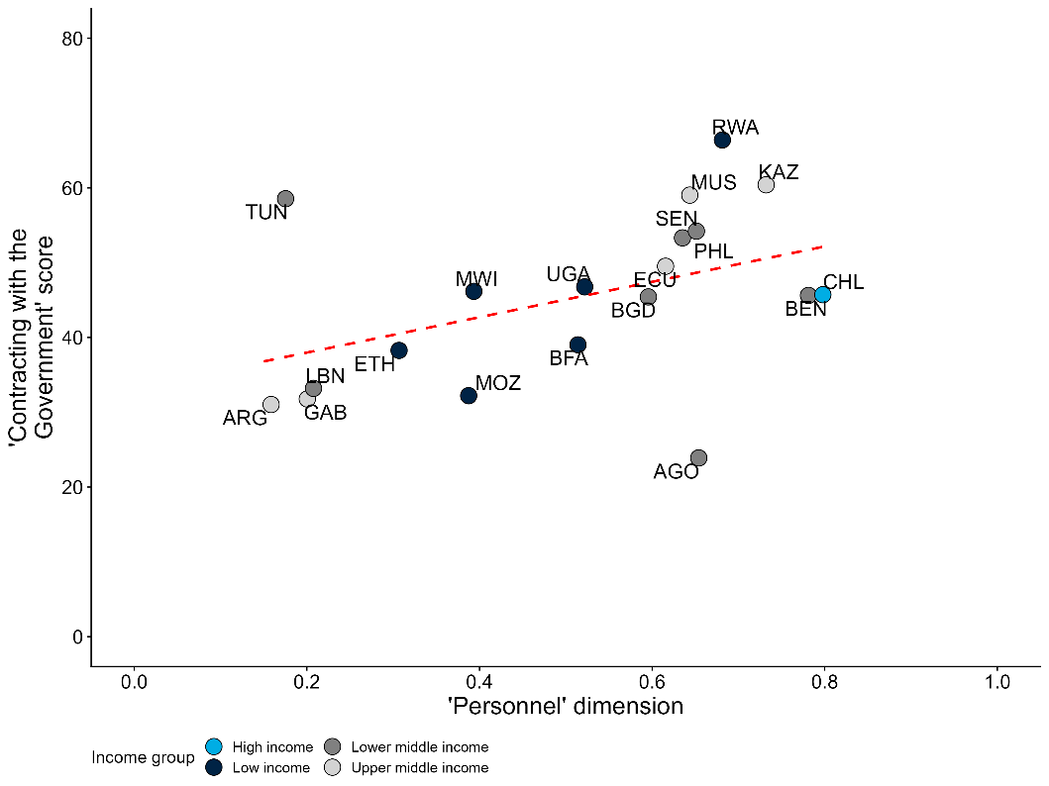
Source: MAPS and Nogues Comas and Mendes dos Santos (2021).
Note: The x-axis is a country-level measure of the quality of procurement personnel derived from the MAPS assessments. The MAPS assessments capture twenty indicators relative to the personnel dimension, reflecting many of the elements cited above as important for competent procurement officials. The criteria are rated as present, partially present, or not present, which are then coded as 2, 1, and 0, respectively. Please see annex 1 for more details on the MAPS criteria used in figures 2.2 and 2.5. The y-axis is a country-level measure of the ease of contract with the government from Nogues Comas and Mendes dos Santos (2021). The indicator combines three dimensions: the steps required to complete the procurement process, the time associated with each step, and the sophistication of e-procurement platforms. The correlation remains significant at the 90% confidence level after controlling for GDP per capita..

Financial resources
Given the economic size of procurement, procurement institutions distribute significant financial resources. The processes through which such sums are managed, however, has an important effect on procurement outcomes and the ability of procurement institutions to realize their mandates. There is a large and important literature in economics on how different types of procurement auctions affect firm bidding strategies and ultimate contract values (Lewis and Bajari 2011; 2014; Decarolis 2018). However, these auction types are generally set by law rather than individual procurement units. The financial resources dimension of procurement units instead refers to two aspects. First, the dimension covers the expenditures available for managing the procurement process, such as procurement staff and their resources. Importantly, this refers to the budget available to procurement units and not the expenditures spent on procurement contracts themselves. Second, the dimension also covers the practices and processes that manage the expenditures spent on procurement contracts themselves. This aspect covers topics such as contract design, renegotiations, and payments.
With respect to expenditures, different procurement units have very different budgets even within a single government. For example, figure 2.3 uses the World Bank’s BOOST public expenditure database to illustrate the heterogeneity in procurement units within a single country: Burkina Faso. For different government entities, the figure plots the ratio between the resources spent on the volume of procurement (as measured by total investment spending) and the resources spent on the office within the entity that manages procurement. (Again, the resources spent on the office that manages procurement includes the procurement staff and their recurrent costs, but not the expenditures spent on procurement contracts themselves.) The plot shows significant institution-level differences. In other words, the scale of resources devoted to managing procurement processes is often not commensurate with the scale of the procurement task. In the agriculture ministry, for instance, the size of investment spending is far larger than the size of the procurement office. This ratio, however, is much smaller for other entities such as the infrastructure ministry. Consistent with this report’s focus on institution-level analysis rather than more aggregate country-level indicators or assessments, the figure emphasizes the importance of understanding differences across procurement institutions within one country.
Figure 2.3 Financial resources available to procurement units within Burkina Faso varies significantly
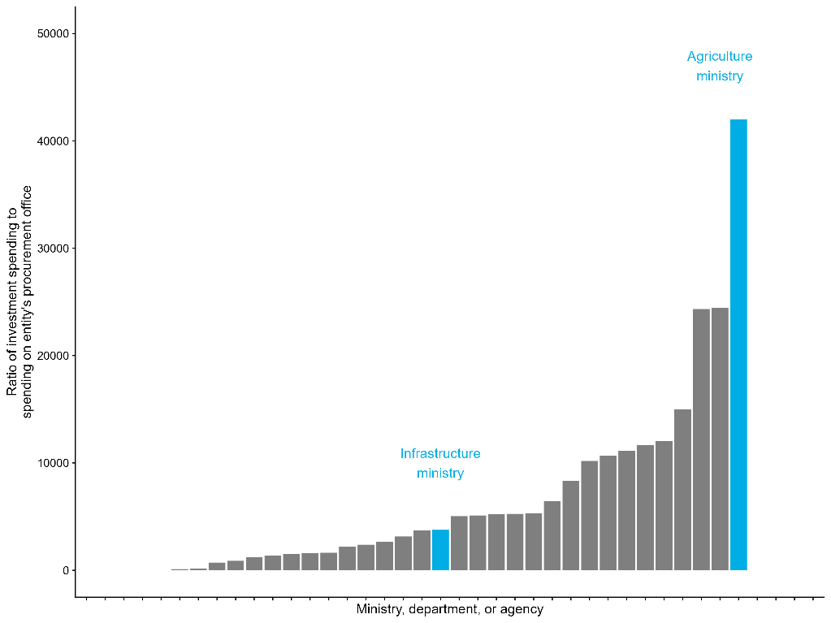
Source: BOOST data.
Note: Each dot represents a different procurement unit within the government of Burkina Faso.
Four challenges characterize the second aspect of procurement institutions’ “financial resources” dimension: cost overruns, contract renegotiations, payment delays, and capacity bottlenecks due to fiscal cycles. First, cost overruns are a persistent problem in public procurement, especially for large-scale public works projects (Decarolis and others 2020). Overruns may occur for a variety of reasons, on the side of buyers as well as the side of suppliers. With respect to suppliers, firms might provide intentionally low prices to win the contract, or they may mismanage a contract during implementation. More importantly for discussions of institutional capacity, cost overruns can occur when procurement officials underestimate the contract budget. This can often be due to the officials’ lack of substantive domain expertise in the good or service being purchased, as discussed above. For instance, particularly in construction projects, design flaws or unforeseen site conditions – such as removing unanticipated rock formations – may require greater costs that foreseen in initial contracts.
Cost overruns typically lead to contract renegotiations, which can greatly increase the cost of the overall contract. Renegotiations impose significant adaptation costs on suppliers, who – anticipating these costs – can respond strategically to markup the price of their initial bids (Bajari, Houghton, and Tadelis 2014). Following these dynamics, the financial processes that create cost overruns and renegotiations also fuel unnecessarily expensive contracts. For well-connected firms that are confident they can renegotiate, the dynamic might occur in reverse. Energy firms connected to the Indian government, for instance, have been found to submit power bids below cost because they know they can renegotiate their contract later when global coal prices increase (Ryan 2020). In this case, the future possibility of renegotiations decreases initial contract costs, but greatly increases overall costs.
Payment delays are also common in public procurement. These delays are not necessarily the fault of public procurement institutions themselves, but they often occur because procurement institutions are insufficiently connected to and integrated with the broader public financial management system. Across the 50 countries covered in the 2024 Business Ready report it took on average 55 days for firms to receive payment for a government contract after submitting the relevant invoice to the contracting authority. Payment in 10 percent of the countries took over 100 days. In southern European countries, other research has found that public entities took an average of five to six months to pay for goods and services they purchased between 2000 to 2010 (Conti and others 2021). Similarly, across local governments in Brazil, public finance laws dictate that public buyers pay their suppliers within 30 days after the verification of procured goods. However, many payments are outside the 30-day window – and the 90th percentile payment length is about 42 days (Dahis, Rica, and Scot 2024). Delays are usually more common in construction projects than smaller contracts for off-the-shelf goods, but where these delays occur, they can decrease firm cash reserves and corporate investment (Abad and others 2023). Payment delays may also lead firms to exit the market, especially those that are smaller and less experienced (Conti and others 2021).This notably runs counter to the common policy goal of increasing SME participation in procurement contracts. In fact, favoring SMEs in contract assignment may be counterproductive if these firms, who tend to be more liquidity constrained, face significant payment delays. This is an example of a potentially beneficial policy that can have adverse outcomes due to inadequate capacity within public institutions.
Government fiscal cycles can also create capacity bottlenecks for procurement units, especially when public budgets have “use-it-or-lose-it” policies. When a public buyer ends the fiscal year with a surplus, such policies require the buyer to lose that surplus, either by not carrying it forward to the next fiscal year or by reducing the buyer’s subsequent budget. Because of this dynamic, contract award values in European countries spike in the final quarter and month of each fiscal year (Lofaro and others 2023). Similarly, the US federal government spends 4.9 times more in the last week of the fiscal year than the rest-of-the-year weekly average (Liebman and Mahoney 2017). Because this spending is rushed before the fiscal deadline, there is a risk that contracts are awarded to lower-quality suppliers and that ultimate implementation will suffer.

Information systems
Public procurement is a complex policy domain with a litany of distinct processes and procedures (Nogues Comas and Mendes dos Santos 2021). Until recently, each step in the procurement process – from distribution of public tenders to the announcement of contract awards – required the communication of information between buyers and suppliers through the exchange of paper documents. Over the last two to three decades, however, the diffusion of information systems specific to public procurement – i.e., e-procurement systems – has streamlined procedures. Figure 2.4 below demonstrates the growth of these systems over this period. In 2024, more than 160 countries have e-procurement systems and more than 100 of these systems include online tendering capabilities. While these information systems are potential solutions to help procurement institutions implement their mandates more efficiently, reduce costs, and decrease corruption, they are also not necessarily a straightforward or automatic remedy for weak institutional capacity.
The most obvious potential promise of e-procurement systems is their ability to reduce transaction costs at each step of the procurement process. E-procurement systems enable tender documents to be published online, where they are more accessible for potential bidders. This is especially important in many low- or middle-income countries where public buyers in rural or remote areas may not be near relevant bidders. For instance, the implementation of e-procurement platforms in Indonesia and India enabled firms outside the buyer’s home region to win contracts (Lewis-Faupel and others 2016). On average, these firms were of a higher quality than firms from the buyer’s home region, which in turn led to improvements in procurement outcomes. Similarly, the introduction of an e-procurement system in Bangladesh increased the number of average bids per contract and increased savings (Blum and others 2023).
Figure 2.4 Many countries have e-GP systems, but system capabilities vary widely
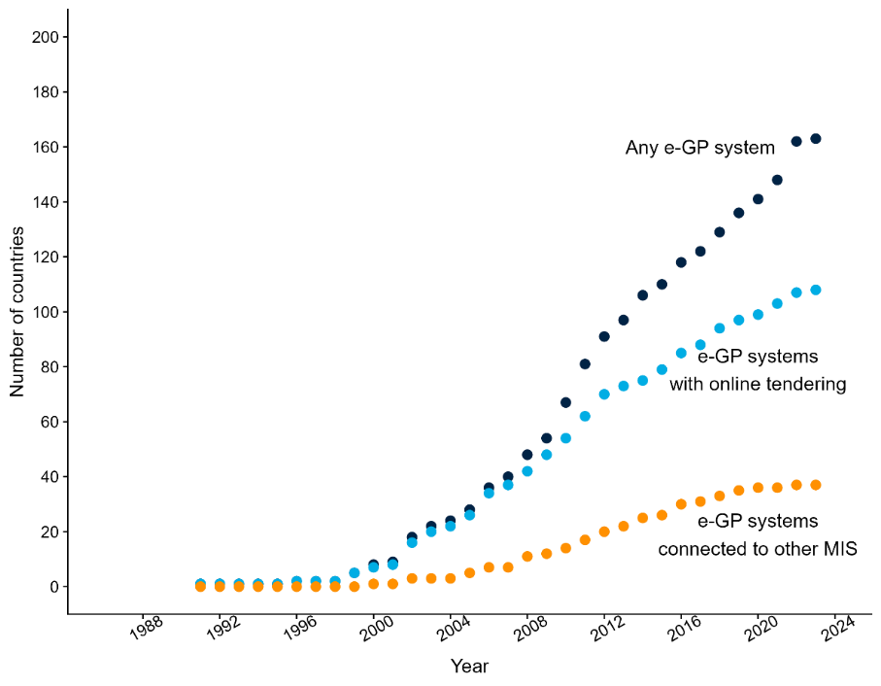
Source: GovTech Maturity Index.
Note: Any e-GP system refers to the countries that have any type e-government procurement system. The countries with e-GP systems with online tendering are a subset of the first group where tendering can be done online. The countries with e-GP systems connected to other MIS are a subset of the first group where the procurement system is connected to others management information systems (MIS) with the government.
The electronic management of tender documents and firm bids also enables procurement officials to study these documents and award contracts more efficiently than on paper. While analog systems require officials to manually enter information, many e-procurement systems automatically fill in forms based on information that suppliers submit with their bid. This mechanism decreases processing times and minimizes data entry errors. In Bangladesh, the total time for processing a government tender – i.e., from the publication of the tender advertisement to the contract award – decreased by about 16 days on average following the adoption of an e-procurement system (Blum and others 2023).
In addition to reducing transaction costs, e-procurement systems can decrease corruption that occurs through the procurement process. E-procurement systems increase transparency because they make it easier for firms and civil society organizations to access information about public tenders and contract awards. Increased transparency should enable firms and citizens to monitor and oversee the procurement process more easily. However, it is difficult to empirically isolate the effects of these systems on procurement-related corruption. E-procurement systems may save public buyers financial resources. However, it is difficult to directly trace these savings to a decrease in corrupt practices as opposed to less malign efficiency improvements that occur because firms can more easily access tenders or because paperwork is processed more quickly (Blum and others 2023; Lewis-Faupel and others 2016).
Despite their many promises, e-procurement systems are not a “silver bullet” for improving procurement institutions’ capacity. For instance, not all e-procurement systems are the same and the design of some systems is much better than others. Figure 2.4 above shows that, while about 160 countries in the world had some type of system by 2024, only about 40 of those systems were directly connected to other information management systems outside procurement. Moreover, information systems will not fulfill their promise if bureaucrats have neither the ability nor the incentive to fully use them. In fact, there are concrete reasons why public officials would resist using such platforms. If officials lack the technical skills necessary to understand and use new technologies, for instance, they may avoid information systems and continue with status quo processes (Adam and Fazekas 2021). More maliciously, corrupt public officials or those who serve corrupt political principals may have strong incentives to sidestep information systems that make their work more transparent. As a result, though many countries nominally have e-procurement systems, there is often significant heterogeneity in how public buyers use them and for what purpose (Schuster and others 2023).
While transparency can often help decrease procurement-related corruption or collusion, not all types of transparency are equally effective. In particular, policymakers should carefully consider which pieces of procurement information are made transparent as well as when during the procurement process. The timing of transparency is especially important in procurement: ex ante transparency refers to the availability of information before a contract is awarded, while ex post transparency is concerned with the availability of information after the award (Bauhr and others 2019). The former is likely more effective at curbing corruption or collusion, since it enables fair competition and empowers firms to monitor tender requirements or bid selection (Bauhr and others 2019). By contrast, the audience of ex post transparency – i.e., citizens, civil society – is much more diffuse, and thus has less of a direct stake in monitoring than bidding firms.

Management practices
The quality of management in the public sector is an important determinant of government productivity and effectiveness (Rasul and Rogger 2018; Rasul, Rogger, and Williams 2021). Procurement institutions are no different. Management practices that contribute to excessive workloads, for instance, have been found to harm procurement outcomes (Giuffrida and Raiteri 2023). Similarly, in the United States, procurement outcomes are most strongly correlated with the degree of employee cooperation – a finding that is potentially due to public procurement’s complexity (Decarolis and others 2020). As noted, procurement requires many different steps and activities spread across different individuals with different skills, so it is understandable that appropriately coordinating these processes requires effective management.
Notably, however, experts debate the extent to which effective management in public procurement requires strict rules or whether procurement officials should have more autonomy and discretion. Autonomy and discretion refer to practices that empower public officials with broad decision-making latitude when managing and awarding contracts. These may include the usage of non-price factors in competitive procurement processes or – in more extreme cases – the ability to award contracts to firms without a competitive auction. Though important for achieving value-for-money, non-price evaluation criteria introduce subjectivity and require more skilled evaluators. From the bidder perspective, greater discretion and more non-price criteria can also create confusion with respect to how bids will be evaluated. In procurement institutions, the extent of discretion is often a function of the legal rules that set thresholds below which officials have more flexibility in contract awards. Beyond these precise legal rules, discretion can also be limited through oversight mechanisms in which other officials have opportunities to monitor or review evaluator decisions.
Limiting discretion through rules and oversight is often thought to increase competition for public contracts, thereby decreasing prices and improving procurement outcomes. Along these lines, there is substantial evidence that procurement methods involving higher levels of discretion – such as restricted competition or direct awards – often leads to favoritism, corruption, and worse outcomes. In particular, these relatively flexible, high-discretion procurement methods can incentivize public buyers to manipulate their contract values to be just below the mandated thresholds, thereby avoiding competitive auctions (Baltrunaite and others 2021; Szucs 2024). Contracts awarded through such high-discretion methods are in turn more likely to go to politically connected firms and show signs of worse contract performance (Baltrunaite and others 2021; Caires, Peralta, and Mendes 2023; Szucs 2024).
On the other hand, overly rigid rules and oversight that limit discretion and autonomy may actually constrain the public officials, who are best placed to increase efficiency (Kelman 1990). Procurement practitioners, for instance, often view strict price-only rules as limiting flexibility for decisions that may ultimately improve value-for-money. In particular, discretion may have positive effects if it enables buyers to direct contracts towards trusted suppliers with which they have long-term relationships. This is especially important when buyers have incomplete information about the quality of bids or the capacity of potential suppliers to successfully execute a contract. As such, increasing discretion can increase the probability that the same firms repeatedly win contracts, even if this does not negatively affect procurement outcomes (Coviello, Guglielmo, and Spagnolo 2018). Experimental evidence from Pakistan, for instance, demonstrates that granting procurement officers more autonomy from monitors actually reduces prices without reducing quality (Bandiera and others 2021).

Governance dimensions

Accountability
As described in chapter 1, this report is concerned with accountability mechanisms either within government or between government and society. This contrasts with broader definitions of accountability (e.g., elections holding politicians accountable to citizens). Accountability relationships that connect procurement institutions to oversight actors can broadly be divided into oversight prior to the contract award and oversight after the contract award. Most procurement systems also have complaints processes, whereby firms can submit complaints that challenge the validity or legality of a procurement process. These are a particular type of post-contract award oversight. Finally, the broader transparency of a country’s procurement process enables civil society organizations to also hold procurement institutions accountable.
Pre-contract award oversight primarily focuses on whether the procurement process is respected. For instance, in Burkina Faso, agents from the Directorate for the Regulation of Public Procurement and Financial Engagement (DG-CMEF in French) are posted within each contracting authority and monitor whether the legal framework is respected (World Bank 2022c). Though important, the mere presence of internal auditors does not guarantee effective oversight since the auditors themselves may be corrupt or simply inefficient. For example, the individual profile of internal monitors in Pakistan has a significant effect on procurement outcomes – especially on delays (Bandiera and others 2021). Intentionally withholding approval is one key mechanism whereby these auditors can manipulate the process.
Post-contract award oversight examines whether the winning bidder was selected fairly and for reasons that respect the tender specifications. This oversight may be conducted by procurement-specific regulatory entities – such as the Public Procurement and Disposal of Public Assets Authority (PPDA) in Uganda – or more general audit offices that are responsible for auditing a variety of government functions. Generally speaking, the publication of audits can provide incentives that decrease corruption risk (Avis, Ferraz, and Finan 2018). However, the threat of ex post oversight may also skew the incentives of procurement actors. Audits in Chile, for example, decreased the use of procurement auctions that were more auditable because they had more regulated and transparent steps (Gerardino, Litschig, and Pomeranz 2022).
Procurement regulatory entities are a type of post-award oversight in which bidding firms may file an appeal or complaint about a procurement contract they believe was awarded unfairly. Firms in Burkina Faso, for instance, may appeal a contract award to the Authority for the Regulation of Public Procurement (ARCOP in French) – an independent regulatory body where representatives from the government, the private sector, and civil society adjudicate appeals (box 2.1). Likewise, Hungary’s procurement regulatory body averaged almost 2,000 complaints per year between 2019 and 2021, collectively covering about 5 percent of the country’s procurement contracts during that period (OECD 2023a). Despite their importance, however, there are few – if any – rigorous academic articles that study the effectiveness of procurement regulatory entities.
Box 2.1 Accountability in public procurement: Example of Burkina Faso
Most countries have a procurement regulatory agency, which plays an important accountability role in public procurement. These entities provide an important post-award oversight function for the procurement system by adjudicating complaints from bidding firms about the procurement process or contract awards. Given the importance and sensitivity of public procurement, these agencies typically enjoy some form of independence – at least nominally – from politicians and other parts of public administration. As public institutions that provide an accountability relationship within government, they are an important example of the accountability principle from the conceptual framework. Moreover, these regulatory bodies are themselves public institutions to which the report’s framework can be applied.
In Burkina Faso, the most relevant procurement regulatory entity – the Authority for the Regulation of Public Procurement (ARCOP in French) – has received positive reviews in recent international assessments. For instance, Burkina Faso’s 2017 PEFA rates the country’s procurement complaint management (PEFA indicator 24.4) as an “A.” Comparing across each country’s most recent PEFA scores, only 25% of other countries from sub-Saharan Africa have received an “A” for that same indicator. While Burkina Faso’s procurement regulatory entity falls short of international best practice (see below), it is still a useful example of oversight in a context of limited institutional capacity.
As an independent administrative authority, ARCOP has formal financial autonomy from the rest of the government. ARCOP is responsible for training procurement officials, conducting audits or evaluations of Burkina Faso’s procurement system, and – perhaps most importantly – adjudicating procurement-related disputes (World Bank 2022c). When a bidding firm wants to dispute a particular tender or contract award, the firm files an administrative complaint with the System for Dispute Settlement (ORD in French), a committee within ARCOP that reviews procurement complaints and rules on their validity.
As part of ARCOP, the ORD has considerable institutional independence from the rest of the government. The committee consists of twenty-four representatives of different stakeholders in the procurement process. Eight members are civil servants representing the public sector and appointed by either the prime minister, the finance minister, the infrastructure minister, or the health minister. Eight other members represent the private sector and are appointed by professional associations or the Burkinabe Chamber of Commerce. The final eight individuals represent civil society organizations working on governance and corruption. Every complaint before the ORD is reviewed by a smaller sub-committee of three representatives, one from each of these three groups.
The presence of representatives from the private sector and civil society in the ORD – rather than just representatives of the government – helps to strengthen ARCOP’s accountability function. Between 2014 and 2021, ARCOP received complaints from more than 1,500 different firms. They were filed against contracting authorities ranging from ministries to small local governments. The ORD judged many of these complaints to be valid and ordered the contracting authority to revisit the award. The system is not perfect, however. For instance, it is relatively cumbersome and difficult for a bidder to file a dispute. As a result, many smaller or less experienced firms are either not aware of or do not take advantage of the dispute mechanism. That said, the system enables bidders who believe they have been treated unfairly to have some means of recourse.
While ARCOP exercises an accountability role vis-à-vis procuring entities, ARCOP is itself a public institution to which this report’s analytical framework can be applied. ARCOP’s own capacity is limited due to important shortcomings along the organizational and governance dimensions, which limits its ability to fully deliver on its mandate. For instance, relative to its responsibilities or mandates described above, the 2022 MAPS assessment of Burkina Faso’s public procurement system noted that ARCOP does not provide sufficient training for procurement officials, nor does it conduct sufficient audits of the procurement system (World Bank 2022c). Procurement audits, for instance, are not exhaustive; they happen rarely and only on a small sample of contracts and contracting authorities. Every entity and every contract does not need to be audited, but the MAPS assessment makes clear that the current status quo is not sufficient to address potential accountability concerns.
ARCOP’s own institutional capacity suffers in part due to issues related to its own financial resources. The entity’s most significant and consistent funding source is supposed to be a user fee that bidding firms pay when they file a dispute with the ORD. In theory, this should give ARCOP an important degree of independence from politicians who decide budget allocations within the government. However, the 2022 MAPS report notes that these fees are insufficient for covering ARCOP’s costs and are a primary reason why ARCOP’s ability to audit the system is constrained (World Bank 2022c). These dynamics highlight the important interactions that can occur between the capacity of multiple institutions within the same government. More specifically, improving the accountability of procurement institutions in Burkina Faso – and therefore their institutional capacity – may require careful attention to the institutional capacity of other related institutions, such as ARCOP.

Independence
As noted, procurement institutions ideally award contracts based on their two key mandates: balancing quality and price while also pursuing strategic policy objectives. To realize these mandates in practice, procurement institutions require sufficient independence from two types of pressures. The first pressure is from the private sector firms who hope to win public contracts. Given the significant financial stakes involved, these suppliers have a strong incentive to offer bribes to officials in exchange for favoritism in the procurement process (Decarolis and others 2020: Campos and others 2021). Without sufficient independence from private sector interests, the promise of kickbacks can also incentivize procurement officials to award contracts based on the size of bribes rather than quality, price, or policy objectives.
In addition to pressure from potential suppliers, procurement officials often face pressure from their own political principals. Politicians can interfere in contract awards to favor firms for personal enrichment, political finance, or both (Boas, Hidalgo, and Richardson 2014; Brierley 2020; Titl, Witte, and Geys 2021). For example, procurement methods with significant discretion have been found to be more likely to result in contracts awarded to suppliers that are connected to the ruling party (Szucs 2024). Politicians can also exert pressure by selecting who serves as a procurement official (Sigman 2023). Even if selection into procurement institutions is meritocratic, politicians may still exert pressure by threatening to rotate officials to undesirable or isolated workplaces (Brierley 2020).
Whether pressures come from firms or politicians, they have many negative implications for procurement outcomes. Contracts awarded to politically connected firms often result in higher prices and the selection of less-productive suppliers (Mironov and Zhuravskaya 2016; Szucs 2024). Political interference in the procurement process can also lead to more contracts with cost overruns (Bellodi, Morelli, and Vannoni 2024) or renegotiations. Across several different contexts, distribution of contracts based on political favoritism rather than price, quality, and strategic objectives has been found to result in poorer procurement outcomes (Brogaard and others 2021). In Bulgaria, for instance, reducing non-competitive procurement practices suggestive of corruption could help save about 0.7 billion euros (World Bank 2023c)
Beyond procurement outcomes, insufficient independence also harms the ability of procurement institutions to fuel private sector development more broadly. In particular, insufficient independence and subsequent corruption acts as an impediment to private sector growth by discouraging market entry and propping up otherwise unproductive firms. After a municipality receives an anti-corruption audit in Brazil, for instance, the municipality experiences an increase in the number of firms receiving public procurement contracts (Colonnelli and Prem 2022). Meanwhile, politically connected firms in these municipalities perform worse after the audits. Similarly, many firms can be discouraged from bidding for public contracts if they doubt the integrity of the public buyers (Colonnelli and others 2024). The implication is that – especially for public buyers who are not seen as independent – only well-connected firms willing to pay bribes will actually bother to submit bids.

Transparency
The concept of transparency in procurement institutions is connected to several of the organizational and governance components discussed above. In principle, tender advertisements and procurement data can be published and made transparent through many different avenues, such as official government gazettes or newspapers. In practice, though, procurement information may still be difficult to access if it is only available in physical publications. Instead, transparency in public procurement is most effective when procurement information is made publicly accessible through e-procurement information systems, as described above. While such systems require firms to have internet access, the publication of tender information on digital platforms diversifies the types of firms that bid on public contracts (Blum and others 2023; Lewis-Faupel and others 2016).
Transparency in procurement institutions helps enable the other two governance dimensions: accountability and independence. Accountability actors can more effectively hold procurement institutions in check when they have detailed information about the institutions’ behavior. That said, which actors benefit depends on the data in question. As noted, ex ante transparency – i.e., transparency in the tender criteria prior to the contract award – is most effective, because it allows for horizontal monitoring by bidders, who have a strong incentive to monitor contract information and ensure that the contract is awarded fairly (Bauhr and others 2019). In contrast, ex post transparency – i.e., transparency in the contract award – may be most helpful to citizens and civil society (e.g., non-profit organizations, journalists) as well as national procurement regulators (Duguay, Rauter, and Samuels 2023).
Regardless of the accountability actor in question, increasing the transparency of procurement institutions and tender information has many positive effects on procurement outcomes. Publicizing tender information leads to more competition (Coviello and Mariniello 2014) and attracts different kinds of bidders, particularly those who are not based near the public buyer (Lewis-Faupel and others 2016; Kenny and Crisman 2016). There is debate, however, on how these effects ultimately impact contract execution. Publicizing tender information can reduce the cost of procurement without affecting renegotiations or delays (Coviello and Mariniello 2014). Conversely, transparency may actually restrict the discretion of procurement officials and prevent them from using private information to direct contracts towards suppliers they know will perform well (Duguay, Rauter, and Samuels 2023). The ultimate effect of transparency may therefore depend on the capacity and incentives of procurement officers to identify high-performing firms.
There is considerable cross-country variation in the transparency of procurement institutions. The MAPS assessments capture fourteen indicators relative to this dimension, including legal rules around the publication of tender opportunities, the publication of information in a structured and machine-readable format, and the availability of procurement statistics. Figure 2.5 plots the share of possible points that countries could have received for their transparency-related elements. (Please see footnote 32 and annex 1 for more details on how this measure is constructed.) Like with the measure of personnel in procurement institutions from figure 2.2, Chile’s procurement institutions score as best-performing for transparency. Lebanon, Gabon, and Tunisia are the worst performers and score well below average. Interestingly, according to GTMI data, every country in figure 2.5 except for Malawi has an e-GP system. However, the wide variation in the MAPS indicator suggests that the mere presence of a system does not ensure transparency. The implementation and usage of that system – aspects which are captured in the MAPS indicator – appear to be more important.
Figure 2.5 While many countries’ procurement institutions have e-GP systems, there is wide variation in transparency
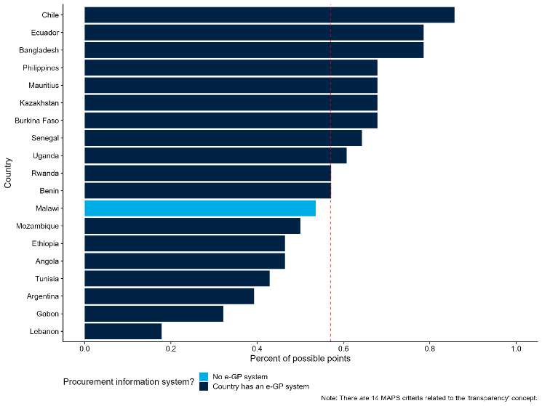
Source: MAPS and GTMI.
Note: The x-axis is a country-level measure of transparency in procurement personnel derived from the MAPS assessments. Please see annex 1 for more details and a list of the MAPS indicators used to calculate the measure.

Procurement institutional challenges span multiple dimensions
Most procurement institutional problems involve multiple dimensions of the framework. For example, the third problem in Table 2.1 concerns both personnel and information systems. Because many issues span several dimensions, the framework helps identify relevant interventions or reforms for procurement institutions. Clearly defining the agency’s mandate is crucial, as this guides assessment of which issues and dimensions affect that mandate.
Many of the problems mentioned in the table below can hinder procurement-related outcomes such as efficiency of government spending, quality of public works, and speed of government contracting. All these outcomes relate to private sector development. Quality public works, for instance, help ensure that transportation costs are low and supply chains are resilient. Many common outcomes are affected by more than one dimension as illustrated by literature. For instance, the efficiency of government spending is related to the competence of procurement personnel, those personnel’ s independence from political pressures, and the transparency of procurement processes. Organizing outcomes of interest in this way helps to diagnose where interventions could help improve procurement-specific outcomes as well as private sector development more broadly as detailed in the sections below.
Table 2.1 Procurement outcomes are linked to the organization and governance dimensions
Procurement problem | Organizational and governance dimensions | Procurement outcome
Procurement officials do not have sufficient knowledge of procurement methods or markets to minimize costs while maximizing quality. | - Personnel: 20% of the variation in quality-adjusted prices paid is attributable to the individual officers who manage the procurement process (Best, Hjort, and Szakonyi 2023).  - Personnel: More competent procurement units are associated with fewer cost overruns (Decarolis and others 2020). | Efficiency of government spending
Procurement officials may also lack sufficient market knowledge to write tender or contract documents relevant to the market in question. This may attract an insufficient number of high-quality firms. | - Information systems: Implementation of e-procurement platforms in Indonesia and India enabled more high-quality firms to win contracts, thus improving the quality of the ultimate infrastructure that was built (Lewis-Faupel and others 2016). | Quality of public goods
Procurement activities are arduous and complex because they rely on paper-based, manual processes that require approval from many different stakeholders. The number and manual nature of these steps creates delays. | - Information systems: Total time for processing a government tender decreased by about 16 days on average after the adoption of an e-procurement system in Bangladesh (Blum and others 2023).  - Accountability: More competent procurement units are associated with fewer time delays and renegotiations (Decarolis and others 2020).  - Personnel: Identity of individual procurement monitors in Pakistan greatly influences procurement delays (Bandiera and others 2021). | Speed of government contracting
Politicians or other decision-makers impose unnecessary or unrealistic time-constraints that rush steps in the procurement process and hinder effective implementation. | - Management practices: Decreasing officer workloads (i.e., adding one additional officer to a team) leads to a 28% increase in probability that contracts will generate a patent (Giuffrida and Raiteri 2023). | Innovation (i.e., patent filings)
Firms, politicians, or other public officials pressure procurement officials to award contracts to specific, favored firms. These firms may not be the most qualified, thereby increasing costs or decreasing quality. | - Independence: Contracts awarded to politically connected firms result in higher prices and the selection of less-productive suppliers (Mironov and Zhuravskaya 2016; Szucs 2024)  - Transparency: Publicizing tender information reduces procurement costs by increasing the number of bidders (Coviello and Mariniello 2014).  - Independence: Procurement methods that allow for greater officer discretion are more likely to be awarded to suppliers connected to ruling politicians (Szucs 2024).  - Independence: Firms that donate to political campaigns are more likely to afterwards receive a significant increase in the size of contracts they win (Boas, Hidalgo, and Richardson 2014). | Reduced Corruption

Applying the framework: Corruption and “passive waste” in public procurement
The inefficient use of public resources, through corruption or other types of waste, is a common problem in public procurement. It is difficult (almost by definition) to quantify how much financial resources are lost through corruption in procurement, but corruption risks are large and present throughout the procurement process (OECD 2016). In addition to outright corruption, procurement may create “passive waste” (Bandiera, Prat, and Valletti 2009). This type of waste refers to administrative inefficiencies that do not accrue any direct benefits to officials but that, if removed, would make all procurement officials better off. Excessive red tape or poor coordination are examples. This report’s analytical framework offers a useful tool for understanding corruption, passive waste, and similar multifaceted challenges faced by procurement institutions. Importantly, the framework emphasizes that any potential solutions should approach the problem from multiple angles and will inevitably involve trade-offs.
While procurement-related corruption is often treated as a personnel challenge, the report’s framework highlights why the problem is more complicated. A commonly proposed solution for minimizing corruption in procurement institutions is to change who is appointed to be a procurement official. The assumption is that more professional personnel with higher ethical standards will be less likely to misappropriate financial resources (World Bank 2023b). Another commonly proposed solution is to professionalize the procurement cadre through training programs. In addition to helping address corruption, more qualified officials may also help decrease passive waste, as they may be better equipped to scrutinize complex bids and minimize costs (Best, Hjort, and Szakonyi 2023). While these approaches can certainly help address corruption and passive waste, considering the framework’s other dimensions and components reveals that the personnel dimension is only one piece of the puzzle.
For instance, addressing procurement-related corruption will almost always require considering procurement officials’ independence from political pressures. As noted above, procurement institutions face multiple pressures that exacerbate corruption risks. Extracting financial resources through the procurement process, for example, is an important channel through which politicians can raise funding for political campaigns – and they can pressure even highly skilled officials to award contracts to firms they know will provide kickbacks or campaign contributions (Sigman 2023). Even professional bureaucrats hired through a meritocratic system can succumb to the preferences of their political principals, particularly if those politicians can transfer the bureaucrats to undesirable posts in rural, isolated areas (Brierley 2020). Addressing corruption therefore requires that policymakers and practitioners consider not only the personnel aspects of career, skills, and compensation, but also the extent to which politicians have control over these features of the procurement system.
Likewise, strengthening management practices within procurement institutions is another important tool for addressing corruption and waste. Policymakers who fear the misuse of public resources may choose to place strict controls on procurement officials, limiting their discretion through formal rules and subjecting them to close oversight. These reforms could make sense, given the evidence that discretion in procurement can lead to corruption (Baltrunaite and others 2021; Szucs 2024). However, even if such efforts decrease corruption, they may also increase passive waste. Broadly, more oversight and more rules can often overemphasize compliance at the expense of procurement outcomes – as when such rules prevent officials from quickly contracting with firms that they know are capable and will deliver. Some degree of discretion, in other words, may have positive effects on procurement outcomes (Coviello, Guglielmo, and Spagnolo 2018).
The optimal amount of discretion likely depends on the context, the quality of governance, and – in particular – the personnel awarding procurement contracts. Constraints on discretion are most effective in low-capacity settings, while increased discretion is actually optimal in high-capacity countries. Importantly, however, there can be a large degree of institutional heterogeneity even within the same government. In Italy, for instance, increasing procurement discretion increased favoritism primarily for public buyers with less-qualified staff and less-transparent processes (Baltrunaite and others 2021). Related evidence from a randomized control trial in Pakistan indicates that an officer’s autonomy reduces prices and delays when they are overseen by an inefficient monitor (Bandiera and others 2021). This suggests that granting procurement officers more freedom can improve efficiency and lower waste, as long as delays are caused by supervisors rather than the officers themselves. These strong links among the personnel, independence, and management practices elements of the framework underline that tackling corruption and passive waste in public procurement requires a multi-faceted approach that addresses several areas at once. Focusing on just one component alone may only provide a partial remedy—or, worse, could produce negative, unintended outcomes.

Chapter 3. Public Institutions that Regulate the Private Sector
Regulations are laws and formal rules that influence how markets operate. Regulations establish requirements and standards for goods and services, affecting the behavior of firms, consumers, and public institutions. Regulations influence (and often constrain) the behavior of firms and consumers across multiple areas of economic activity. Whether in business registration or bankruptcy laws, regulations have profound consequences for private sector development and economic growth (Klein and Hadjimichael 2003). For example, regulations affect business entry decisions by defining the requirements to open a business. While these business regulations may intend to protect consumers from firm malpractices, they may also inadvertently protect incumbents firms (World Development Report 2024). Thus, designing and enforcing regulations that enable private sector development, while protecting the public interest, is a complex task.
Regulations can enable private sector development, but this requires regulatory institutions capable of designing and enforcing them well. A vibrant private sector is characterized by healthy competition between firms, as well as high quality goods and services for consumers (Jacobs and Ladegaard 2010). Well-designed and enforced regulations can protect and even strengthen these market characteristics by reducing barriers to entry, deterring cartel formation, and making information available for consumers (World Bank 2016a, Licetti and others, 2021). However, the benefits of regulations depend on the capacity of regulatory institutions that design and implement them (Laffont 2005, Estache and Wren-Lewis 2010, Jacobs and Ladegaard 2010). Regulatory institutional capacity manifests itself in various dimensions. For instance, regulators’ expertise enables regulatory institutions to monitor and interpret market developments accurately, designing regulations that adequately address changing technological conditions. Additionally, institutional independence prevents capture by incumbent firms, which may otherwise pressure regulatory institutions to enact regulations that restrict market entry (Müller 2023, Slimane and Abir 2021).
This chapter applies the report’s conceptual framework to regulatory institutions. Drawing on empirical evidence and global data, the chapter demonstrates how it is possible to implement a data-driven assessment of the capacity of regulatory institutions. The chapter begins by identifying regulatory institutions’ policy mandates and then shows how the framework’s organizational and governance dimensions can be applied and measured using data and country examples. The chapter concludes by applying the conceptual framework to the utilities sector, with a case study on telecoms regulatory agencies in Peru.

Conceptual framework for regulatory institutions
Regulatory institutions’ organizational and governance dimensions shape their capacity to achieve key policy mandates. For example, the governance dimension of accountability– in the form of consultations with regulated firms –improves firm compliance with manufacturing regulations (Malesky and Taussig 2019). Likewise, organizational issues such as leadership vacancies in regulatory institutions, as well as limited staffing – key aspects in the personnel and management practices of this report’s conceptual framework – cause delays in the implementation of regulations (Carpenter 2002; Bolton, Potter and Thrower 2016). This report focuses on the organizational and governance dimensions that shape the capacity of regulatory institutions to achieve their policy mandates (figures 3.1.a and b).
Figures 3.1.a and 3.1.b Overview of organizational dimensions and governance dimensions in regulatory institutions
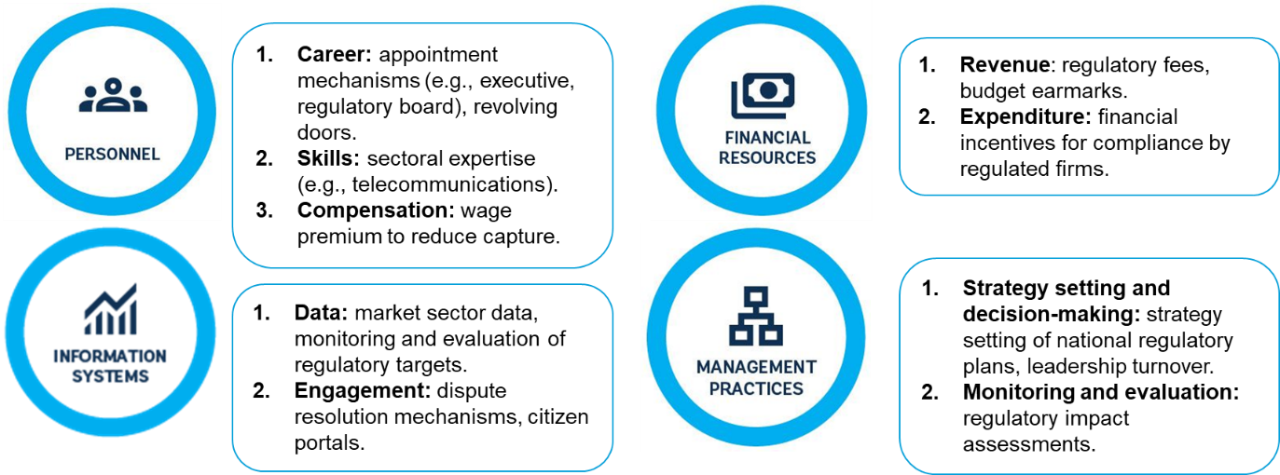
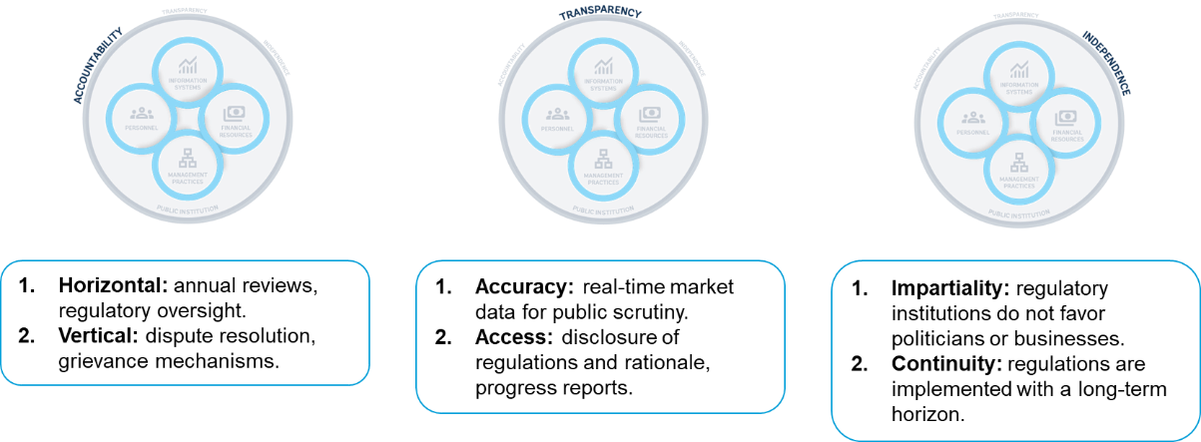
Source: Author’s elaboration. Adapted from Kim, Kumar, Ramalho, and Russell (forthcoming).
The capacity of regulatory institutions varies across countries in the same sector and across sectors in the same country. One way to assess this variation in regulatory institutional capacity is to measure how well regulatory frameworks are translated into public services to firms (World Bank 2024a). Data from B-Ready show that the quality of public services associated to regulations vary substantially across countries in the same sector and sectors within the same country (figure 3.2). For example, New Zealand and Singapore are top performers in the implementation of their regulatory frameworks on average, yet they display substantial variation across sectors in the same country. Across the sample, implementation gaps are generally higher in financial services and business entry than in utilities and market competition.
Figure 3.2. Implementation gap in regulatory frameworks varies across countries and their sectors
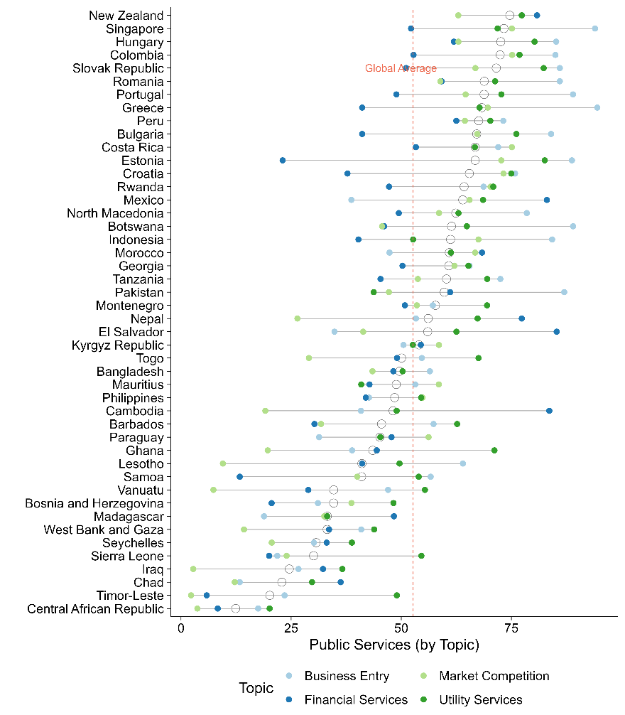
Source: Business Ready. Public services are defined as the set of “government-provided services that support regulatory compliance, including institutions and infrastructure that enable business activity.” Higher scores denote better public services.

Policy mandates
Regulatory institutions have three main policy mandates: promoting competition, improving quality of good and services, and ensuring accessibility. These regulatory mandates at times complement one another. For example, promoting competition is often a means to an end, improving the quality of goods and services due to innovation from new entrants, or accessibility because of lower prices (World Development Report 2024). Because of these synergies, competition is typically a core policy mandate for regulatory agencies known as competition authorities. Policy mandates vary according to the country, sector, and policy priorities that are determined in the policy arena (Jacobs and Ladegaard 2010). Regulatory institutions design and enforce regulations to achieve these mandates, and regulatory institutional capacity is defined as the ability to do so. Sometimes, these mandates lead to trade-offs. For example, setting and enforcing quality standards can lead to higher prices and reduced access. Ultimately, managing these complementarities and trade-offs requires context-specific and fine-tuned adjustments by capable regulatory institutions (Jacobs and Ladegaard 2010).
Regulatory institutions play an important role in promoting competition in markets. Some sectors, such as utilities, are vulnerable to natural monopolies. Regulatory institutions such as competition authorities can address this by implementing regulations that prevent abuse of natural monopoly power and try to emulate the competitive market setting (Joskow 2007). Typically, promoting competition requires the design of regulatory policies that reduce anti-competitive practices, complemented by price-setting (e.g., a price cap regulation, as described in Laffont and Tirole 1993). The World Bank regularly applies the Markets and Competition Policy Assessment Toolkit to identify regulations that limit competition and induce distortions in the market, providing an evidence-based approach for regulatory reforms. In some cases, reducing regulations may promote competition. For example, business sectors with fewer regulatory barriers to competition in the Philippines are more likely to adopt ICT technologies (World Bank 2016b). On the other hand, regulations such as exclusivity rights limit firm entry (World Bank 2018).
Regulatory institutions also play an important role in improving the quality of goods and services. Information asymmetries between firms and consumers can occur when there is uncertainty regarding the underlying quality of goods (Akerloff 1978). In these cases, regulations can improve access to information for consumers and empower them to choose better quality goods and services. For example, regulatory institutions can require food producers to provide accurate and reliable information on nutritional facts (e.g., caloric value, macronutrient contents) that enable consumers to make informed decisions on their dietary intake (Christoph and others 2018). Regulatory institutions can also implement regulations that ensure food safety and quality standards for goods and services (Kotsanopoulos and Arvanitoyannis 2017, World Development Report 2025). In financial sector regulation, banking regulators may set in place rules that protect consumers from malpractice such as fraud or deception (Levitin 2012). However, onerous standards can be prohibitively costly for firms, reducing incentives for firms to enter the market and thus reducing competition. Regulatory institutions therefore should assess trade-offs between mandates when improving the quality of goods and services in the private sector.
Regulatory institutions influence who can access private sector goods and services. Digital technologies such as the internet and mobile phones are often concentrated among consumers with higher income, creating a digital divide (World Bank 2016b). In these contexts, telecoms regulatory institutions can ensure access to populations that would otherwise be excluded from such goods and services. For example, a telecoms regulator can set regulations that require mobile providers to provide coverage to communities in remote areas. Similarly, an energy regulatory institution may require electricity providers to connect underserved communities (e.g., rural areas) even if that is unprofitable to firms (Kelly and Rossotto 2012). These potential trade-offs between accessibility and firm profits need to be carefully assessed, so that firms still choose to join the market despite access-enhancing regulations. At the same time, policy mandates such as promoting competition and ensuring access can complement each other. Prices of goods and services are one determinant of accessibility: generally, lower prices increase access, so regulatory institutions should ensure that competition between firms drives prices down (figure 3.3).
Figure 3.3. Countries with regulations that reduce competition have higher prices in mobile services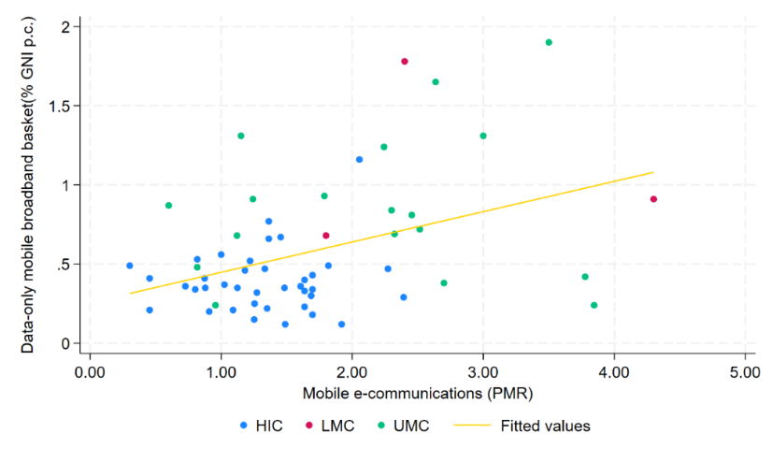
Source: Own elaboration using OECD PMR 2023-2024; WBG-OECD PMR & ITU 2024.
Note: PMR scale 0-6 (6 more restrictive). The indicator evaluates regulatory restrictions on market entry and conduct, as well as the extent and quality of public ownership, across eight network sectors: electricity, natural gas, air, rail, road, and water transport, and fixed and mobile telecommunications. PMR data for Ecuador , Kazakhstan, Kosovo, Malaysia, Moldova, Montenegro, Russian Federation, Serbia, the Philippines, and Viet Nam are based on the WBG–OECD 2018 PMR scores. These were collected between 2018 and 2022 using the previous methodology and should therefore be interpreted with caution. HIC = High-income countries; UMC = Upper-middle-income countries; LMC=Lower-middle-income countries. The data-only mobile broadband basket (2GB, 3G and above) refers to the cheapest non-promotional option providing at least 2 GB of high-speed data over a 30-day period from the operator with the largest market share. The data-only mobile broadband basket is expressed as a share of GNI per capita.
Regulatory institutions can fail to deliver their policy mandates due to a wide range of governance and organizational challenges. These include:
- Politicians appoint regulators who tilt the rules in favor of certain firms and private interests to the detriment of the interest of consumers.
- Regulators lack sufficient knowledge of markets to address market failures without undermining private sector development and competition levels.
- Regulatory institutions do not have sufficient incentives to collaborate with the private sector, which is often crucial for understanding the secondary and potentially unintended impact of regulations on firms.
- Monitoring compliance with regulations can be arduous and complex because of insufficient data and information systems to manage that data.
- Politicians or other decision-makers can cause disruptive changes in leadership of regulatory agencies, making it difficult to approve new regulations to address technological or market changes.

Organizational dimensions

Personnel
Personnel is a key dimension to consider when assessing the capacity of regulatory institutions. Regulators need to understand complex markets, such as those in the financial and electricity sectors. These are often very large and profitable markets where small changes in regulations can have a significant monetary impact for the firms operating in those markets. Therefore, it is crucial that recruitment, promotion and dismissal practices are structured in a way that prevents conflicts of interest between regulators and regulated firms and provides them with sufficient independence to carry out their intended functions. Additionally, regulators should have the qualifications needed to understand the market and that they are adequately paid.
The recruitment and dismissal processes for the heads of regulatory institutions can set the incentives for the whole agency. In general, heads of regulatory agencies tend to be appointed by heads of government, particularly in telecoms regulators (figure 3.4). While this arrangement can improve policy alignment with the priorities of government, it also constrains the regulatory institutions’ ability to pursue their regulatory mandates independently from the short-term interests of a head of government. For example, a head of government might appoint the regulatory agency head based on loyalty rather than on ability to implement the mandate impartially. To ensure a degree of independence between priorities of the executive and the regulatory institution, some countries require that heads of agencies be appointed by a board of the regulatory authority or reviewed by the legislature (e.g., Parliament). The latter arrangement is rare: according to data from the Governance of Sector Regulators published in 2023, the legislature is involved in only 27 percent of appointments to leadership of regulatory institutions for OECD member countries (Van Langen and others, 2025)). Flexibility in dismissal of regulators can be beneficial if their conduct reflects undue influence or partiality in regulatory decisions that favor specific firms. But it brings the risk that regulators are dismissed to reshape regulatory institutions according to the short-term political priorities, as opposed to long-term stability and competitiveness of markets (OECD 2017). Flexibility in dismissal of regulators can be beneficial if their conduct reflects undue influence or partiality in regulatory decisions that favor specific firms. But it brings the risk that regulators are dismissed to reshape regulatory institutions according to the short-term political priorities, as opposed to long-term stability and competitiveness of markets (OECD 2017).
Figure 3.4 Telecoms regulatory institutions’ heads are appointed by the head of state in nearly half of all countries | Figure 3.5. Countries with higher income tend to have more specialized staff personnel in banking regulators, but there is substantial overlap across income groups
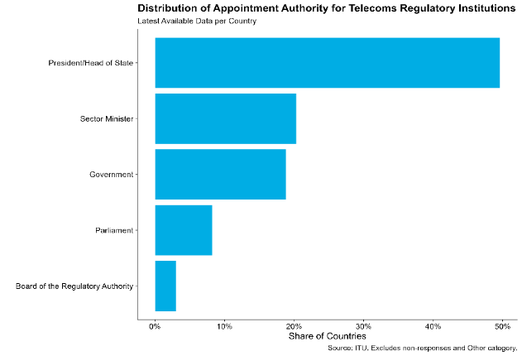 | 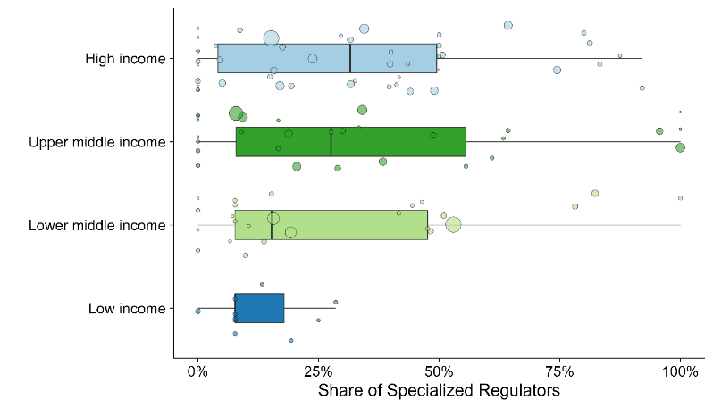
Source: International Telecoms Union.  Note: Most recent data available for country respondents. Self-reported answers from telecoms authorities that are part of the International Telecoms Union, a United Nations agency that specializes in digital technologies. The sample includes 133 countries. | Source: Authors’ elaboration based on data from the Bank Regulation and Supervision Survey (2021) and World Bank.  Note: The share is computed as the total number of professional bank supervisors specialized in bank functions (e.g., treasury) or risks (e.g., credit markets) divided by the total number of supervisors (excluding support functions and management). The size of each circle is proportional to the total workforce in the regulatory institution. Country income groups reflect the latest classification provided by the World Bank.
Regulatory institutions should be staffed by personnel with adequate sectoral expertise. Because sectors are complex and regulations can have unintended consequences, personnel in regulatory institutions need expertise to design and enforce regulations appropriate to their sector (Stern 2000). In financial regulation, for example, regulators should have relevant skills and specialization in specific bank and risk functions. There is substantial cross-national variation in the share of specialized banking regulators, even when accounting for countries’ income levels (figure 3.5). While countries in the high-income group tend to have more specialized staff, the median is below 50 percent and the range is wide. Generally, regulatory institutions in low-income countries have less specialized staff.
Given the skills requirements and the risks of capture, compensation is a key consideration for ensuring the appropriate staffing of regulatory institutions. To attract and retain competent personnel, regulatory institutions typically pay salaries with a positive wage premium with respect to prevalent wages in the public sector. This was the strategy used by regulatory institutions in Brazil, which pay comparatively higher salaries than other public institutions in the federal government (Santos, Brandão and Maia 2015).

Financial Resources
Regulatory institutions’ funding streams comprise budget earmarks, regulatory fees, or a mixture of both (World Bank 2019a). Each one of these financing mechanisms has implications for the incentive structure of regulatory institutions. If regulatory institutions rely on fees, they may overregulate in an attempt to increase their budget. In contrast, budget earmarks provide more stability across fiscal years and enable institutions to separate their funding needs from their policy mandates.
For OECD countries, these financing mechanisms vary across sectoral regulatory agencies and income levels. Telecoms regulatory agencies in countries in the lower income tercile tend to rely exclusively on regulatory fees (60 percent respectively). In contrast, countries in the upper tercile rely on a blend of fees and earmarked budget (53.3 percent) (figure 3.6. panel a). Rail regulatory agencies tend to generally rely on national budgets (64.3 percent in the upper tercile), depending less on fees (figure 3.6. panel b). Air transport regulatory agencies instead rely predominantly on mixed mechanisms, although budget funding remains common in middle-tercile economies (figure 3.6, panel C). Energy regulators consistently rely on regulatory fees across income groups, with fees accounting for 53.3 percent in the lower tercile, 40 percent in the middle tercile, and 40 percent in the upper tercile (figure 3.6, panel D). Overall, telecom and energy regulators tend to draw a large share of resources from regulatory fees, whereas rail regulators rely mostly on national budgets and air transport regulators exhibit more variation.
Figure 3.6. Financing mechanisms vary across income levels and types of sector regulatory agencies
Panel A. Telecoms regulators | Panel B. Rail regulators
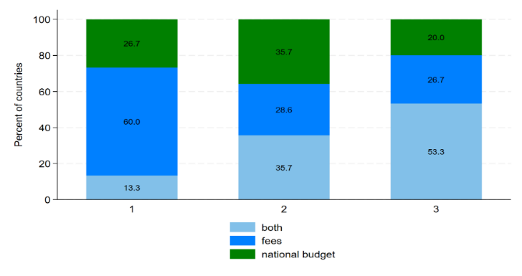 | 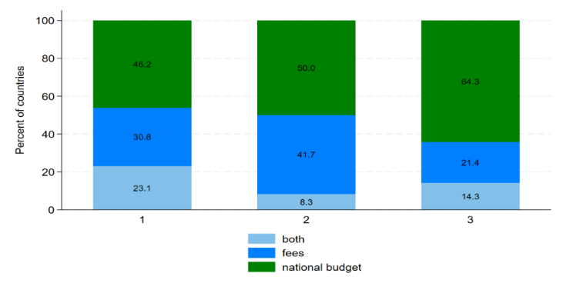
Panel C. Air transportation regulators | Panel D. Energy regulators
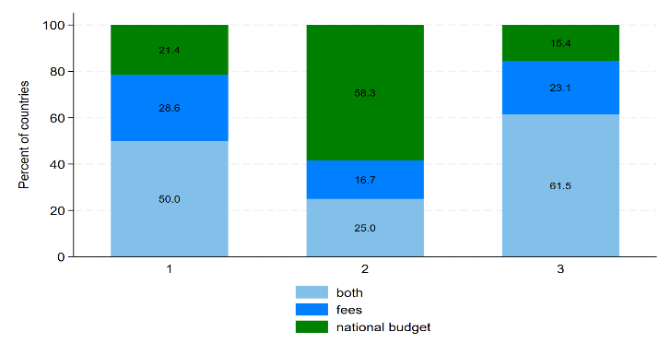 | 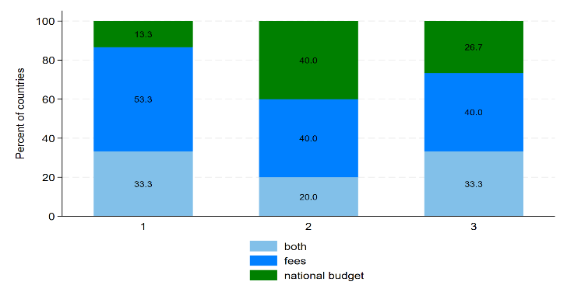
Source: Authors’ elaboration based on data from the OECD’s 2023 Indicators on the Governance of Sector Regulators.
Note: Numbers in the horizontal axis correspond to each tercile of national GNI per capita for respondents, which include OECD member countries and select non-member countries (e.g., Brazil). Sample includes 45 countries.
Beyond the type of financing mechanism, another key consideration is the adequacy of funding. After the financial crisis of 2007-8, heightened scrutiny of banking supervisors led to concerns about the adequacy of their institutional set-up to regulate a financial services market that had grown in complexity and scale. Regulatory institutions need adequate funding, authority to spend it effectively, and the capacity to collect revenues. For example, Levy and Spiller (1994) find that regulatory institutions with adequate public financial management are associated with credibility and long-term investments in the enforcement of regulatory frameworks.

Information systems
Regulatory institutions’ information systems include data on market characteristics needed to inform the regulatory process, as well as websites that make regulations and other documents publicly available. Regulatory institutions regulate a dynamic and evolving market. To ensure that their knowledge of the market is accurate and up-to-date, regulatory institutions require information in the form of data (OECD 2021). Data enables monitoring of market trends, technological developments, and compliance with existing regulations, including target metrics. Recent evidence suggests that automated data gathering on air pollution can enhance the quality and accuracy of information for environmental regulators: Greenstone and others (2022) find that the introduction of automated air pollution monitoring stations in China reduced misreporting in the air pollution reports produced by local government officials.
Because markets are complex, regulatory institutions need to leverage multiple data sources. This, in turn, requires that these data sources are interoperable, so that regulatory institutions can connect multiple data sources to paint a holistic picture of market conditions. B-Ready gathers data on how interoperable information systems are across multiple topics, including business entry and financial services (figure 3.7). Countries such as New Zealand, Rwanda, and Croatia tend to have more interoperable information systems, but still show variation across sectors and services such as business entry. For example, in Rwanda, information systems on business entry (e.g., company information and identifiers) are set up for automated data exchanges across agencies more often than in the financial sector (e.g., a centralized registry of bank collaterals). In some countries, such as Mexico, the difference across regulatory institutions in the same country is almost as large as the average difference across countries, providing further evidence that government institutions are far from homogeneous.
Figure 3.7. The interoperability of information systems vary within the same countries and across sectors and services
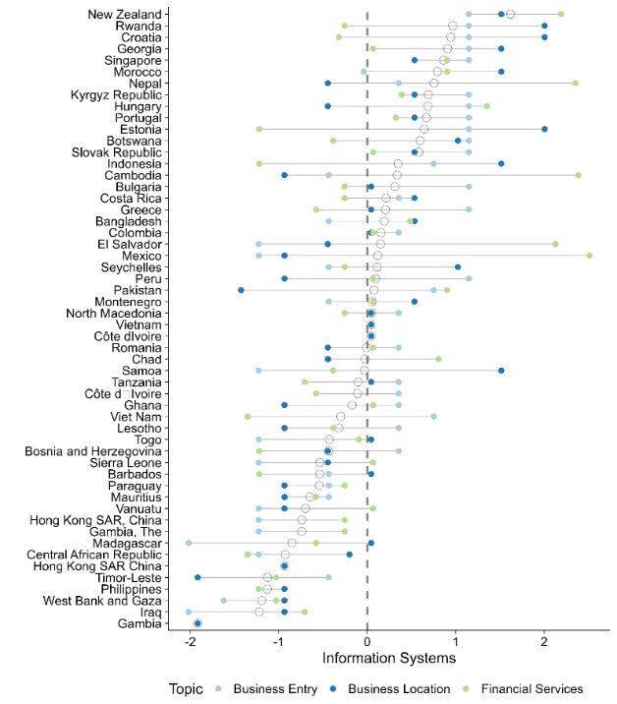
Source: Author’s elaboration based on data from B-Ready.
Note: Each circle represents a different sector/topic in the B-Ready data. Indicators are scored based on the presence of good practices in interoperability of information systems, such as a centralized and integrated data registry. Indicators for each topic are z-scores, computed by subtracting the topic-specific mean and dividing by the standard deviation, to account for differences in the scoring of indicators.

Management practices
Regulatory institutions benefit from management practices such as strategy setting and monitoring and evaluation mechanisms. Setting a strategy and committing to it in the medium-long term is an important foundation for a regulatory institution. Strategic management requires clear objectives and plans to guide the internal functioning of the regulatory institution and establish the different roles and responsibilities, complemented by mechanisms for coordination with relevant public institutions (OECD 2014). These management practices synergize with each other: role clarity enables other institutions to identify where coordination is relevant, while coordination can reduce role duplication and clarify the scope of a regulatory institution. Regulatory overlap and duplication is commonplace. For example, a study of tourism in Cusco, Peru, found significant overlap in the mandates of government agencies regulating tourism, increasing the cost and complexity for travel agencies to acquire their business licenses (World Bank 2019c). Strategy-setting is generally a responsibility of heads of regulatory institutions, who ensure institutional alignment with a forward-looking vision. Evidence suggests that strategy-setting as a management practice varies across countries and types of sectoral regulatory agencies (figure 3.8).
Figure 3.8. Sector regulatory agencies in OECD countries publish and report their strategic objectives consistently
Within-country and across sector variation in the setting and disclosure of strategic objectives
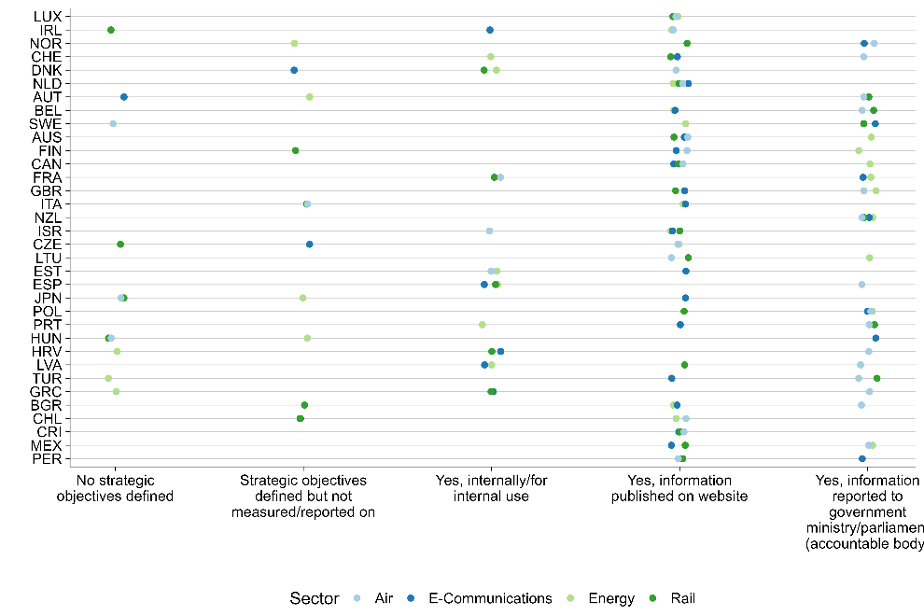
Source: Authors’ elaboration based on data from the OECD’s 2023 Indicators on the Governance of Sector Regulators. Each circle represents an individual sector regulatory institution and their type of management practice. Circles are displaced to reduce overlap. Economies are ordered by GDP per capita (constant international dollars , 2017), latest data available. The sample includes 45 countries.
Monitoring and evaluation of regulations are useful management tools for regulatory institutions. Regulatory impact assessments (RIAs) are a commonly used tool that enable the review, evaluation, and adjustment of the regulatory process according to their actual or expected impact on regulated entities (Ladegaard 2005; Ladegaard, Lundkvist, and, Kamkhaji 2018; OECD 2020). Through RIA, regulatory institutions can make better informed decisions of what and how to regulate, minimizing unwanted consequences for firms and consumers. As such, these impact assessments are an opportunity for regulatory institutions to adjust their strategy, learning from the consequences of regulations and predicting what can occur in the future. In addition, robust strategy-setting and monitoring and evaluation facilitate coordination between regulatory institutions and other relevant public institutions.

Governance Dimensions

Accountability
Accountability enables regulatory institutions to be responsive to external stakeholders, including politicians and the private sector. The variety of stakeholders with competing interests makes accountability a challenge for regulatory institutions. They require a broad set of accountability mechanisms, linking the regulatory institution to each type of stakeholder: politicians, firms, and citizens. To ensure accountability of politicians, as well as other public institutions, annual reviews and regulatory oversight committees can be established (OECD 2014). For accountability to the private sector and citizens, dispute resolution, grievance mechanisms, and opportunities to provide public comments on proposed regulations enable firms and the public to voice their concerns and shape regulations. Evidence suggests that these accountability mechanisms, including consultations, increase foreign direct investment and regulatory compliance by firms (Hebous, Kher, and Tran 2020; Malesky and Taussig 2019).
The accountability of sector regulators varies across institutions within the same country. Drawing on data from the Governance of Sector Regulators collected by the OECD, it is possible to visualize the variation in the accountability of sector-specific regulatory institutions for OECD countries. The accountability indicators used in the dataset combine multiple types of accountability: with respect to the executive and legislative branches, regulated entities, and citizens. The data shows significant variation in the degree of accountability across sector regulators, although the type of accountability is consistent within sectors (e.g., to the parliament or to the public). For example, energy and e-communications regulatory agency scores high on accountability to both the legislature and to the public, while water regulatory agency scores low for both (figure 3.9).
Figure 3.9. Accountability to the legislature and to the public varies across sectors: energy and e-communications sector regulatory agencies are more accountable
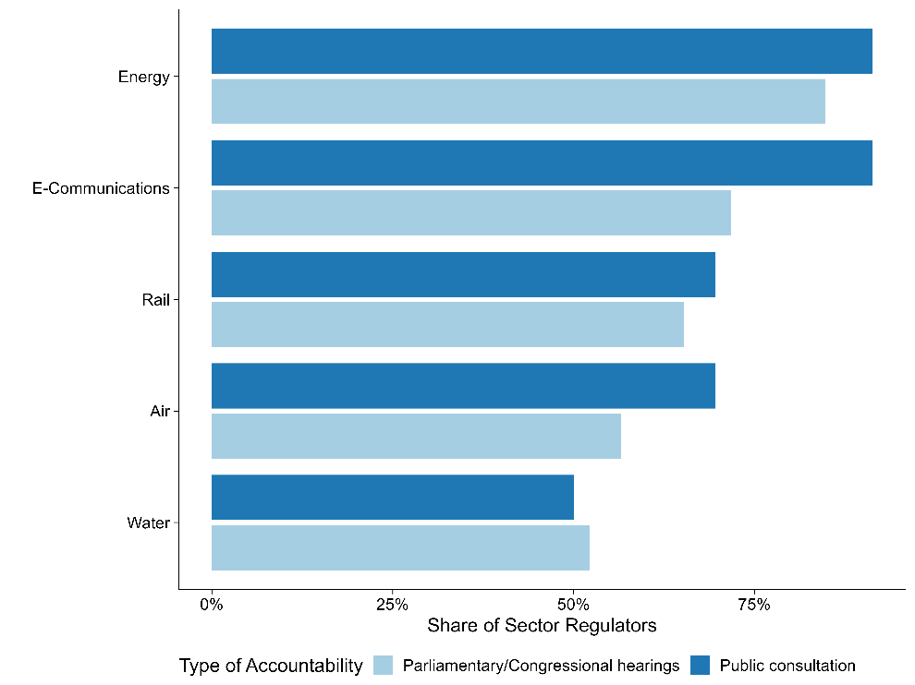
Source: Authors’ elaboration based on data from the Governance of Sector Regulators. Share of sector regulators is computed per sector. Each bar color corresponds to a different type of accountability (e.g., to the legislature or to the public). Data is self-reported and reviewed by the OECD. Not all sector regulatory agencies have responded to the questionnaire for each country. Specific questions include to whom the regulatory agency is accountable (e.g., parliament or congress), does the government collect feedback through public consultation. Sample size is 230 sector regulators in 46 countries.

Transparency
Regulatory institutions can set in place rules and processes that enable them to strengthen their transparency. Transparency is the degree to which regulatory institutions disclose regulations, the level of implementation – and the regulatory process itself – to the public. For example, regulatory frameworks on infrastructure projects and services can be disclosed for access to the public and key stakeholders (World Bank 2020). In addition, information should be accurate by, for example, providing real-time and high-quality data on markets for public scrutiny. The Electricity Regulatory Index for Africa reveals significant variation in transparency practices for regulatory institutions in the energy sector (figure 3.10). Energy regulatory agencies in Uganda, Kenya, and Tanzania show higher levels of transparency, while Zambia and Nigeria lag behind. A study on the energy sector of the Latin America and the Caribbean region found that improved governance of energy regulatory agencies (e.g., transparency) is associated with increased reliability and connectivity of the electricity grid (Andres, Guasch, and Azumendi 2009). Transparency reduces the risk of regulatory capture by making public how regulatory decisions are made, creating opportunities for greater scrutiny and accountability of regulatory institutions’ operations. As such, transparency enhances the functioning of accountability rules and processes.
Figure 3.10. Transparency of regulatory institutions in the energy sectors varies across countries in Africa
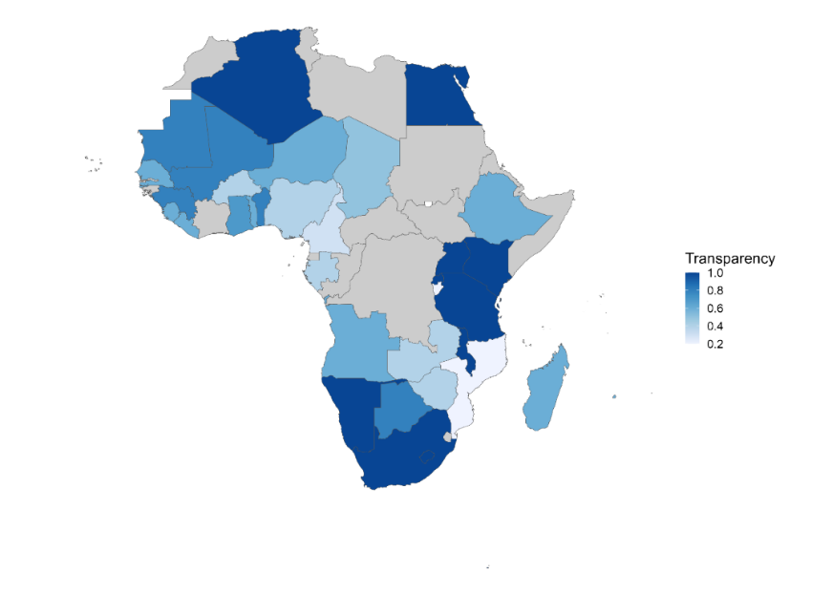
Source: Electricity Regulatory Index for Africa, 2022.
Note: Data is collected through a questionnaire sent to electricity regulators. The indicator assesses the extent to which regulatory agencies adopt international practices regarding transparency (with higher scores indicating a greater degree of adoption). This includes publication of information on regulatory procedures, regulatory decisions and rationale underlying these decisions.

Independence
Independence protects regulatory institutions from undue influence by politicians and the private sector. Independence refers to the rules and processes to prevent regulatory capture, ensuring that regulators are free from undue influence from politicians and the private sector (Carpenter and Moss 2013). Undue influence is a key distinction between independence and accountability mechanisms, the latter of which involves stakeholders exercising legitimate influence. An example of undue influence is revolving door appointments, which enable private sector firms to capture the regulatory institution by appointing their own staff to positions in regulatory institutions and rewarding regulators with jobs when they leave regulatory institutions (Dal Bó 2006). Independence rules and procedures can protect regulatory institutions from capture by politicians and are particularly important for organizational dimensions such as personnel and financial resources. One of the benefits of independence is that it can ensure continuity in the regulatory framework. For example, regulatory institutions can commit to implementing regulations with a long-term horizon, which reduces the risk of sudden regulatory changes and lowers risk for regulated entities (World Bank 1997, 2017). Within recruitment, it is important to consider how regulatory staff are hired and whether competitive selection processes take place. In addition, revolving doors may occur, increasing the risk of regulatory capture (Dal Bó 2006).
Systematic evidence on independence of sector regulatory institutions is limited primarily to developed countries. The majority of systematically collected data on the independence of sector regulators is done by the OECD. Drawing on those data, it is possible to map out variation across and within countries in the independence of sectoral regulators (figure 3.11, panel A). It is also possible to look at specific dimensions of independence, focusing on the independence of financial resources (panel B). For example, assessing who proposes and discusses the budget for the regulatory institution (e.g., the regulatory agency or another governmental institution/ministry). The country ranking for overall independence can be different from the ranking for independence of financial resources.
Figure 3.11. Independence of sector regulatory agencies vary across and within countries
Panel A. Overall independence | Panel B. Independence of financial resources
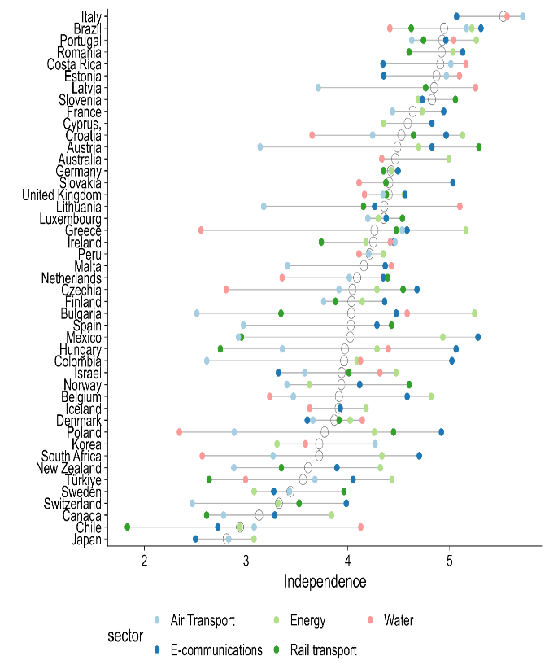 | 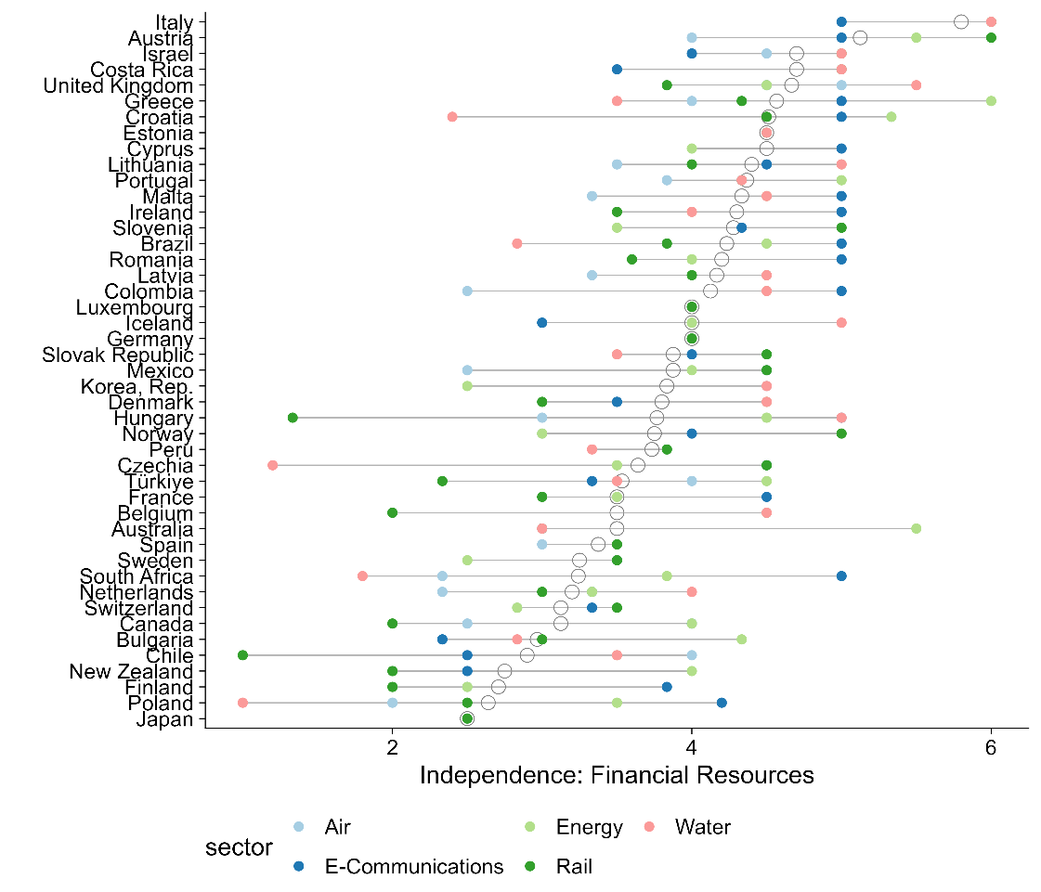
Source: Authors’ elaboration based on data from the Governance of Sector Regulators. Scores vary from 0 (lowest independence) to 6 (highest independence). Each color corresponds to a different sector regulator. Data is self-reported and reviewed by the OECD. Not all sector regulatory agencies have responded to the questionnaire for each country. Sample includes 45 countries. Panel A: Questions on independence cover multiple areas, including relationship with the executive, staff, and budget. Specific questions include what is the legal status of the regulatory agency (e.g., independent body), how is the majority of staff appointed (e.g., positions are advertised publicly and candidates selected by selection panel), and what is the length of budget appropriations (e.g., at least three years). Panel B: Questions on independence that specifically cover the budget (i.e., financial resources). For example, who is responsible for proposing and discussing the regulator’s budget? Scoring based on OECD schemata for the Governance of Sector Regulators indicators, 2023 methodology.

Regulatory institutional challenges span multiple dimensions
Regulatory institutional challenges are multidimensional. Most are closely tied to two or more dimensions. For instance, the first problem in table 3.1 below relates to the personnel dimension but also the information systems dimension. Institutional challenges span multiple dimensions, revealing connections between different parts of the framework. The definition of a problem is intrinsically linked to the institution's mandate. This report’s framework diagnoses what kinds of institutional reforms are most relevant for addressing problems common to achieving regulatory institutions’ mandates. For instance, low quality of goods and services may be a result of outdated information systems as well as lack of expertise by regulatory personnel that make it difficult to identify and enforce quality issues. Organizing outcomes of interest in this way helps to diagnose where interventions could help improve regulatory-specific outcomes as well as private sector development more broadly as detailed in the sections below.
Table 3.1 Regulatory outcomes are linked to the organization and governance dimensions
Regulatory problem | Organizational and governance dimensions | Regulatory outcome
Regulators lack sufficient knowledge of markets, as well as sufficient data and information systems to address market failures without undermining private sector development and competition levels. | - Information systems: Outdated tracking systems limit the data available for regulators to enforce quality standards (OECD 2021).  - Personnel: Regulatory staff may lack the required level of expertise to identify and diagnose quality issues (Stern 2000).  - Accountability: Not providing firms the opportunity to participate in and provide comments on regulations deduces the likelihood that firms will comply with existing chemical safety standards (Malesky and Taussig 2019). | Improve the quality of goods and services
Politicians appoint regulators who tilt the rules in favor of certain firms and private interests to the detriment of the interest of consumers.  Politicians or other decision-makers can cause disruptive changes in leadership of regulatory agencies, making it difficult to approve new regulations to address technological or market changes. | - Independence: Regulatory institutions may be pressured by firms to either increase barriers to entry or refrain from enacting competition-enhancing regulations, through revolving door appointments (Dal Bó 2006).  - Management practices: Infrequent review and adjustment of competition regulations. Regulations may not be updated regularly to reflect market changes.  - Financial resources: Underfunding of market studies and regulatory audits. Lack of funding can limit the ability to conduct thorough analyses and audits, hindering market regulation. | Promote competition
Regulatory institutions do not have sufficient incentives or resources to provide information to the public. | - Transparency: Limited transparency in real-time data for public scrutiny, which prevents identification of excluded users.  - Financial resources: Inadequate financial incentives to attract private sector investment in underserved areas. There may not be enough benefits to encourage private companies to invest. | Ensure access
Source: Author’s elaboration

Applying the framework: Case study on telecoms regulatory institutions in Peru
Telecommunications play a significant role in economic development, although the digital divide in Latin America and the Caribbean (LAC) remains noticeable. Telecommunications can provide network externalities and support economic activity by improving information flows for firms and consumers (Röller and Waverman 2001). However, coverage and access to mobile services are not uniform across LAC (World Bank 2016b). The region has seen slower growth in broadband connectivity, as indicated by the Global System for Mobile Association’s (GSMA) Telecom Connectivity Index. This stagnation is primarily attributed to regulatory frameworks that constrain the expansion of the telecommunications sector (World Bank 2017b).
This case study analyzes the design and implementation of telecoms regulation by the Ministry of Transport and Communications (MTC) and the Organismo Supervisor de Inversión Privada en Telecomunicaciones (OSIPTEL) in Peru. MTC and OSIPTEL are the main regulatory institutions for mobile services. OSIPTEL is a specialized regulatory institution attached to the Presidential Council of Ministers with de jure technical, administrative, and financial autonomy. OSIPTEL’s broad mission is to improve the quality of services and customer protection in telecommunications, all within a framework of equitable and open competition. It focuses particularly on regulations for mobile internet and services which include, among others, spectrum broadband allocation and mobile network infrastructure (e.g., cellular radio towers). The Ministry of Transport and Communications (MTC), which is mandated with broader infrastructure regulation (including telecoms infrastructure). In particular, the MTC is responsible for building and offering concessions for the national optic fiber network (Red Dorsal Nacional de Fibra Óptica, RDNFO) in rural areas, in an attempt to bridge the urban-rural digital divide (OECD 2023b).
As table 3.2 illustrates, implementation problems can have their roots in multiple organizational or governance dimensions, highlighting the interconnected nature of the framework’s components. For example, the low participation is spectrum auctions is driven by inadequate systems for monitoring market dynamics (an information systems issue) and lack of information shared with market participants (a transparency issue).
Table 3.2. Using the framework to diagnose potential sources of policy implementation problems in telecom regulatory agencies
Implementation problem | Potential Sources of Problems |  | Possible solutions
 | Information Systems | Management Practices
Lack of oversight and clear metrics in spectrum auctions lead to low participation and compromise the integrity of the auction process | Unclear market performance metrics lead to low participation by bidders  Inadequate systems for monitoring market dynamics and spectrum use.  Accountability: Lack of comprehensive and up-to-date information hinders audits.  Transparency: Insufficient clarity in market performance metrics provided to market participants. |  | Establish real-time data collection and analysis systems.  Establish clear, standardized market performance metrics and regular evaluations/audits that are publicized to market participants.
Regulatory delays in the drafting and enactment of regulatory frameworks cause regulatory uncertainty in telecoms operators |  | Frequent leadership turnover disrupts regulatory decisions.  Delays in inter-institutional coordination due to differing agendas and priorities among involved entities.  Independence: politically motivated appointments of heads of regulatory agencies compromise independence. | Ensure that heads of regulatory agencies serve for a fixed term and subject to review by either the legislature or regulatory board.  Strengthen decision frameworks so that there is clarity of mandate between multiple regulatory institutions.

Competitive Spectrum Auctions
Better quality of information systems could enhance monitoring progress and ensure compliance in spectrum use, increasing the number of potential bidders in spectrum auctions. Currently, the regulators’ outdated tracking systems and inadequate regulatory compliance tools impede effective oversight. For example, after auctions to allocate radio spectrum to mobile services providers, OSIPTEL was unable to sufficiently track compliance, which resulted in operators either misusing or underusing their allocated spectrums. Improving real-time data collection and analytical capabilities would enhance compliance, enabling accurate monitoring with respect to the use of broadband spectrums. Clearer market performance metrics could lead to more competitive bidding behavior, affecting the overall competitiveness of the spectrum auction.
Transparency and accountability issues, such as inconsistent regulatory updates and communication delays to mobile operators, have significantly impacted stakeholder engagement and trust in Peru’s broadband sector. Two key mobile service regulations – the National Broadband Plan and the Broadband Law – are designed to expand broadband access, but transparency issues such as a lack of clear metrics on how radio spectrums will be allocated have undermined their success. To address this, some regulators’ norms emphasize timely and clear communication to ensure stakeholders are well-informed, facilitating smoother policy implementation. Transparency issues also make it challenging to enforce accountability. For example, if the regulatory agency does not publish responses to comments by regulated entities, it is difficult to hold the agency accountable for regulatory decisions they have made. Inadequate auditing processes have further weakened regulatory accountability. Spectrum caps and competitive spectrum auctions require robust accountability mechanisms such as audits to prevent market monopolization and ensure fair competition; irregular implementation of these audits leads to uneven compliance with allocated spectrum bands.

Regulatory delays
Strengthening the independence of the regulatory agencies could provide more managerial stability and consequently regulatory certainty. Frequent changes in political leadership and shifting regulatory priorities in Peru have created an unstable environment for long-term telecom infrastructure projects. The average tenure of ministers and vice ministers of communications is notably short, with many serving less than a year. Figure 3.12 shows the tenure of the nineteen ministers who oversaw telecoms regulation in Peru from 2009 to 2023, while also highlighting the timing of key regulatory decisions. The average ministerial tenure is short, leading to fragmented policy implementation and disruptions. Because the Ministry of Transportation and Communications (MTC) is responsible for regulating the telecoms sectors, these frequent leadership changes have contributed to inconsistent policy directives, fragmented efforts, and delays in executing critical regulatory milestones. For example, the implementation of the National Broadband Plan and Spectrum Caps experienced delays due to shifting priorities caused by frequent managerial turnover. This case exemplifies how lack of independence can have an impact on management practices and the how organizational dimensions and governance dimensions are intertwined.
Figure 3.12 Frequent leadership change is a challenge for achieving key regulatory milestones
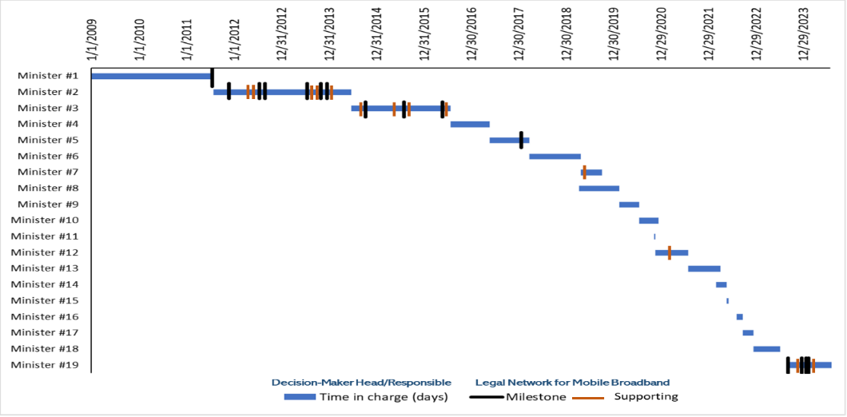
Source: Author’s elaboration.
Note: Each black line represents key legislative or regulatory acts (Milestones) that have significantly impacted the mobile internet service sector. Each orange line represents other legislative or regulatory acts (Supporting) that complemented Milestones. For instance, key regulatory milestones, like the 4G spectrum auction and Mobile Virtual Network Operator (MVNO) regulations, were also delayed due to leadership changes. Each transition in leadership often shifts priorities, resulting in inconsistent implementation and lack of follow-through on existing plans.
Independence is crucial for unbiased decision-making, but regulatory agencies have faced challenges in maintaining it. According to the Framework Law on Regulatory Agencies, all of Peru’s regulatory institutions should operate autonomously, reporting to the Presidency of the Council of Ministers and enjoying administrative, functional, technical, economic, and financial independence. In practice, however, this independence is subject to intervention by the legislative and executive branches. For example, the 2021-2022 Congress proposed a bill to alter the composition of regulatory councils and the criteria for membership. In May 2024, the Executive requested legislative powers to modify the Framework Law on Regulatory Bodies to increase executive oversight of regulatory institutions. This proposal suggested unifying their regulatory functions to achieve cost savings and operational efficiencies. In practice, this centralization risked diluting regulatory independence by unifying functions without taking into account different sectors’ distinct regulatory needs, creating spaces for the politicization of technical issues and reducing legal certainty for private investments. The proposal was ultimately rejected by Congress.
A key challenge for telecoms regulation in Peru is the lack of inter-institutional coordination. Telecoms is a complex system, requiring regulatory institutions to focus on regulating specific services and infrastructure, while coordinating their efforts. As mentioned earlier, OSIPTEL is responsible for improving the quality of services and protect consumers, while ensuring competition. The Ministry of Transport and Communications, on the other hand, focuses on telecoms infrastructure such as cell towers. In theory, these two institutions should coordinate their regulatory efforts: a high-quality mobile service requires the maintenance or roll-out of mobile service infrastructure to support it. In practice, these institutions have often failed to coordinate their regulatory efforts, working either in isolation or competing with one another. This lack of inter-institutional coordination and collaboration has led to both regulatory delays and the uneven implementation of regulations that sought to improve the quality of mobile services.

Annex 1. Methodology for Assessing Procurement Systems (MAPS) indicators
Figures 2.2 and 2.5 are constructed based on specific criteria coded in the Methodology for the Assessment of Procurement Systems (MAPS) framework. For each country, the MAPS assessment rates each criterion as present, partially present, or not present. These ratings are then coded as 2, 1, and 0, respectively. The two figures plot the percentage of possible points that countries could have received for their personnel-related criteria.

Table A1.1 Criteria in the MAPS framework relevant for the “personnel” dimension:
MAPS Pillar | Criteria
Pillar 1: Legal, Regulatory, and Policy Framework | None.
Pillar 2: Institutional Framework and Management Capacity | - One or several agencies is clearly responsible for providing tools and documents, including integrity training programs, to support training and capacity development of the staff responsible for implementing procurement.  - One or several agencies is clearly responsible for supporting the professionalization of the procurement function (e.g., development of role descriptions, competency profiles, and accreditation and certification schemes for the profession).  - The institution’s internal organization, authority, and staffing are sufficient and consistent with its responsibilities.  - The centralized procurement body’s internal organization and staffing are sufficient and consistent with its responsibilities.  - Responsibility for the management and operation of the system is clearly defined.  - Government officials have the capacity to plan, develop, and manage e-procurement systems.  - Procurement staff are adequately skilled to reliably and efficiently use e-procurement systems.  - Substantive permanent training programs of suitable quality and content for the needs of the system.  - Routine evaluation and periodic adjustment of training programs based on feedback and need.  - Advisory service or help desk function to resolve questions by procuring entities, suppliers, and the public.  - A strategy well-integrated with other measures for developing the capacity of key actors involved in public procurement.  - Procurement is recognized as a specific function, with procurement positions defined at different professional levels, and job descriptions and the requisite qualifications and competencies specified.  - Appointments and promotion are competitive and based on qualifications and professional certification.  - Staff performance is evaluated on a regular and consistent basis, and staff development and adequate training are provided.  - The country has established and consistently applied a performance measurement system that focuses on both quantitative and qualitative aspects.
Pillar 3: Public Procurement Operations and Market Practices | None.
Pillar 4: Accountability, Integrity, and Transparency of the Public Procurement System | - There is an established program to train internal and external auditors to ensure that they are qualified to conduct high-quality procurement audits, including performance audits.  - The selection of auditors requires that they have adequate knowledge of the subject as a condition for carrying out procurement audits; if auditors lack procurement knowledge, they are routinely supported by procurement specialists or consultants.  - Auditors are selected in a fair and transparent way and are fully independent.  - The appeals body is adequately resourced and staffed to fulfill its functions.  - Regular training programs are offered to ensure sustained awareness and implementation of measures.

Table A1.2 Criteria in the MAPS framework relevant for the “transparency” dimension:
MAPS Pillar | Criteria
Pillar 1: Legal, Regulatory, and Policy Framework | - The legal framework requires that procurement opportunities are publicly advertised, unless the restriction of procurement opportunities is explicitly justified.  - Publication of opportunities provides sufficient time, consistent with the method, nature, and complexity of procurement, for potential bidders to obtain documents and respond to the advertisement. The minimum time frames for submission of bids/proposals are defined for each procurement method, and these time frames are extended when international competition is solicited.  - Publication of open tenders is mandated in at least one newspaper of wide national circulation or on a unique Internet official site where all public procurement opportunities are posted. This should be easily accessible at no cost and should not involve other barriers (e.g., technological barriers).  - Opening of tenders in a defined and regulated proceeding, immediately following the closing date for bid submission.  - Records of proceedings for bid openings are retained and available for review.
Pillar 2: Institutional Framework and Management Capacity | - One or several agencies are clearly assigned the function of providing procurement information without creating gaps or overlaps in responsibility.  - In support of the concept of open contracting, more comprehensive information is published on the online portal in each phase of the procurement process, including the full set of bidding documents, evaluation reports, full contract documents including technical specification, and implementation details.  - Information is published in an open, structured, and machine-readable format, using identifiers and classifications.
Pillar 3: Public Procurement Operations and Market Practices | - The selection and award processes are carried out effectively, efficiently, and in a transparent way.  - Procurement statistics are available and a system is in place to measure and improve procurement practices.  - The records are complete and accurate, and easily accessible in a single file.
Pillar 4: Accountability, Integrity, and Transparency of the Public Procurement System | - Requirements in combination with actual practices ensure that all stakeholders have adequate and timely access to information as a precondition for effective participation.  - As part of the anti-corruption framework, statistics on corruption-related legal proceedings and convictions are compiled and reports are published annually.  - There are legal provisions to protect whistle-blowers, and these are considered effective.

References
Abad, Jose, Vincente Bermejo, Vicente Cunat, and Rafael Zambrana. 2023. “Government Arrears and Corporate Decisions: Lessons from a Natural Experiment.” Working paper, Bank for International Settlements (bis), Basel, Switzerland.
Adam, Isabelle, and Mihály Fazekas. 2021. “Are Emerging Technologies Helping Win the Fight Against Corruption? A Review of the State of Evidence.” Information Economics and Policy 57.
Addison, Douglas M. 2013. "The quality of budget execution and its correlates." Working Paper No. 6657, World Bank Policy Research, Washington, D.C.
Akerlof, George A. 1978. "The market for lemons: Quality uncertainty and the market mechanism." In Uncertainty in economics, 235-251. Academic Press.
Andres, L., Guasch, J.L. and Azumendi, S.L., 2009. Regulatory governance and sector performance: methodology and evaluation for electricity distribution in Latin America. In Regulation, Deregulation, Reregulation. Edward Elgar Publishing.
Andrews, Matt, Lant Pritchett, and Michael Woolcock. 2017. Building state capability: Evidence, analysis, action. Oxford University Press.
Andrews, Matthew, Marco Cangiano, Neil Cole, Paolo De Renzio, Philipp Krause, and Renaud Seligmann. 2014. "This is PFM." CID Working Paper Series No. 285, Harvard University, Cambridge, MA.
Avis, Eric, Claudio Ferraz, and Frederico Finan. 2018. “Do Government Audits Reduce Corruption? Estimating the Impacts of Exposing Corrupt Politicians.” Journal of Political Economy 126 (5): 1912–64.
Azulai, Michel, Imran Rasul, Daniel Rogger, and Martin J. Williams. 2020. "Can training improve organizational culture? Experimental evidence from Ghana’s civil service." Working Paper, Economic Development and Institutions.
Bajpai, Rajni, Bernard C. Myers, 2020. Enhancing Government Effectiveness and Transparency: The Fight Against Corruption (English). Washington, D.C. World Bank Group.
Baltrunaite, Audinga, Cristina Giorgiantonio, Sauro Mocetti, and Tommaso Orlando. 2021. “Discretion and Supplier Selection in Public Procurement.” Journal of Law, Economics, and Organization 37 (1): 134–66.
Bandiera, Oriana, Andrea Prat, and Tommaso Valletti. 2009. "Active and passive waste in government spending: evidence from a policy experiment." American Economic Review 99 (4): 1278-1308.
Bandiera, Oriana, Michael Carlos Best, Adnan Qadir Khan, and Andrea Prat. 2021. "The allocation of authority in organizations: A field experiment with bureaucrats." The Quarterly Journal of Economics 136 (4): 2195-2242.
Banerjee, Abhijit, Esther Duflo, and Nancy Qian. 2020. “On the Road: Access to Transportation Infrastructure and Economic Growth in China.” Journal of Development Economics 145: 102442.
Bauhr, Monika, Ágnes Czibik, Jenny de Fine Licht, and Mihály Fazekas. 2019. “Lights on the Shadows of Public Procurement: Transparency as an Antidote to Corruption.” Governance 33 (3): 495–523.
Bellodi, Luca, Massimo Morelli, and Matia Vannoni. 2024. “A Costly Commitment: Populism, Economic Performance, and the Quality of Bureaucracy.” American Journal of Political Science 68 (1): 193–209.
Bersch, Katherine, Sérgio Praça, and Matthew M. Taylor. 2016. "State capacity, bureaucratic politicization, and corruption in the Brazilian state." Governance 30 (1): 105-124.
Bertelli, Anthony M., Mai Hassan, Dan Honig, Daniel Rogger, and Martin J. Williams. 2020. "An agenda for the study of public administration in developing countries." Governance 33 (4): 735-748.
Bertrand, Marianne, Robin Burgess, Arunish Chawla, an“ Guo Xu. 2020. "The glittering prizes: Career incentives and bureaucrat performance." The Review of Economic Studies 87 (2): 626-655.
Berwick, Elissa, and Fotini Christia. 2018. "State capacity redux: Integrating classical and experimental contributions to an enduring debate." Annual Review of Political Science 21(1): 71-91.
Besley, T., & Coate, S. 2003. “Elected versus appointed regulators: Theory and evidence.” Journal of the European Economic Association, 1(5), 1176-1206.
Best, Michael Carlos, Jonas Hjort, and David Szakonyi. 2023. "Individuals and organizations as sources of state effectiveness." American Economic Review 113 (8): 2121-2167.
Bloom, Nicholas, Renata Lemos, Raffaella Sadun, and John Van Reenen. 2015. "Does management matter in schools?" The Economic Journal 125 (584): 647-674.
Blum, Jurgen, Arkopal Datta, Mihaly Fazekas, Sushmita Samaddar, and Ishtiak Siddique. 2023. “Introducing E-Procurement in Bangladesh: The Promise of Efficiency and Openness.” Working Paper No. 10390, World Bank Policy Research, Washington, D.C.
Boas, Taylor, F. Daniel Hidalgo, and Neal Richardson. 2014. “The Spoils of Victory: Campaign Donations and Government Contracts in Brazil.” Journal of Politics 76 (2): 415–29.
Bolton, Alexander, Rachel Augustine Potter, and Sharece Thrower. 2016 "Organizational capacity, regulatory review, and the limits of political control." The Journal of Law, Economics, and Organization 32 (2): 242-271.
Brierley, Sarah. 2020. “Unprincipled Principals: Co-Opted Bureaucrats and Corruption in Ghana.” American Journal of Political Science 64 (2): 209–22.
Brogaard, Jonathan, Matthew Denes, and Ran Duchin. 2021. “Political Influence and the Renegotiation of Government Contracts.” Review of Financial Studies 34 (6): 3095–3137.
Brown, Ashley C., Jon Stern, Bernard William Tenenbaum, and Defne Gencer. 2006. Handbook for evaluating infrastructure regulatory systems, World Bank, Washington DC: World Bank Publications.
Buntaine, Mark T. Bing Zhang and Patrick Hunnicutt. 2021. “Citizen monitoring of waterways decreases pollution in China by supporting government action and oversight.” Proceedings of the National Academy of Sciences Vol. 118 | No. 29
Caires, Filipe, Susana Peralta, and Diogo Mendes. 2023. “Contract Splitting in Public Procurement.” Working Paper, European University Institute, Fiesole FI, Italy.
Callen, Michael and Gulzar, Saad and Hasanain, Syed Ali and Khan, Muhammad and Rezaee, Arman. 2015. “Personalities and Public Sector Performance: Evidence from a Health Experiment in Pakistan." HKS Working Paper No. RWP15-023, http://dx.doi.org/10.2139/ssrn.2613671
Camaj, Lindita. 2013. "The media’s role in fighting corruption: Media effects on governmental accountability." The International Journal of Press/Politics 18 (1): 21-42.
Campos, Nicolás, Eduardo Engel, Ronald Fischer, and Alexander Galetovic. 2021. “The Ways of Corruption in Infrastructure: Lessons from the Odebrecht Case.” Journal of Economic Perspectives 35 (2): 171–90.
Canen, Nathan, Rafael Ch, and Leonard Wantchekon. 2023. “Political uncertainty and the forms of state capture.” Journal of Development Economics, Volume 160, January 2023, 102972
Carpenter, Daniel P. 2002. "Groups, the media, agency waiting costs, and FDA drug approval." American Journal of Political Science 46 (3): 490-505.
Carpenter, Daniel P. and David A. Moss. 2013, Preventing regulatory capture: special interest influence and how to limit it, Cambridge, MA: Cambridge University Press.
Centeno, M. A., Kohli, A., & Yashar, D. J. 2017. Unpacking states in the developing world: Capacity, performance, and politics. States in the developing world, 1-32, Cambridge University Press.
Chassang, Sylvain, and Juan Ortner. 2019. “Collusion in Auctions with Constrained Bids: Theory and Evidence from Public Procurement.” Journal of Political Economy 127 (5): 2269–2300.
Chaurey, Ritam, and Duong Trung Le. 2022. “Infrastructure Maintenance and Rural Economic Activity: Evidence from India.” Journal of Public Economics 214: 104725.
Christoph, Mary J., Nicole Larson, Melissa N. Laska, and Dianne Neumark-Sztainer. 2018. "Nutrition facts panels: who uses them, what do they use, and how does use relate to dietary intake?." Journal of the Academy of Nutrition and Dietetics 118 (2): 217-228.
Colonnelli, Emanuele, and Mounu Prem. 2022. “Corruption and Firms.” The Review of Economic Studies 89 (2): 695–732.
Colonnelli, Emanuele, Francesco Loiacono, Edwin Muhumza, and Edouard Teso. 2024. “Do Information Frictions and Corruption Perceptions Kill Competition? A Field Experiment on Public Procurement in Uganda.” NBER Working Paper, No. W32170, Cambridge, MA.
Conti, Maurizio, Leandro Elia, Antonella Rita Ferrara, and Massimiliano Ferraresi. 2021. “Governments’ Late Payments and Firms’ Survival: Evidence from the European Union.” Journal of Law and Economics 64 (3): 603–27.
Coviello, Decio, and Mario Mariniello. 2014. “Publicity Requirements in Public Procurement: Evidence from a Regression Discontinuity Design.” Journal of Public Economics 109:76–100.
Coviello, Decio, Andrea Guglielmo, and Giancarlo Spagnolo. 2018. “The Effect of Discretion on Procurement Performance.” Management Science 64 (2): 715–38.
Coviello, D., Deserranno, E., Persico, N., & Sapienza, P. 2024.” Effect of mood and worker incentives on workplace productivity.” The Journal of Law, Economics, and Organization, 40(2), 362-393.
Deserranno, E., Philipp Kastrau, & León-Ciliotta, G. 2022. “Promotions and productivity: the role of meritocracy and pay progression in the public sector." STEG Working Paper, No. WP037, London.UK.
Dahis, Ricardo, Bernardo Ricca, and Thiago Scot 2024. "Speed of Payment in Procurement Contracts: The Role of Political Connections." Available at SSRN 3934021.
Dahlstrom, C., & Lapuente, V. 2022. “Comparative bureaucratic politics.” Annual Review of Political Science, 25(1), 43-63.
Dal Bó, Ernesto, Frederico Finan, and Martín A. Rossi. 2013. "Strengthening state capabilities: The role of financial incentives in the call to public service." The Quarterly Journal of Economics 128 (3): 1169-1218.
Dal Bó, Ernesto. 2006 "Regulatory capture: A Review.” Oxford review of economic policy 22 (2): 203-225.
Dasgupta A, and Kapur D. 2020. “The Political Economy of Bureaucratic Overload: Evidence from Rural Development Officials in India.” American Political Science Review.;114(4):1316-1334..
Decarolis, Francesco, Leonardo Giuffrida, Elisabetta Iossa, Vincenzo Mollisi, and Giancarlo Spagnolo. 2020. “Bureaucratic Competence and Procurement Outcomes.” Journal of Law, Economics, and Organization 36 (3): 537–97.
Decarolis, Francesco, Raymond Fisman, Paolo Pinotti, and Silvia Vannutelli. 2020. “Rules, Discretion, and Corruption in Procurement: Evidence from Italian Government Contracting." National Bureau of Economic Research. No. 28209, Cambridge, MA.
Decarolis, Francesco. 2018. “Comparing Public Procurement Auctions.” International Economic Review 59 (2): 391–419.
Duguay, Raphael, Thomas Rauter, and Delphine Samuels. 2023. “The Impact of Open Data on Public Procurement.” Journal of Accounting Research 61 (4): 1159–1224.
Estache, Antonio, and Liam Wren‐Lewis.2010. "On the theory and evidence on regulation of network industries in developing countries." In The Oxford Handbook of Regulation edited by Robert Baldwin, Martin Cave, and Martin Lodge, 371-406, Oxford Academic, UK
Eutsler, Jared, M. Kathleen Harris, L. Tyler Williams, and Omar E.Cornejo. 2023. "Accounting for partisanship and politicization: Employing Benford's Law to examine misreporting of COVID-19 infection cases and deaths in the United States." Accounting, Organizations and Society 108, 101455.
Evans, Peter and Rauch, James E. 2000. "Bureaucratic structure and bureaucratic performance in less developed countries." Journal of Public Economics 75 (1): 49-71.
Evans, Peter, and James E. Rauch. 1999 "Bureaucracy and growth: a cross-national analysis of the effects of “Weberian” state structures on economic growth." American Sociological Review 64 (5): 748-765.
Finan, F., Olken, B. A., & Pande, R. 2017. “The personnel economics of the developing state.” Handbook of economic field experiments, 2, 467-514.
Foarta, Dana, and Michael Ting. 2023. "Organizational capacity and project dynamics." Stanford University Graduate School of Business Research Paper. 4321890. SSRN.
Fukuyama, Francis. 2013. "What is governance?" Governance 26 (3):347-368.
Gailmard, Sean. 2010. "Politics, principal–agent problems, and public service motivation." International Public Management Journal 13 (1): 35-45.
Garcia-Santana, Manuel, and Marta Santamaria. 2024. “Governments’ Home Bias and Efficiency Losses: Evidence from National and Subnational Governments.” FRB of New York Staff, Working paper.
Gerardino, Maria Paula, Stephan Litschig, and Dina Pomeranz. 2022. “Distortion by Audit: Evidence from Public Procurement.” NBER Working Paper, No. 23978, Cambridge, MA.
Gingerich, Daniel W. 2013 "Governance indicators and the level of analysis problem: empirical findings from South America." British Journal of Political Science 43 (3): 505-540.
Giuffrida, Leonardo, and Emilio Raiteri. 2023. “Bureaucratic Frictions and Innovation Procurement.” CESifo Working Paper 10775, Available at SSRN: https://ssrn.com/abstract=4646361 or http://dx.doi.org/10.2139/ssrn.4646361.
Greenstone, Michael, Guojun He, Ruixue Jia, and Tong Liu. 2022. "Can technology solve the principal-agent problem? Evidence from China’s war on air pollution." American Economic Review: Insights 4, (1): 54-70.
Grindle, Merilee S. 1997. "Divergent cultures? When public organizations perform well in developing countries." World Development 25 (4): 481-495.
Grindle, Merilee S. 2007. "Good enough governance revisited." Development Policy Review 25 (5): 533-574.
Grindle, Merilee S., 2012. Jobs for the boys: Patronage and the state in comparative perspective. Harvard University Press.
Hanson, Jonathan K., and Rachel Sigman. 2021. "Leviathan’s latent dimensions: Measuring state capacity for comparative political research." The Journal of Politics 83 (4): 1495-1510.
Hasnain, Zahid, Daniel Oliver Rogger, Daniel John Walker, Kerenssa Mayo Kay and Rong Shi. 2019. “Innovating Bureaucracy for a More Capable Government." World Bank Working Paper 134585, Washington, D.C..
Hebous, Sarah, Priyanka Kher, and Trang Thu Tran. 2020. "Regulatory risk and FDI." In Global Investment Competitiveness Report: Rebuilding Investor Confidence in Times of Uncertainty. Washington, DC: The World Bank.
Honig, D., 2024. Mission driven bureaucrats: Empowering people to help government do better. Oxford University Press.
Honig, D. 2022. "Managing for motivation as public performance improvement strategy in education & far beyond." Research on Improving Systems of Education, CID Faculty Working Paper Series.
Honig, D. 2021. “Supportive management practice and intrinsic motivation go together in the public service.” Proceedings of the National Academy of Sciences, 118(13), e2015124118.
IFC. 2021. Creating Markets in Pakistan: Country Private Sector Diagnostic, the International Finance Corporation, Washington, DC.
IFC. 2023a. Creating Markets in Moldova: Country Private Sector Diagnostic, the International Finance Corporation, Washington, DC.
Iyer, Lakshmi and Anandi Mani. 2012. “Traveling Agents: Political Change and Bureaucratic Turnover in India." Review of Economics and Statistics 94:723-39.
Jacobs, Scott and Peter Ladegaard. 2010, Regulatory Governance in Developing Countries, International Finance Corporation, Multilateral Investment Guarantee Agency and Washington, DC: The World Bank.
Joskow, Paul L.2007. "Regulation of natural monopoly." Handbook of Law and Economics 2: 1227-1348.
Kelly, Tim, and Carlo Maria Rossotto, eds. 2012. Broadband strategies handbook. World Bank Publications, Reports No. 67620, Washington DC.
Kelman, Steven. 1990. “Procurement and Public Management: The Fear of Discretion and the Quality of Government Performance." American Enterprise Institute, Washington, D.C.
Kenny, Charles, and Ben Crisman. 2016. “Results Through Transparency: Does Publicity Lead to Better Procurement?” Working Paper 437, Center for Global Development, Washington, D.C.
Khemani, Stuti; Dal Bó, Ernesto; Ferraz, Claudio; Finan, Frederico Shimizu; Stephenson Johnson, Corinne Louise; Odugbemi, Adesinaola Michael; Thapa, Dikshya; Abrahams, Scott David. Making politics work for development: harnessing transparency and citizen engagement (English). Policy Research Reports Washington, D.C.: World Bank Group.
Khemani, S. 2019. “What is state capacity?” Working Paper, No, 8734, World Bank Policy Research, Washington, D.C.
Kim, Galileu, Tanu Kumar, Rita Ramalho and Stuart Russell. 2025. “Institutional Capacity for Policy Implementation: An Analytical Framework”, forthcoming
Klein, Michael and Bita Hadjimichael. 2003. The Private Sector in Development: Entrepreneurship, Regulation, and Competitive Disciplines, The World Bank Publications, Washington DC
Kotsanopoulos, Konstantinos V., and Ioannis S. Arvanitoyannis. 2017. "The role of auditing, food safety, and food quality standards in the food industry: A review." Comprehensive Reviews in Food Science and Food Safety 16 (5):760-775.
Kosack, Stephen, and Archon Fung. 2014. "Does Transparency Improve Governance?" Annual Review of Political Science 17 (1): 65-87.
La Cascia, Hunt, Adrian Fozzard, Diana Carolina Annandsingh Rattia, and Yolanda Saito. 2023. “Green Public Procurement: An Overview of Green Reforms in Country Procurement Systems (English)." Climate Governance Papers, Washington, D.C.
Ladegaard, Peter Farup, Petter Lundkvist, and Jonathan Camillo Kamkhaji. 2018. "Giving Sisyphus a helping hand: pathways for sustainable RIA systems in developing countries." Working Paper, No, 8367, World Bank Policy Research, Washington, D.C.
Ladegaard, Peter. 2005. "Improving business environments through Regulatory Impact Analysis-Opportunities and challenges for developing countries." In International Conference on Reforming the Business Environment, Cairo, Egypt,29:1089-1127.
Laffont, Jean-Jacques, and Jean Tirole. 1993. A theory of Incentives in Procurement and Regulation. Cambridge, MA: MIT press.
Laffont, Jean-Jacques. 2005. Regulation and development. Cambridge, UK: Cambridge University Press.
Levitin, Adam J. 2012. "The consumer financial protection bureau: An introduction." Rev. Banking & Fin. L. 32, 321.
Levitsky, Steven, and María Victoria Murillo. 2009. "Variation in institutional strength." Annual Review of Political Science 12 (1):115-133.
Levy, Brian and Spiller, P. T. 1994. “The Institutional Foundations of Regulatory Commitment: A Comparative Analysis of Telecommunications Regulation.” Journal of Law, Economics, & Organization, 10(2), 201–246.
Lewis, G.,and Bajari, P. 2014. “Moral hazard, incentive contracts, and risk: evidence from procurement.” Review of Economic Studies, 81(3), 1201-1228.
Lewis, Gregory, and Patrick Bajari. 2011. “Procurement Contracting with Time Incentives: Theory and Evidence.” Quarterly Journal of Economics 126 (3): 1173–1211.
Lewis-Faupel, Sean, Yusuf Neggers, Benjamin A. Olken, and Rohini Pande. 2016. "Can electronic procurement improve infrastructure provision? Evidence from public works in India and Indonesia." American Economic Journal: Economic Policy 8 (3): 258-283.
Liebman, Jeffrey, and Neale Mahoney. 2017. “Do Expiring Budgets Lead to Wasteful Year-End Spending? Evidence from Federal Procurement.” American Economic Review 107 (11): 3510–49.
Liscow, Zachary, Will Nober, and Cailin Slattery. 2023. “Procurement and Infrastructure Costs.” NBER Working Paper, No. 31705, Cambridge, MA.
Liu, Guoer. 2023. "Where Are the Missing Dead? How Metrics Management Mitigates Official Data Misreporting in China." Journal of Political Institutions and Political Economy 4 (2): 231-258.
Licetti, Martinez, Goodwin, Martha, Tanja K. Sanchez Navarro, Dennis Carreras, Schabauer, Noelia. 2021. “Fixing Markets, Not Prices: Policy Options to Tackle Economic Cartels in Latin America and the Caribbean.” World Bank. Washington, DC.

Locke, E. A., & Latham, G. P. 2002. “Building a practically useful theory of goal setting and task motivation: A 35-year odyssey.” American Psychologist, 57(9), 705–717.
Lofaro, Ryan J, Emily A Boykin, Clifford P McCue, and Eric Prier. 2023. “Year-End Spending Spikes and Single Bid Procedures: An Analysis of Public Procurement in the European Economic Area.” Public Finance and Management 21 (2): 135–66.
Lourenço, Joana S., Renos Vakis, and Laura Zoratto.2022. "The behavioral professional: Improving decision-making and performance in the public sector." Working Paper No. 168343, Washington, D.C.
Malesky, Edmund, and Markus Taussig. 2019. "Participation, government legitimacy, and regulatory compliance in emerging economies: a firm-level field experiment in Vietnam." American Political Science Review 113 (2): 530-551.
Mann, Michael. 1984. "The autonomous power of the state: its origins, mechanisms and results." European Journal of Sociology/Archives européennes de sociologie 25 (2): 185-213.
Martimort, D. 1999. “The life cycle of regulatory agencies: Dynamic capture and transaction costs.” The Review of Economic Studies, 66(4), 929-947.
McDonnell, Erin Metz. 2017. "Patchwork leviathan: How pockets of bureaucratic governance flourish within institutionally diverse developing states." American Sociological Review 82 (3): 476-510.
Mironov, Maxim, and Ekaterina Zhuravskaya. 2016. “Corruption in Procurement and the Political Cycle in Tunneling: Evidence from Financial Transactions Data.” American Economic Journal: Economic Policy 8 (2): 287–321.
Müller, K., 2023. “Electoral cycles in macroprudential regulation. American Economic Journal: Economic Policy," 15 (4): 295-322.
Nogues Comas, Antoni Albert, and Nuno Felipe Mendes dos Santos. 2021. “Measuring Public Procurement Rules and Practices: Benchmarking a Recurrent Infrastructure Contract.” Policy Research Working Paper 9651. Washington, D.C.
North, D.C., 1990. Institutions, Institutional Change and Economic Performance. 1st edition. New York: Cambridge University Press.
OECD. 2014. “The Governance of Regulators, OECD Best Practice Principles for Regulatory Policy.” Paris: OECD Publishing.
OECD. 2016. “Preventing Corruption in Public Procurement. Organization for Economic Cooperation and Development.” Paris: OECD Publishing.
OECD. 2017. “Creating a Culture of Independence: Practical Guidance against Undue Influence, The Governance of Regulators.” OECD Publishing, Paris.http://dx.doi.org/10.1787/9789264274198-en
OECD. 2020. “Regulatory Impact Assessment, OECD Best Practice Principles for Regulatory Policy.” Paris: OECD Publishing.
OECD. 2021. “Data-Driven, Information-Enabled Regulatory Delivery,” in Data-Driven, Information-Enabled Regulatory Delivery, Paris: OECD Publishing.
OECD. 2023a. “Professionalization in Public Procurement: A review of current initiatives and challenges," OECD Public Governance Policy Papers, Paris: OECD Publishing.
OECD. 2023b. “Progress Review of Peru's Telecommunications Regulator: Driving Performance, The Governance of Regulators.” Paris: OECD Publishing.

OECD. 2025. “The 2023 Indicators on the Governance of Sector Regulators.” https://www.oecd.org/content/dam/oecd/en/publications/reports/2025/03/the-2023-indicators-on-the-governance-of-sector-regulators_eb33f9bb/dc22e402-en.pdf

Olken, Benjamin A. 2007. "Monitoring corruption: evidence from a field experiment in Indonesia." Journal of Political Economy 115 (2): 200-249.
Ordóñez, L. D., Schweitzer, M. E., Galinsky, A. D., & Bazerman, M. H. 2009. “Goals gone wild: The systematic side effects of overprescribing goal setting.” Academy of Management Perspectives, 23(1), 6-16.
Pepinsky, Thomas B., Jan H. Pierskalla, and Audrey Sacks. 2017. "Bureaucracy and service delivery." Annual Review of Political Science 20 (1): 249-268.
Rasul, Imran, and Daniel Rogger. 2018. "Management of bureaucrats and public service delivery: Evidence from the Nigeria” civil service." The Economic Journal 128 (608): 413-446.
Rasul, Imran, Daniel Rogger, and Martin J. Williams. 2021. "Management, organizational performance, and task clarity: Evidence from Ghana civil service." Journal of Public Administration Research and Theory 31 (2): 259-277.
Reinikka, Ritva, and Jakob Svensson. 2011. "The power of information in public services: Evidence from education in Uganda." Journal of Public Economics 95, no. 7-8: 956-966.
Rijkers, Bob, Caroline Freund, and Antonio Nucifora. 2017. “All in the family: State capture in Tunisia” Journal of Development Economics, Volume 124, January 2017, Pages 41-59
Ritz, Adrian, Gene A. Brewer, and Oliver Neumann. 2016. "Public service motivation: A systematic literature review and outlook." Public Administration Review 76 (3): 414-426.
Röller, Lars-Hendrik, and Leonard Waverman. 2001. "Telecommunications infrastructure and economic development: A simultaneous approach." American economic review 91 (4): 909-923.
Rogger, Daniel, and Christian Schuster, eds. 2023. The Government Analytics Handbook: Leveraging Data to Strengthen Public Administration. World Bank Publications, Washington, D.C.
Ryan, Nicholas. 2020. “Contract Enforcement and Productive Efficiency: Evidence from the Bidding and Renegotiation of Power Contracts in India.” Econometrica 88 (2): 383–424.
Sandefur, Justin, and Amanda Glassman. 2015. "The political economy of bad data: Evidence from African survey and administrative statistics." The Journal of Development Studies 51 (2): 116-132.
Saussier, Stephane, and Jean Tirole. 2015. “Strengthening the Efficiency of Public Procurement.” Notes Du Conseil d’analyse Economique 22 (3): 1–12.
Schillemans, Thomas and Madalina Busuioc. 2015. “Predicting Public Sector Accountability: From Agency Drift to Forum Drift.” Journal of Public Administration Research and Theory, Volume 25, Issue 1, Pages 191–215, https://doi.org/10.1093/jopart/muu024
Schuster, Christian, Kim Sass Mikkelsen, Daniel Rogger, Francis Fukuyama, Zahid Hasnain, Dinsha Mistree, Jan Meyer‐Sahling, Katherine Bersch, and Kerenssa Kay. 2023. "The Global Survey of Public Servants: Evidence from 1,300,000 Public Servants in 1,300 Government Institutions in 23 Countries." Public Administration Review 83 (4): 982-993.
Scur, Daniela, Raffaella Sadun, John Van Reenen, Renata Lemos, and Nicholas Bloom.2021. "The World Management Survey at 18: lessons and the way forward." Oxford Review of Economic Policy 37 (2): 231-258.
Shamdasani, Yogita. 2021. “Rural Road Infrastructure and Agricultural Production: Evidence from India.” Journal of Development Economics 152: 102686.
Sigman, Rachel. 2023. Parties, Political Finance, and Governance in Africa: Extracting Financial resources and Shaping States in Benin and Ghana. Cambridge University Press.
Soifer, Hillel. 2008. "State infrastructural power: Approaches to conceptualization and measurement." Studies in comparative international development 43: 231-251.
Smart, S. R. 1994. “The consequences of appointment methods and party control for telecommunications pricing.” Journal of Economics & Management Strategy, 3(2), 301-323.
Stasavage, David. 2003. "Transparency, democratic accountability, and the economic consequences of monetary institutions." American Journal of Political Science 47 (3): 389-402.
Stern, Jon. 2000. "Electricity and telecommunications regulatory institutions in small and developing countries." Utilities Policy 9 (3): 131-157
Szucs, Ferenc. 2024. “Discretion and Favoritism in Public Procurement.” Journal of the European Economic Association 22 (1): 117–60.
Tendler, Judith. 1998. “Good Government in the Tropics.” Baltimore: John Hopkins Univ. Press.
Toral, G. 2023. “How Patronage Delivers: Political Appointments, Bureaucratic Accountability, and Service Delivery in Brazil.” American Journal of Political Science, 68: 797-815.
Trinh, Minh. 2019. "Statistical Misreporting from Below, as Seen from (Very High) Above." MIT Political Science Department Research Paper No. 2019-22
Vogler, Jan P. 2020. "The political economy of the European Union: An exploration of EU institutions and governance from the perspective of polycentrism." In Exploring the Political Economy and Social Philosophy of Vincent and Elinor Ostrom, 145-181., edited by Peter J. Boettke, Bobbi Herzberg, and Brian Kogelmann. Rowman & Littlefield International.
Williams MJ. 2021. “Beyond state capacity: bureaucratic performance, policy implementation and reform. Journal of Institutional Economics." 17(2):339-357.
Williams, Martin J. 2017. "The political economy of unfinished development projects: Corruption, clientelism, or collective choice." American Political Science Review 111 (4): 705-723.
World Bank. 1997. “World Development Report 1997; The state in a changing world” Washington DC.
World Bank. 2001. “The Regulation and Supervision of Banks around the World: A New Database.” Policy Research Working Paper; No. 2588. Washington DC.
World Bank. 2002. World development report 2002: building institutions form building institutions for markets, World Development Report, World Development Indicators, Washington, DC.
World Bank. 2004. World Development Report 2004: Making services work for poor people - Overview (English). World Development Report, World Development Indicators, Washington, DC.
World Bank. 2006. “Handbook for evaluating infrastructure regulatory systems.” The World Bank Publications, Washington DC.
World Bank. 2011. Telecommunications Regulation Handbook: Tenth Anniversary Edition, World Bank and the International Telecommunication Union, Washington DC.
World Bank. 2016a. Doing Business 2016 Measuring Regulatory Quality and Efficiency. 13th Edition, Washington DC.
World Bank. 2016b. World development Report 2016: Digital Dividends. Washington DC.
World Bank. 2017a. World development report 2017: Governance and the law, Washington DC.
World Bank. 2017b. “Innovative Business Models for Expanding Fiber-Optic Networks and Closing the Access Gaps." Digital Development Partnership, Washington DC.
World Bank. 2018. “Promoting Open and Competitive Markets in Road Freight and Logistics Services: World Bank, Markets and Competition Policy Assessment Tool Applied in Peru, The Philippines and Vietnam." Washington DC.
World Bank. 2019a. “Governing Infrastructure Regulators in Fragile Environments: Principles and Implementation Manual. International Development in Practice." Washington DC.
World Bank. 2019b. “Innovating Bureaucracy for a More Capable Government." Washington DC.
World Bank. 2019c. “Business Licensing Reforms: Insights from Selected Country Experiences.” Washington DC.
World Bank. 2020. “Infrastructure Governance, Assessment Framework." Washington DC.
World Bank. 2021. Aiming high: Navigating the next stage of Malaysia’s development. Country Economic Memorandum. Washington DC.
World Bank. 2022a. "Water Supply and Sanitation Policies, Institutions, and Regulation: Adapting to a Changing World-Policy Brief." Washington DC.
World Bank. 2022b “A Global Procurement Partnership for Sustainable Development: An International Stocktaking of Developments in Public Procurement." Washington DC.
World Bank. 2022c. “Evaluation Du Système de Passation Des Marches Publics Du Burkina Faso.” Methodology for Assessing Procurement Systems (MAPS).” Washington DC.
World Bank. 2023a. “The Business of the State.” Washington DC.
World Bank. 2023b. Chad - Country economic memorandum: Boosting growth and reducing vulnerability. Washington DC.
World Bank. 2023c. Bulgaria Public Finance Review. Washington, DC.
World Bank. 2024a. Business Ready 2024. Washington, DC.
World Bank. 2024b. Making Procurement Work Better: An Evaluation of the World Bank’s Procurement System. Washington, DC.

The Global Survey of Public Servants is an international research initiative led by the Bureaucracy Lab at the World Bank, in collaboration with academic institutions such as the University College of London, Stanford University and University of Nottingham. The survey respondents are public servants, providing individual- and organizational-level insights into human resource management in the government. While the specific topics covered in the survey vary by country, they generally include attitudes and behaviors of public officials, management practices, among others. Additional details can be found on the Global Survey of Public Servants’ website.
See Levitsky and Murillo (2009); Williams (2021); World Bank (2017a); Pepinsky, Pierskalla and Sacks (2017); Bertelli and others (2020); Tendler (1998); and Grindle (2007).
Foarta and Ting (2023).
There is an expansive literature on state capacity. These include Mann (1984); Soifer (2008); Fukuyama (2013); Hanson and Sigman (2021); Berwick and Christia (2018); and Khemani (2019)
For arguments for conceptual refinement, see Centeno, Kohli and Yashar 2017, Williams 2023. For empirical work on variation of institutional capacity within the same state, see Gingerich (2013); Azulai and others (2020); Bersch, Praça, and Taylor (2016); McDonnell (2017)
See Andrews, Pritchett, and Woolcock (2017) for a discussion of how isomorphic mimicry can undermine state capacity.
Dal Bó, Finan and Rossi (2013); World Bank (2021).
The BOOST data contains highly disaggregated budget and expenditure data for a range of different countries. These microdata are derived from the chart of accounts. The countries were selected based on availability of harmonized data.
For more on organizational culture, see Honig (2022); Gailmard (2010); Grindle (1997); Khemani (2019); Lourenço, Vakis, and Zoratto (2022) ; Ritz, Gene and Neumann. (2016).
Note that the framework does not refer to “electoral accountability” here, i.e., the linkage between public institutions and citizens that occurs through elections and the ballot box. The framework sees these as aspects of the policy arena, which is not within the scope of the report’s framework.
Independence and accountability are compatible with structured consultations with the private sector. Firms are often important stakeholders for public institutions and the above accountability dimension highlights how public institutions should consult them during the implementation process. Independence requires that these accountability mechanisms follow due process, ideally with strong mechanisms for transparency and oversight. Private sector consultations structured in these ways are therefore compatible with both the independence and accountability dimensions, while informal attempts of influence like patronage appointments are not.
System governance information includes audit reports, compliance reports, etc.
As such, this report complements the work of the World Bank Business Ready (B-Ready) report, which has a wider scope and focuses on good practices in regulatory frameworks, public services, and operational efficiency for enabling the private sector.
This definition is adapted from the OECD and Jacobs and Ladegaard (2010). These external-facing regulations are distinct from internal-facing rules and laws that govern how public institutions operate. The latter are considered a branch of administrative law.
The issue of regulatory enforcement varies by country. In some countries, the responsible entities are justice institutions. In others, the regulatory institutions themselves have the mandate for enforcement. For example, regulatory institutions overseeing the water sector may be responsible for inspecting water resources. The use of risk ratings can inform the management of these water resources as in South Africa, which used these ratings to monitor supply and demand of water, informing both policy dialogue and mitigation measures. (World Bank, 2022a).
More information can be found here: www.mapsinitiative.org. Please see annex 1 for a more detailed discussion of how the indicators are constructed from the MAPS assessments.
As an example of the MAPS personnel measure, consider a country for which the MAPS assessment declared that 10 of the 20 personnel-related indicators were “partially present,” 5 of the indicators were “present,” and 5 of the indicators were “not present.” The measure would therefore assign 10 points to the partially present indicators (one point each), 10 points to the “present” indicators (2 each), and 0 points to the “not present” indicators. The total number of possible points is 40 (i.e. 20 indicators times 2 possible points for each indicator). The measure is then the total earned points (i.e. 20) divided by the total number of possible points (i.e. 40) or 20 / 40 = 0.50.
This definition is adapted from the OECD and Jacobs and Ladegaard (2010). These external-facing regulations are distinct from internal-facing rules and laws that govern how public institutions operate. The latter are considered a branch of administrative law.
The four topic areas were chosen because they represent sectors (e.g., utilities) and services that are often subject to regulations by specialized regulatory agencies (e.g., banking supervisor, competition authority, and utilities regulator).
Note that the appointment of heads of regulatory agencies directly links the organizational dimension of personnel to the governance dimension of independence. This cross-cutting characteristic of organizational and governance dimensions is emphasized in Chapter 1 of this report.
The definition of accountability in the Governance of Sector Regulators is similar to the one presented in this report. Namely: accountability covers the mechanisms to hold the regulatory agency to account on its performance and decision making. This concerns the regulator’s accountability vis-à-vis the executive, legislature, regulated entities, users and society (OECD 2025).
The transparency indicator is composed of three sub-indicators: information on regulatory procedures, information on regulatory decisions, and publication of regulatory documents and decisions.
While some countries have rules safeguarding regulatory institutions from revolving doors (e.g., cool-off periods), implementation of such safeguards is uneven.
The definition of independence employed in the Governance of Sector Regulators is: “this dimension looks at the degree to which regulatory agencies can operate independently, free from undue influence from government and regulated entities. The independence dimension covers three sub-dimensions: relationship with the executive, staff and budget” (OECD 2025).
Henceforth referred to as Connectivity Index. The Connectivity Index comprises about 31 indicators. This index provides a broad overview of mobile and broadband services. To gain deeper insights into the institutional ecosystem of the telecom service sector, the indicators are split into two categories: (i) Sector-responsibility indicators: metrics that the telecommunications sector directly controls, reflecting internal capabilities and performance.; and (ii) coordination-dependent indicators: metrics requiring collaboration with other sectors, highlighting the need for cross-sectoral policies and public infrastructure support.
The case study is adapted from a background paper prepared for this report, selectively applying that paper’s proposed methodology, the Implementation of Regulatory Governance Assessment (IRGA), which assesses and provides recommendation to strengthen the institutional capacity of regulatory institutions.
For the remainder of this section, we refer to mobile internet and services as mobile services, for conciseness.
Highlighted by norms like Law 29904 and DS 004-2021-MTC.
Note that these ministers do not directly manage OSIPTEL, due to its de jure autonomy. However, the ministers heading the Ministry of Transportation and Telecommunications (MTC) often coordinate with OSIPTEL in designing and implementing regulations on telecoms.
For more information, see https://www.congreso.gob.pe/Docs/comisiones2023/PueblosAndinos/files/informes/so-024-informe-opinion-cpaaae-pl-7752-2023-cr-04-06-2024.pdf.
See resolutions: Res 040-2005-CD-OSIPTEL and Res 012-2008-CD-OSIPTEL.

